Hamburg: Retail space let
Italian fashion label Elisabetta Franchi moving to Neuer Wall

Hamburg, 20 January 2022 – Neuer Wall in the centre of Hamburg is already the address for well-known international luxury brands such as Chanel, Dolce & Gabbana and Giorgio Armani. In July 2022 the row of luxury shops will be augmented by one more prêt-à-porter brand; Elisabetta Franchi, a ladies’ fashion label from Italy is opening a mono-brand store at Neuer Wall 84. It will be the largest of the 90 mono-brand stores that Franchi operates around the world and the first time that this Italian brand has opened a shop in Germany. Jan Kucht, one of the store’s two franchisees, also operates the “Dresscode Winterhude” boutique in Hamburg’s Winterhude district, where Elisabetta Franchi apparel is already one of the brands in stock. In order to make the brand better-known and better-selling, it was decided to open a mono-brand store. As exclusive agent Grossmann & Berger, a member of German Property Partners (GPP), assisted the client in the search for suitable premises and brokered the lease for a property offering some 554 m² in total.

The store’s standout feature is the huge shop window in the façade designed by the famous BRT Bothe Richter and Teherani firm of architects. The rental space consists of some 370 m² of sales space (ground floor) and 184 m² of storage and ancillary space (first floor). Located in the south section of Neuer Wall, the store is in an area that has seen an amazing revival process in recent years. In the immediate neighbourhood one finds the meticulously refurbished “Stadthöfe”, a complex that includes the boutique hotel “Tortue”. Increasingly, high-end labels are taking space in this part of Neuer Wall; recent arrivals include Isabel Marant, Anine Bing and MYKITA.

Type of use | Ladenfläche
Stadt, Stadtteil | Hamburg, Neustadt
Straße | Neuer Wall 84
Vermieter | Barmenia
Mieter | Fashion BC2J GmbH
Vermittler | Grossmann & Berger GmbH
Ladenfläche | ca. 370 m² (EG)
Lager/Nebenfläche | ca. 184 m² (1. OG)

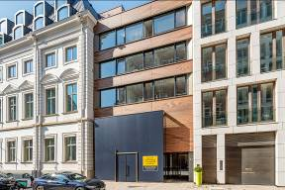 | Photo:  Elisabetta Franchi, an Italian fashion label, is opening a store on Neuer Wall, very close to the “Stadthöfe” ensemble. Grossmann & Berger brokered the rental unit.  Source of image: Christine Prexel / Grossmann & Berger GmbH
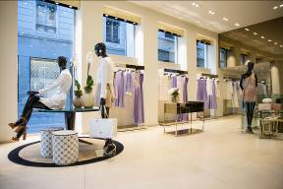 | Photo:  Elisabetta Franchi stores have a uniform interior design. The new store in Hamburg will look similar to this one in Lyon.  Source of image: Elisabetta Franchi

Please consult our website for Grossmann & Berger’s data privacy policy. Here you will also be able to access our press kit and the associated Terms of Use. If in future you would prefer not to receive any more information from our press office, please e-mail us at presse@grossmann-berger.de quoting as reference "Abmeldung aus Presseverteiler” / “Unsubscribe from press mailing list”.

