Change at the top
Sandra Ludwig now heads investment

Hamburg/Berlin, 7th December 2020 - Starting on 1st January 2021 Sandra Ludwig will become a managing director at Grossmann & Berger, member of German Property Partners (GPP). Together with Holger Michaelis she will be heading the commercial property investment sector in Hamburg and Berlin. Mr Michaelis will be responsible for Berlin, Mrs Ludwig for Hamburg. In addition, she will be head of the sector dealing with buy-to-let investments in Hamburg.

Mrs Ludwig worked for Jones LangLaSalle for more than ten years, latterly as the head of Retail Investment Germany, which operated nationwide from a base in Hamburg. Prior to that Mrs Ludwig was employed as a director of Rickmers Immobilien Management where she took responsibility for business development, purchasing and sales of properties belonging to a variety of asset classes.

“We are delighted that Mrs Ludwig has joined Grossmann & Berger; customers on the investment market regard her highly and she is well-respected in the business,” comments Frank Brockmann, chairman of the supervisory board of Grossmann & Berger. “With her help we intend to start a new, vigorous chapter in the investment market.”

Axel Steinbrinker is resigning from senior management at the end of the year for personal reasons. From 1st January 2015 until the end of 2020, he was co-head, with Holger Michaelis, of commercial property investments in Hamburg and Berlin. Mr Steinbrinker will remain with the company in the investment sector.

As of 1st January 2021, the management board of Grossmann & Berger thus consists of Sandra Ludwig, Holger Michaelis, Andreas Rehberg (spokesman) and Lars Seidel.

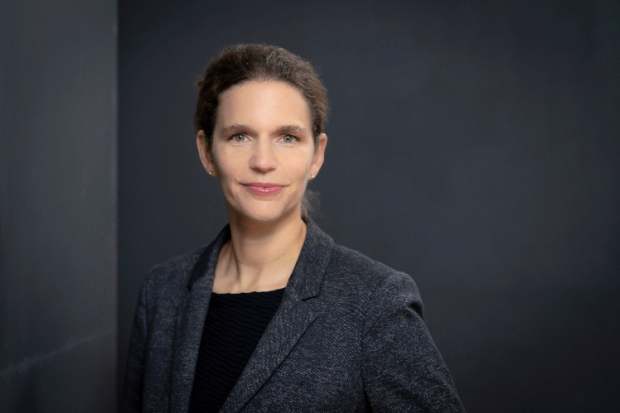 | Photo:  Sandra Ludwig becomes new head of Investment at Grossmann & Berger on 1st January 2021.  Source: Grossmann & Berger GmbH

About Grossmann & Berger
Grossmann & Berger GmbH is one of the leading service providers for selling and letting commercial and residential properties in North Germany. Headquartered in Hamburg, the Company has a branch office in Berlin, a total of 14 property shops, and over 190 employees who cover the entire North German market. With over 85 years of experience in the business, Grossmann & Berger offers a complete package of real estate expertise. Grossmann & Berger is a member of the HASPA Group of Companies, which also includes Germany's largest savings bank, Hamburger Sparkasse (Haspa). Moreover, the Company is a founding member of the nation-wide commercial property network German Property Partners (GPP) and the working group of brokers associated with banks and building societies, Arbeitsgemeinschaft ImmobilienVermittler Banken Bausparkassen e.V. (IVBB).

Please consult our website for Grossmann & Berger’s data privacy policy. Here you will also be able to access our press kit and the associated Terms of Use. If in future you would prefer not to receive any more information from our press office, please e-mail us at presse@grossmann-berger.de quoting as reference "Abmeldung aus Presseverteiler” / “Unsubscribe from press mailing list”.

