Hamburg: Office letting market 1st-4th quarters of 2019
Gloomy outlook for companies seeking office space

Hamburg, 6 January 2020 - In 2019 the total amount of office space let in Hamburg was 545,000 m² and thus some 8 % below the prior year’s figure. Information analysed by Grossmann & Berger, a member of German Property Partners (GPP), reveals that the volume of empty space continued to contract and by the end of the year the vacancy rate had reached an all-time low of 2.9 %. “In conjunction with the strong rise in land and construction costs, the low level of vacant space led to a significant rise in office rents in 2019,” says managing director Andreas Rehberg. In view of the high proportion of pre-lettings - 73 % of the space due for completion in 2020 and 2021 is already taken - the market will not benefit from these new buildings. Consequently, office rents will rise even further. “In 2020 Hamburg will remain a landlord’s market. Because so little office space is on the market, companies seeking new office premises have extremely little scope to negotiate terms. Meanwhile, even when larger suites between 1,000 and 2,000 square metres in size become available, three or four firms will be competing for the space. Therefore clients are now offered practically no inducements to sign,” adds Rehberg.

Market details:
- The 4th quarter was the weakest of the four with take-up of office space at 110,000 m².
- Overall in 2019 twelve leases for more than 5,000 m² of space were signed (2018: 15). None of the six agreements to rent more than 10,000 m² (2018: 5) was concluded in the 4th quarter. The biggest new agreement involved some 8,175 m² which energy firm Lichtblick has rented off-plan in the “CONNEXION” office development at Klostertor 1.
- Year on year the average rent rose by 12.0 % from €15.80/m²/month to € 17.70/m²/month. By the end of the year, the premium rate had risen 7.3 % to mark a new high of €29.50/m²/month
- Although some 304,000 m² of new office property will be completed in 2020/2021, this will not ease the tight market because 73 % of the volume has been pre-let. “Therefore speculative developments stand an excellent chance on the market,” forecasts Rehberg.
- As the volume of available space continues to shrink, Grossmann & Berger expect take-up of office space in 2020 to be in the region of the ten-year average of 530,000 m².

Office market | Hamburg | 2019 | Q1-4
Space take-up [m²] | 545,000
against prior yr [%] | -7.6
Premium rent [€/m²/month net of services] | 29.50
against prior yr [%] | +7.3
Average rent [€/m²/month net of services] | 17.70
against prior yr [%] | +12.0
Stock of office space [millions m²] | 13.8
Vacant space [m²] | 400,400
against prior yr [%] | -16.1
Vacancy rate [%] | 2.9
Completions 2020+2021 [m²] | 304,000
Pre-let ratio [%] | 73
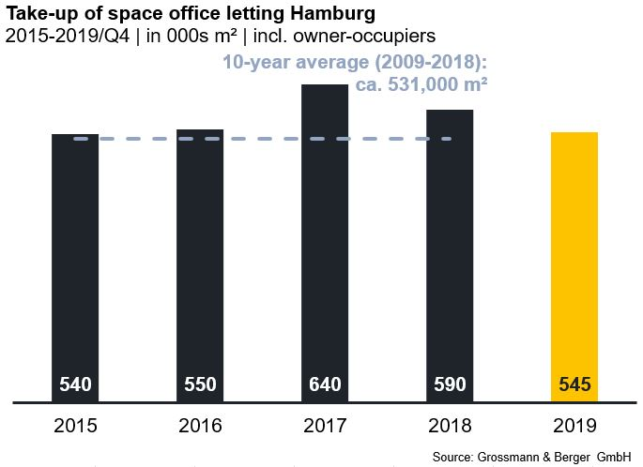

Selected agreements | offices in Hamburg | 1st to 4th quarters 2019
Tenant/owner-occupier | Property/project | Street no. | Sub-market | Rental area  [ca. m²]
Otto Group | “OTTO GOeast” | Werner-Otto-Strasse 1-7 | Hamburg East | 40,000
Xing | “Unilever-Haus” | Strandkai 1 | HafenCity | 22,000
Vattenfall Europe | “EDGE Elbside” | Amerigo-Vespucci-Platz | HafenCity | 17,500
University of Hamburg | Former telephone exchange /  Humanities Research Center | Schlüterstrasse 51-59 | Alster West | 15,000
German Institute of Global and Area Studies | Former telephone exchange /  Humanities Research Center | Schlüterstrasse 51-59 | Alster West | 10,000

New transactions or those occurring in the quarter in this report are highlighted

The complete market survey will soon be available and can be downloaded from our website.

About Grossmann & Berger
Grossmann & Berger GmbH is one of the leading service providers for selling and letting commercial and residential properties in North Germany. The Company has ten offices in Hamburg, and one each in Berlin, Ahrensburg, Lüneburg, Norderstedt and on the Island of Sylt, permitting comprehensive coverage of the North German market. With over 85 years of experience in the business, the Company offers a complete package of real estate expertise. Grossmann & Berger belongs to the HASPA Group and is a founding member of the national commercial real estate network German Property Partners (GPP).

Please consult our website for Grossmann & Berger’s data privacy policy. Here you will also be able to access our press kit and the associated Terms of Use. If in future you would prefer not to receive any more information from our press office, please e-mail us at presse@grossmann-berger.de quoting as reference "Abmeldung aus Presseverteiler” / “Unsubscribe from press mailing list”.

