Hamburg: Office letting market, 1st-4th quarters of 2020
The new normal - viewings with social distancing and mask

Hamburg, 4th January 2021 - From the start of the 2nd quarter of 2020 business on Hamburg’s office-letting market was dominated by the economic impact of the coronavirus pandemic. Take-up of space did revive a little in the 4th quarter to total 90,000 m², including space in the “Elbtower”, up from 85,000 m² in the 3rd quarter and 70,000 m² in the 2nd quarter. Overall, however, as figures from Grossmann & Berger, a member of German Property Partners (GPP), show, take-up of space in 2020 totalled 340,000 m². The result is thus some 40 % below that of the prior year. It is the lowest total take-up of office space recorded since 2003.

Covid-19 vaccines offer ray of hope
“The vaccination campaign now under way is a ray of hope. However, in the short term the situation remains tense in view of the current rates of infection. Many companies are still reticent when it comes to making a decision about new premises. Nevertheless, we have reached a state of “new normal”. Customers now regularly view offices, but observe social distancing and wear a mask,” says managing director Andreas Rehberg. “Due to the difficult economic situation we do not expect to see brisk demand for office space in the first half of 2021. The market is and will continue to be determined by the infection rates.”

Market details:
- Unlike take-up rates, rental charges for offices in Hamburg were largely unchanged in 2020, despite the coronavirus pandemic. The average rent fell back year on year by 1.1 % to €17.50/m²/month, whereas the premium rent grew by 3.4 % to €30.50/m²/month. Rehberg confirms that, “Here in Hamburg we are a long way from seeing a dramatic slump in office rents.” Potential tenants do, however, have a rather better chance of negotiating incentives such as rent-free periods or building cost subsidies.
- On the supply side, the situation has continued to ease. Reflecting the acute shortage of space in 2019 the vacancy rate, including sub-let space, was 2.9 %; it now stands at 3.5 %. In the 3rd quarter of 2020 the vacancy rate was 3.3 %. Totalling 35,000 m² the amount of sub-let space on the market has risen by 77 % year on year. However, this increase of 15,000 m² is minuscule in comparison with a total stock of office space of 13.9m m². In the year ahead Grossmann & Berger expects to see more space coming onto the market unless there is a marked rise in take-up.

Office market | Hamburg | 2020 | Q1 -4
Space take-up [m²] | 340,000
against prior yr [%] | -37.6
Premium rent [€/m²/month net of services] | 30.50
against prior yr [%] | +3.4
Average rent [€/m²/month net of services] | 17.50
against prior yr [%] | -1.1
Stock of office space [millions m²] | 13.9
Vacant space incl. sub-let space [m²] | 486,000
against prior yr [%] | +21.4
Vacancy rate incl. sub-let space [%] | 3.5
Completions 2020+2021 [m²] | 378,000
Pre-let ratio [%] | 61
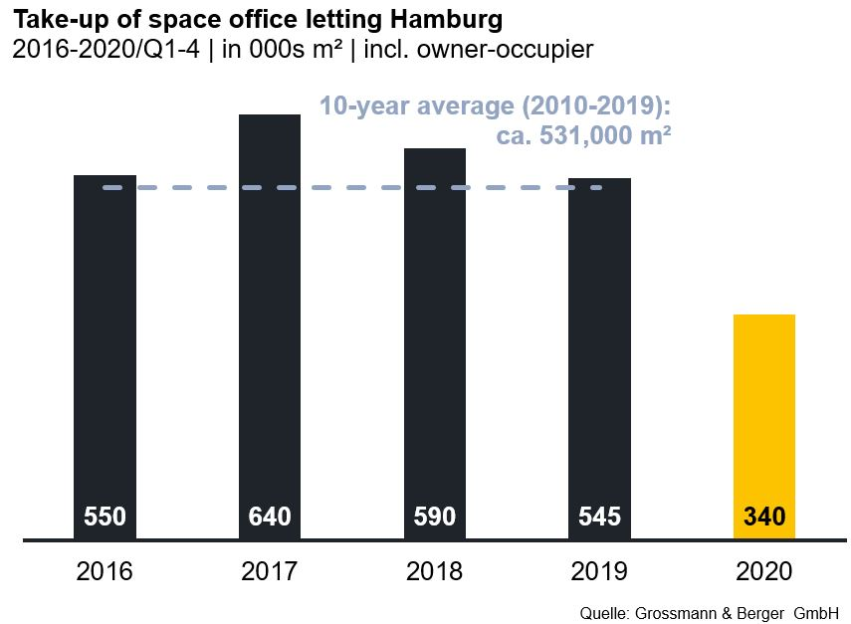

Selected agreements | offices in Hamburg | 1st to 4th quarters 2020
Tenant/owner-occupier (oo) | Property/project | Street no. | Sub-market | Rental area  [ca. m²]
Hamburg Commercial Bank (HCOB) | “Elbtower” | Zweibrückenstrasse | HafenCity | 11,000
Hamburg Verkehrsanlagen (HHVA) (oo) |  | Am Neumarkt 40 | Wandsbek | 6,800
Hansainvest Hanseatische Investment | “Oval Office” | Überseering 10 | City North | 6,000
Wärtsilä SAM Electronics |  | Behringstrasse 120 | Altona | 5,900
MSH Medical School Hamburg | “HafenCity Gate” | Am Sandtorkai 74-77 | HafenCity | 5,800

Transactions occurring in the quarter covered by this report are highlighted

The complete market survey will soon be available and can be downloaded from our website.

About Grossmann & Berger
Grossmann & Berger GmbH is one of the leading service providers for selling and letting commercial and residential properties in North Germany. Headquartered in Hamburg, the Company has a branch office in Berlin, a total of fourteen property shops, and over 190 employees who cover the entire North German market. With over 85 years of experience in the business, Grossmann & Berger offers a complete package of real estate expertise. Grossmann & Berger is a member of the HASPA Group of Companies, which also includes Germany's largest savings bank, Hamburger Sparkasse (Haspa). Moreover, the Company is a founding member of the nation-wide commercial property network German Property Partners (GPP) and the working group of brokers associated with banks and building societies, Arbeitsgemeinschaft ImmobilienVermittler Banken Bausparkassen e.V. (IVBB).

Please consult our website for Grossmann & Berger’s data privacy policy. Here you will also be able to access our press kit and the associated Terms of Use. If in future you would prefer not to receive any more information from our press office, please e-mail us at presse@grossmann-berger.de quoting as reference "Abmeldung aus Presseverteiler” / “Unsubscribe from press mailing list”.

