Hamburg: Office letting market, 1st-3rd quarters of 2021
Great willingness to change fuels take-up of space

Hamburg, 30th September 2021 - Hamburg’s office letting market is gathering momentum, as may be seen from the 3rd-quarter take-up of 135,000 m² of space. So far this year, a total of 360,000 m² of office space has been taken up in Hamburg by new tenants or owner-occupiers. This translates into growth of 44 % against the same period a year ago which was marked by the coronavirus crisis. “As a result of the pandemic, existing organization models have come under scrutiny and firms are thus very willing to explore changes. At present, the end of a rental term is frequently seen as a chance to re-organize the business and make a new start at a different location. In this respect, the recovery is reflected in the take-up of space,” says Andreas Rehberg, managing director of Grossmann & Berger, a member of German Property Partners (GPP), commenting on the growth trend. Accordingly, Rehberg expects the year to close with take-up of office space in Hamburg totalling over 460,000 m².

Market details:
- The vacancy rate for office space in Hamburg stabilized at 3.8 %, slightly above the 3.3 % noted a year ago, but unchanged from the preceding quarter.
- Contrary to expectations at the beginning of the year, the take-up of sub-let space has declined since the prior quarter because many firms have opted not to let but to use the space themselves. “Most businesses with space reserves that could be sub-let are reluctant to make a hasty decision and prefer to wait and see how the situation develops. Additionally, it is often difficult to sub-let space because rental periods are limited, alterations cannot be made and no refurbishing budget is available,” says Rehberg. Nevertheless, in terms of actual figures, the amount of sub-let space has grown year on year from 30,300 m² to 48,500 m².
- Agreements to take large office suites in new-builds which command high prices have pushed the average rent to a new record figure. It increased by 4.6 % to €18.10/m²/month. The calculation is based on all agreements signed in the past twelve months. Thus the figure includes not only the new contracts for offices in the “Ipanema” and the Deelböge office campus, but also the large-volume agreement for space in the “Elbtower” concluded with Hamburg Commercial Bank in the 4th quarter of 2020.
- Year on year the premium rent climbed from €31.00/m²/month to €31.50/m²/month. “Rates have risen for top-quality office space in central locations. One of the reasons for this is the spiralling price of construction, which makes it hard for many developers to calculate project costs accurately,” says Rehberg, commenting on the increase.

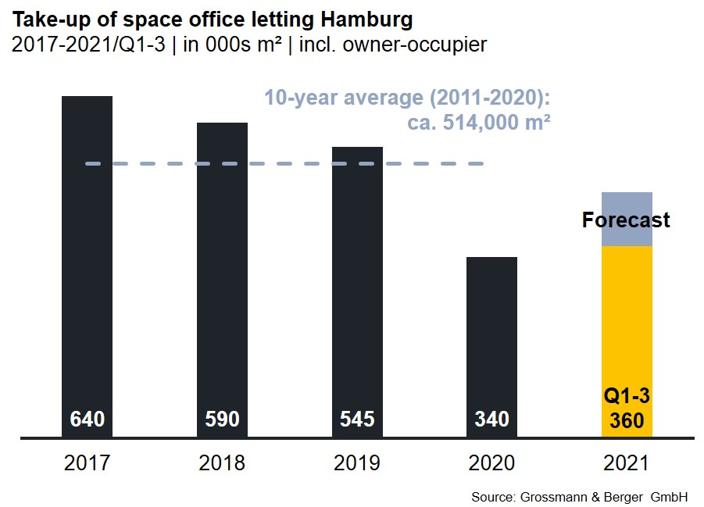
Office market | Hamburg | 2021 | Q 1-3
Space take-up [m²] | 360,000
against prior yr [%] | +44.0
Premium rent [€/m²/month net of services] | 31.50
against prior yr [%] | +3.3
Average rent [€/m²/month net of services] | 18.10
against prior yr [%] | +4.6
Stock of office space [millions m²] | 14.00
Vacant space incl. sub-let space [m²] | 536,700
against prior yr [%] | +15.8
Vacancy rate incl. sub-let space [%] | 3.8
Completions 2021+2022 [m²] | 268,000
Pre-let ratio [%] | 69

Top selected known agreements | offices in Hamburg | 1st-3rd quarters 2021
Tenant / owner-occupier | Property / project | Street no. | Sub-market | Rental area  [ca. m²]
Berenberg Bank | “Ipanema” | Überseering 30 | City North | 19,200
Hamburg State Prosecutor | “Michaelis Quartier” | Ludwig-Erhard-Strasse 11-17 | City | 17,600
Techniker Krankenkasse owner-  occupier (construction start) | Building extension | Bramfelder Chaussee 160-164 | Hamburg East | 14,800
Sysmex Deutschland | Office Campus  Deelböge | Deelböge/Salomon-Heine-Weg | Eppendorf | 13,000
Signal Iduna | “Kap 5” | Kapstadtring 5 | City North | 13,000

Transactions occurring in the quarter covered by this report are highlighted.

The complete office market survey will soon be available and can be downloaded from our website.

About Grossmann & Berger
Grossmann & Berger GmbH is one of the leading service providers in the business of selling and letting commercial and residential properties in North Germany. In addition to its main office in Hamburg, the company has 20 local offices. This allows Grossmann & Berger to cover the entire North German market. In May 2021 the company was augmented by E & G Real Estate and
E & G Private Immobilien, so that Grossmann & Berger also operates in the two South German metropolitan areas of Stuttgart and Munich. Drawing on their comprehensive expertise in the real estate business, some 250 employees provide the full range of relevant services. They also benefit from the company’s more than 85 years standing in the industry. Grossmann & Berger belongs to the HASPA Group and is a founding member of the national commercial real estate network German Property Partners (GPP).

Please consult our website for Grossmann & Berger’s data privacy policy. Here you will also be able to access our press kit and the associated Terms of Use. If in future you would prefer not to receive any more information from our press office, please e-mail us at presse@grossmann-berger.de quoting as reference "Abmeldung aus Presseverteiler” / “Unsubscribe from press mailing list”.

