Hamburg: Office letting market, 1st quarter of 2022
Escalator clause becoming a key issue during lease negotiations

Hamburg, 31st March 2022 – Companies in Hamburg have been very active during the 1st quarter of 2022, with take-up of office space at 135,000 m². “Concerns about the German economy sparked by Russia’s attack on Ukraine are not, for the moment, reflected on the market for office space in Hamburg. On the contrary, most companies have been “doing their homework” over recent months, and are now ready to view properties and implement re-organization plans for their future business needs. This is especially true of large companies,” says Andreas Rehberg, spokesperson for the managing board of Grossmann & Berger, member of German Property Partners (GPP). Against the 1st quarter of 2021 the volume of turnover rose by some 4 %. “Thanks to the current increase in inflation, an escalator clause designed to protect the contracting parties against risks such as inflation, has become a key part of rental negotiations. In particular when longer-term agreements are signed off plan, the escalator clause plays a crucial role,” Rehberg adds.

Market details:
- Between January and March 2022, as in the 1st quarter of 2021, four agreements were signed for premises in the size category of 5,000 m² or more. The leases included those taken by Veolia Umweltservice, Evotec and Vestas Deutschland. Nevertheless, year on year this size category no longer accounted for the largest proportion of take-up (35 % in 2021) because the lion’s share (27 %) had shifted to the 2,000 to 5,000-square-metre sector. The larger size category comprised 20 % of take-up, thus moving down to second place.
- The proportion of owner-occupier transactions grew from 5 % to 16 %, but at 21,000 m² the total was low for Hamburg.
- Since Hamburg companies are increasingly taking space in central locations in order to attract and keep employees, City and HafenCity sub-markets flourished. This is evident from the fact that their share of take-up is higher than in other districts at 29 % and 19 %. “Location and the quality of the building have top priority together with a degree of saving on space requirements,” Rehberg remarks. Hamburg East sub-market also accounted for a double-figure share of take-up (12 %), partly due to the Evotec lease for 5,300 m² of space.
- Year on year the premium rent in Hamburg increased by 50 cents/m²/month, the average rent by 60 cents/m²/month.
- The amount of office space available within six months fell by about 6 % within the space of a year to 493,200 m². For the first time the vacancy rate including sub-let space started to fall back again, from 3.8 % to 3.5 %. “In view of delays within the supply chain and shortages of materials due to the situation in Ukraine, some fit-out or completion dates for new-builds may be pushed back. In the longer term however, one may count on a growing supply of space,” says Rehberg confidently. As matters stand at present, some 53 office buildings will be completed between 2022 and 2023, offering a total volume of 578,000 m². The pre-let ratio was some 60 %.
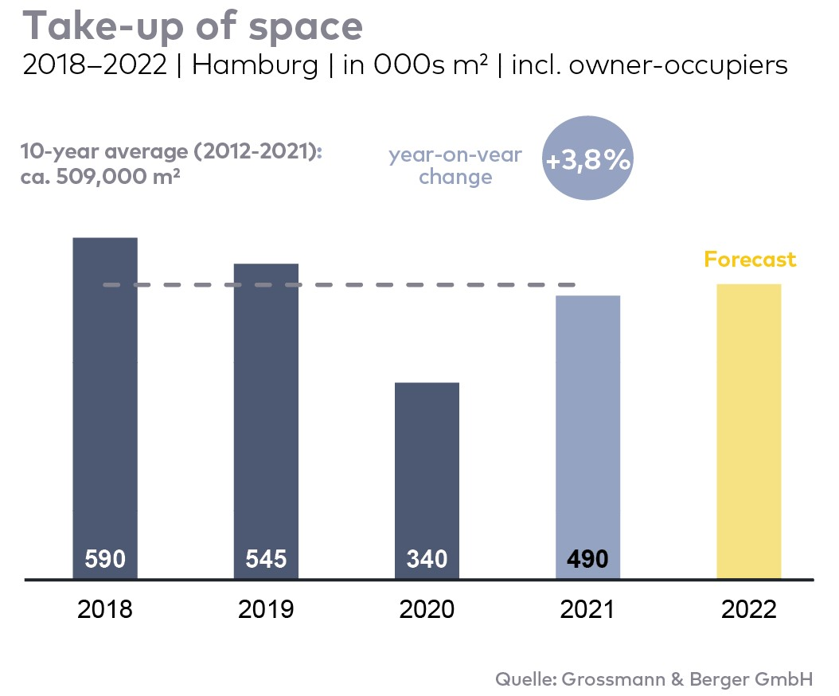
Office market | Hamburg | 2022 | Q1
Space take-up [m²] | 135,000
against prior yr [%] | +3.8
Premium rent [€/m²/month net of services] | 31.50
against prior yr [%] | +1.6
Average rent [€/m²/month net of services] | 18.50
against prior yr [%] | +3.4
Stock of office space [millions m²] | 14.0
Vacant space incl. sub-let space [m²] | 493,200
against prior yr [%] | -5.9
Vacancy rate incl. sub-let space [%] | 3.5
Completions 2022+2023 [m²] | 578,000
Pre-let ratio [%] | 60

Top selected known agreements | offices in Hamburg | 1Q2022
Tenant/owner-occupier | Property/project | Street no. | Sub-market | Rental area  [ca. m²]
Confidential |  | Versmannstrasse, “Elbbrückenquartier” | HafenCity | 11,500
Veolia Umweltservice | “EDGE HafenCity” | Amerigo-Vespucci-Platz 1 | HafenCity | 5,700
Evotec | Essener Bogen 6a-d | Essener Bogen 6a-d | Hamburg East | 5,300
Vestas Deutschland | “ConneXion Office” | Klostertor 1 | City | 5,200
Hapag-Lloyd Kreuzfahrten (Cruise line) | “Europapassage” | Hermannstrasse 9 | City | 4,600

The market survey office letting Hamburg 2022/Q1 will soon be available to download from our website.

About Grossmann & Berger
Grossmann & Berger GmbH is one of the leading service providers in the business of selling and letting commercial and residential properties in North Germany. In addition to its main office in Hamburg, the company has 20 local offices. This allows Grossmann & Berger to cover the entire North German market. In May 2021 the company was augmented by E & G Real Estate and
E & G Private Immobilien, so that Grossmann & Berger also operates in the two South German metropolitan areas of Stuttgart and Munich. Drawing on their comprehensive expertise in the real estate business, some 250 employees provide the full range of relevant services. They also benefit from the company’s more than 85 years standing in the industry. Grossmann & Berger belongs to the HASPA Group and is a founding member of the national commercial real estate network German Property Partners (GPP).

Please consult our website for Grossmann & Berger’s data privacy policy. Here you will also be able to access our press kit and the associated Terms of Use. If in future you would prefer not to receive any more information from our press office, please e-mail us at presse@grossmann-berger.de quoting as reference "Abmeldung aus Presseverteiler” / “Unsubscribe from press mailing list”.

