Hamburg: Office-letting market, 1st quarter of 2021
Time not yet ripe for “bargain hunters”
Hamburg, 7th March 2021 - Office lettings in Hamburg started 2021 with strong year on year growth of more than 30 % in the 1st quarter. Take-up of space in the first three months of 2021 totalled 130,000 m², a result that was very close to the 135,000 m² seen pre-Covid in 2019. Take-up of space in office suites offering more than 5,000 m² rose fourfold year on year to 46,000 m². The reason is that tenants who had for some time been thinking about renting large premises decided to sign agreements in the first three months. Accordingly, this segment accounted for 35 % of the market, up from 12 %.

“Even if the underlying mood of the market is optimistic, despite the current situation, many firms are still adopting a wait and see attitude,” says Andreas Rehberg, managing director of Grossmann & Berger, a member of German Property Partners (GPP), commenting on the present state of the office market in Hamburg.

“Many companies are using this as an opportunity to review their requirements and revise the amount of space they need in future. One thing is certain, quality will be more important than quantity. If more people work away from the office, employers need to rent less space. They can invest the cost savings in offering their employees more attractive workplaces in terms of location and fit-out.” At present, several clients are actively seeking large office suites and the annual take-up of space will thus probably be higher than the level in 2020.

Market details:
- Both the average and premium rents rose year on year. The renewed increase in the average rent, now standing at €17.90/m²/month, resulted from several agreements for large amounts of space in central locations where office rates are higher. For the first time ever the premium rent in Hamburg rose to €31.00/m²/month. “Bargain hunters have definitely not been in luck so far,” remarks Rehberg. “At the moment there is a healthy relationship between supply and demand. Landlords have therefore not yet been prepared to agree to more substantial concessions.” However, if the volume of sub-let space increases during the course of the year, creating a “secondary market”, rents in existing office blocks might come under pressure. In the same quarter a year ago, sub-let space totalled 12,900 m²; in the 1st quarter of 2021, this figure has risen to 43,500 m².
- Accordingly, the landlord-dominated market in Hamburg is slowly moving in favour of the tenants. One indication is the amount of office space available at short notice. In a significant year on year rise, the figure grew by over 100,000 m² in the 1st quarter of 2021; the vacancy rate, including sub-let space, was 3.8 %. The shortage of space that was still apparent in early 2020 is slowly disappearing.

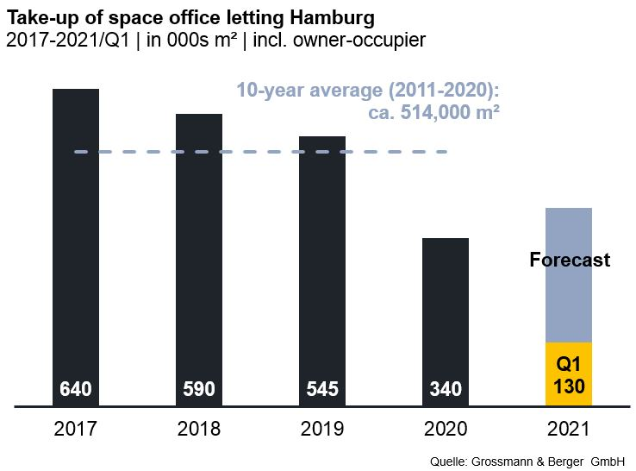
Office market | Hamburg | 2021 | Q1
Space take-up [m²] | 130,000
against prior yr [%] | +36.8
Premium rent [€/m²/month net of services] | 31.00
against prior yr [%] | +3.3
Average rent [€/m²/month net of services] | 17.90
against prior yr [%] | +1.1
Stock of office space [millions m²] | 14.0
Vacant space incl. sub-let space [m²] | 524,100
against prior yr [%] | +27.0
Vacancy rate incl. sub-let space [%] | 3.8
Completions 2021+2022 [m²] | 333,000
Pre-let ratio [%] | 70

Top selected known agreements | offices in Hamburg | 1st quarter of 2021
Tenant/owner-occupier (oo) | Property/project | Street no. | Sub-market | Rental area  [ca. m²]
Wintershall Dea | “denk.mal Hannoverscher Bahnhof” | Am Lohsepark 67-69 | HafenCity | 11,400
Deutsche Bank | “Oval Office” | Überseering 10 | City North | 9,600

The complete office market survey Hamburg will soon be available for download from our website.

About Grossmann & Berger
Grossmann & Berger GmbH is one of the leading service providers for selling and letting commercial and residential properties in North Germany. Headquartered in Hamburg, the Company has a branch office in Berlin, fourteen property shops, and some 190 employees who cover the entire North German market. With over 85 years of experience in the business, Grossmann & Berger offers a complete package of real estate expertise. Grossmann & Berger is a member of the HASPA Group of Companies, which also includes Germany's largest savings bank, Hamburger Sparkasse (Haspa). Moreover, the Company is a founding member of the nation-wide commercial property network German Property Partners (GPP) and the working group of brokers associated with banks and building societies, Arbeitsgemeinschaft ImmobilienVermittler Banken Bausparkassen e.V. (IVBB).

Please consult our website for Grossmann & Berger’s data privacy policy. Here you will also be able to access our press kit and the associated Terms of Use. If in future you would prefer not to receive any more information from our press office please e-mail us at presse@grossmann-berger.de quoting as reference "Abmeldung aus Presseverteiler” / “Unsubscribe from press mailing list”.

