Hamburg: Office letting market 1st-4th quarters of 2021
Hamburg’s diversified economy eases the return to normal business

Hamburg, 4 January 2022 – At the end of another year marked by the COVID pandemic, it is apparent that the Hamburg office letting market has fared better than in 2020. Year on year, take-up of office space in this metropolis on the Elbe grew by 44 % to total 490,000 m² at the end of the 4th quarter of 2021. Summarizing the situation Andreas Rehberg, spokesperson for the management board of Grossmann & Berger, a member of German Property Partners (GPP), says, “This surge definitely speaks of a market recovery. As in the past, Hamburg benefits from the diversity of its economy. It has been very noticeable that service sector firms have been seeking considerably more office space in recent months. They tended to focus on space that was available at the time. Companies which consider only a few locations have as little choice now as before the pandemic. If the fourth wave of the pandemic ebbs as forecast and supply chains return to normal in mid-2022, we expect to see increasing demand for offices in Hamburg. We believe take-up of office space will exceed 500,000 square metres by the end of 2022.”

Market details:
- One indication that Hamburg’s office market has stabilized is that the number of agreements for premises offering more than 5,000 m² of space rose from eight to eleven year on year. Seven agreements were noted in the size category upwards of 10,000 m².
- The biggest new rental agreement was signed in the 4th quarter by Maersk, a shipping company; it has decided to take 13,200 m² of office space in the “Johann Kontor” in order to bring together in one location the employees working in Hamburg for Maersk and its subsidiaries. No other large-volume agreements were concluded between October and December. The biggest owner-occupier transaction in 2021 was the 3rd-quarter construction start to add 14,800 m² of space to the headquarters of the health insurance company Techniker Krankenkasse on Bramfelder Chaussee.
- Owner occupiers accounted for a mere 6 % of the market, a figure unchanged year on year.
- Compared with the preceding quarter, the vacancy rate at the end of the 4th quarter of 2021 remained stable at 3.8 %. At the end of 2020, the figure was 3.5 %. Year on year the amount of office space available within six months rose by 10.6 % to 537,600 m². “Over the course of the year the amount of empty office space is likely to increase, leading to a rise in the vacancy rate, although it should remain in the low single-figure range. Companies are still looking to reduce their space requirements, but not by as much as thought a few months ago. Instead, they are investing in the quality of their premises, which includes generously-dimensioned community areas and breakout spaces,” says Rehberg. “Despite the increase we expect rents to grow steadily in the City and sought-after locations. If more offices stand empty, however, rents for space in peripheral locations could be squeezed.”
- Compared with the preceding quarter, the volume of sublet space was unchanged at 48,450 m² but 40 % higher than the figure at the end of 2020.
- A similar situation was observed for office rents: At the close of 2021 the average rent reached a high of €18.10/m²/month, the same as it was in the preceding quarter. Compared with the end of 2020, however, this average has climbed by 3.4 %. Unchanged against the preceding quarter, the premium rent rose by 3.3 % over twelve months.

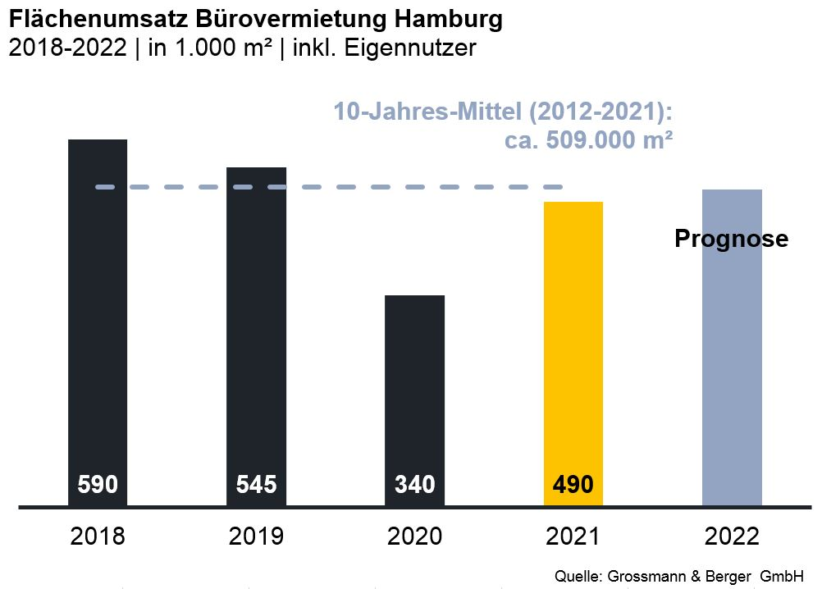
Office market | Hamburg | 2021 | Q1 -4
Space take-up [m²] | 490,000
against prior yr [%] | +44.1
Premium rent [€/m²/month net of services] | 31.50
against prior yr [%] | +3.3
Average rent [€/m²/month net of services] | 18.10
against prior yr [%] | +3.4
Stock of office space [millions m²] | 14.0
Vacant space incl. sub-let space [m²] | 537,600
against prior yr [%] | +10.6
Vacancy rate incl. sub-let space [%] | 3.8
Completions 2022+2023 [m²] | 556,000
Pre-let ratio [%] | 57

Top selected known agreements | offices in Hamburg | 1st-4th quarters 2021
Tenant/owner-occupier | Property/project | Street no. | Sub-market | Rental area  [ca. m²]
Berenberg Bank | “Ipanema” | Überseering 30 | City North | 19,200
Hamburg State Prosecutor | “Michaelis Quartier” | Ludwig-Erhard-Strasse 11-17 | City | 17,600
Techniker Krankenkasse (health ins.) owner-occupier  (construction start) | Building extension | Bramfelder Chaussee 160-164 | Hamburg East | 14,800
Maersk Deutschland Group | “Johann Kontor” | Maersk Deutschland Group | City | 13,200
Sysmex Deutschland | Office Campus  Deelböge | Deelböge/Salomon-Heine-Weg | Eppendorf | 13,000

Transactions occurring in the quarter covered by this report are highlighted.

The complete office market survey will soon be available and can be downloaded from our website.

About Grossmann & Berger
Grossmann & Berger GmbH is one of the leading service providers in the business of selling and letting commercial and residential properties in North Germany. In addition to its main office in Hamburg, the company has 20 local offices. This allows Grossmann & Berger to cover the entire North German market. In May 2021 the company was augmented by E & G Real Estate and
E & G Private Immobilien, so that Grossmann & Berger also operates in the two South German metropolitan areas of Stuttgart and Munich. Drawing on their comprehensive expertise in the real estate business, some 250 employees provide the full range of relevant services. They also benefit from the company’s more than 85 years standing in the industry. Grossmann & Berger belongs to the HASPA Group and is a founding member of the national commercial real estate network German Property Partners (GPP).

Please consult our website for Grossmann & Berger’s data privacy policy. Here you will also be able to access our press kit and the associated Terms of Use. If in future you would prefer not to receive any more information from our press office, please e-mail us at presse@grossmann-berger.de quoting as reference "Abmeldung aus Presseverteiler” / “Unsubscribe from press mailing list”.

