PRESS RELEASE
FLE AQUIRE OFFICE BUILDING NEAR STUTTGART
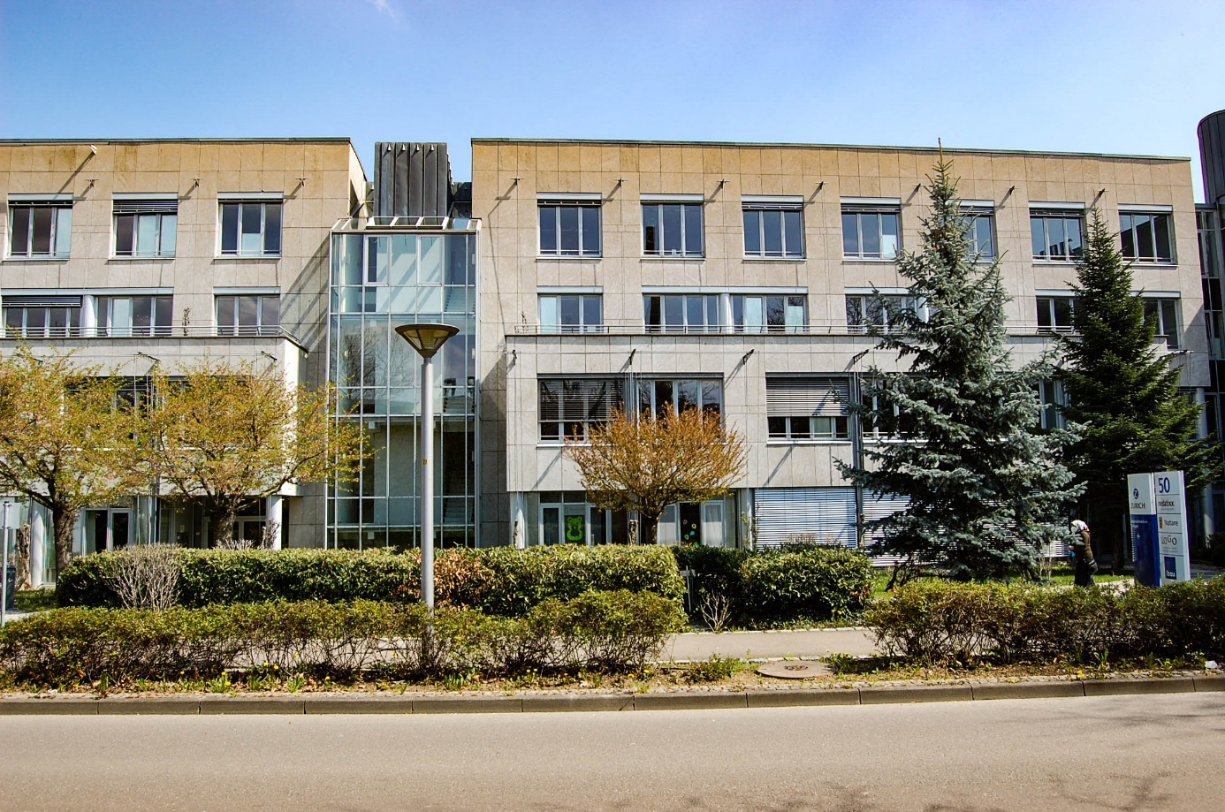

Austrian asset managers FLE GmbH have acquired an office complex at Eastleigh Strasse 50-52 in Kornwestheim near Stuttgart.
Built in 1992 directly next to the Kornwestheim commuter rail station, the property offers more than 6,700m2 of rental space plus an underground parking garage with 109 parking spaces. FLE GmbH have added the asset to their property fund FLE SICAV FIS and are aiming for a long-term development of the site.
The contracting parties have agreed not to disclose the purchase price and further details of the transaction.
Alexander Klafsky, Managing Director of FLE GmbH says: “With this acquisition in Kornwestheim, we reconfirm our confidence in valuable office property also in fringe locations of big cities. The asset at Eastleigh Strasse 50-52 perfectly matches our investment strategy and offers great potentials for the near future. The Stuttgart Region has been an interesting investment location for us for several years.“
The transaction has been exclusively managed by E & G Real Estate, a member of German Property Partners (GPP). Legal advice was provided by Luther and GSK Stockmann.

