Hamburg: Investment market 1st-3rd quarters of 2020
Hamburg investment market proves resilient

Hamburg, 30th September 2020 - Again in the 3rd quarter of 2020 the market for investments in commercial properties in Hamburg seemed largely unimpressed by the effects of the coronavirus pandemic. Indeed, the volume of transactions actually grew by 37 % year on year, with around 70 individual trades generating €3.6bn (2019: €2.7bn, 79 trades). In only two other years, 2007 and 2018, were even higher sales volumes recorded at the end of the 3rd quarter. Many players had adopted a wait and see attitude in the 2nd quarter, but in the 3rd quarter the market gathered so much momentum that commercial properties changed hands for more than €1.6bn between July and September. “Because of the many economic imponderables, most investors decided quality was the safest option. Therefore, core real estate let to highly credit-worthy tenants was in great demand,” says Axel Steinbrinker, managing director of GPP-member Grossmann & Berger, adding, “So far, Germany has survived the recession brought on by the pandemic relatively unscathed. That is a major reason why investors remain eager to buy commercial properties in Hamburg. Even if the coronavirus pandemic drags on into the New Year, we expect to see an interesting rally in the final three months of this year.”

Market details:
- Ten transactions involving properties priced at over €100m (2019: 6) accounted for 55 % of the volume traded, and demonstrated the great demand for prime real estate in Hamburg.
- Irrespective of how work patterns might be changing, office properties remained investors’ favourite asset, accounting for 53 % of the volume traded. Whereas buyers are avoiding hotels (2 %), retail buildings, despite fallout from the lockdown period, were the second-biggest-selling asset with a 20 % share of the market. This is due to Quantum’s sale of two “Karstadt” buildings to Signa.
- In many cities, including Hamburg, there is a growing focus on prime locations. Close to one euro in two was spent on properties in Hamburg City district (44 %). Following in second place, Eppendorf sub-market accounted for 12 % of investments.
- Portfolio trades still comprised a considerable proportion of transactions at 36 %. Adding to earlier company and shareholding takeovers, the 3rd quarter saw portfolio trades such as AEW office properties, bought by Tristan, and the two “Karstadt” buildings already noted.
- Despite travel restrictions, international investors featured heavily on the Hamburg market. Their share of total trading rose to 41 % (2019: 18 %).
- Current uncertainties are inducing investors to put far greater faith in low-risk core real estate, thus putting further pressure on the prime yields on offices and logistics properties. However, yields on hotel and retail assets are expected to rise.

Investment market | Hamburg | 2020 | Q 1-3
Transaction volume [€ millions] | 3,640
against prior yr [%] | +37
Share of trading in CBD [%] | 44
Proportion of international investors [%] | 41
Prime net yield, offices [%] | 2.80
against prior yr [percentage points] | ±0.00
Prime net yield, commercial buildings [%] | 2.70
against prior yr [percentage points] | ±0.00
Prime net yield, logistics properties [%] | 4.20
against prior yr [percentage points] | -0.30
Strongest asset class | Offices
Strongest asset class [%] | 53
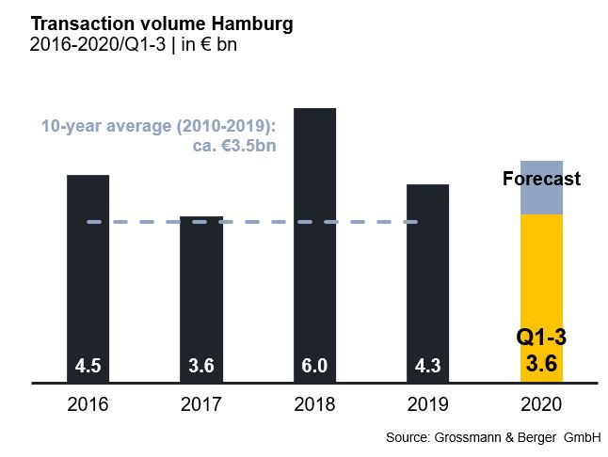

Selected top transactions | investments in Hamburg | 1st to 3rd quarters of 2020
Project/property  Street no. | Sub-market | Asset class | Buyer/investor | Vendor | Purchase price*  [approx. €m]
“Johann Kontor”, Klosterwall 6-8 | City | Mixed use | Captiva / HanseMerkur / Aug. Prien Family Office | Aug. Prien | > 300
Gruner + Jahr publishing house, Am Baumwall 11 | City | Offices | Tishman Speyer | Gruner + Jahr | 300
“Karstadt”, Mönckebergstrasse 16 | City | Retail | Signa Holding | Quantum Immobilien | 260
“Ericus-Contor”, Ericusspitze 2-4 | HafenCity | Offices | Union Investment. | Patrizia | 184
*The purchase prices stated are based on publicly available data, where none is available an estimate is made; transactions occurring in the quarter dealt with in this report are highlighted

The complete market survey will soon be available and can be downloaded from our website.

About Grossmann & Berger
Grossmann & Berger GmbH is one of the leading service providers for selling and letting commercial and residential properties in North Germany. Headquartered in Hamburg, the company has a branch office in Berlin, a total of fourteen property shops, and over 190 employees who cover the entire North German market. With over 85 years of experience in the business, Grossmann & Berger offers a complete package of real estate expertise. Grossmann & Berger is a member of the HASPA Group, which also includes Germany's largest savings bank, Hamburger Sparkasse (Haspa). Moreover, the company is a founding member of the nation-wide commercial property network German Property Partners (GPP) and the working group of brokers associated with banks and building societies, Arbeitsgemeinschaft ImmobilienVermittler Banken Bausparkassen e.V. (IVBB).

Please consult our website for Grossmann & Berger’s data privacy policy. Here you will also be able to access our press kit and the associated Terms of Use. If in future you would prefer not to receive any more information from our press office, please e-mail us at presse@grossmann-berger.de quoting as reference "Abmeldung aus Presseverteiler” / “Unsubscribe from press mailing list”.

