Hamburg: Investment market, 1st-4th quarters of 2020
Flight of capital into core real estate produces second highest annual result ever

Hamburg, 5 January 2021 - By the end of 2020 it was clear that in Hamburg the market for investment in commercial properties had fulfilled the promise of the first three quarters. The dynamic market practically ignored the all-pervading coronavirus crisis to generate 111 transactions with a total volume of €5.37bn. Total investment in Hamburg real estate was 24 % higher than the prior year’s figure (2019: €4.34bn) and, with the exception of 2018 (€5.95bn), the highest result on record. Following the spring lockdown the market rallied extremely well in the 3rd and 4th quarters, providing a very good counter-balance to the wait-and-see attitude observed in the 2nd quarter. “Due to volatile capital markets and low interest rates in 2020 investors’ need to find investments for their capital was greater than their fear of the possible impact of Covid-19. Numerous investors chose to buy real estate in Hamburg thanks to its strong economy and the diversity of its business sectors,” says Sandra Ludwig, new managing director at Grossmann & Berger, a member of German Property Partners (GPP). “Investors increasingly chose the safe options, i.e. core office real estate and avoided the greater risks of hotel and retail properties, whose businesses have been more affected by the pandemic. This trend is likely to continue 2021 too.”

Market details:
- The top priority for most investors in 2020 was to minimize risk. Accordingly, 43 % of the volume traded (€2.29bn) related to properties in Hamburg City.
- A further indication that buyers were focussing on core properties came from the 15 trades priced at over €100m each, which dominated the market and accounted for a share of 52 % (2019: 10 trades, 33 %). The average purchase price per property rose to a new record level of €48m (2019: €37m).
- Although the issue of working from home was omnipresent, investors still place faith in office blocks, which remained the most popular real estate investment, comprising 53 % of total trades. Retail shop properties, badly hit by the lockdown, accounted for 15 %. Hotels, however, were given a wide berth by most investors (2 %).
- Whereas portfolio sales had pushed up the volume of transactions in the middle of the year, they played only a minor role at the end of 2020. Accounting for a 27 % share, their volume fell well below the prior year (40 %).
- Prime yields on the asset class which seems crisis-proof, logistics properties, contracted year on year to 4.00 %. The prime yield on logistics properties will probably fall further, as has already happened at other top locations. On offices and commercial buildings the figures were unchanged year on year at 2.80 % and 2.70 % respectively.
- The current crisis has caused some investors to adjust their strategies. They focus on properties let to good tenants in attractive locations. This trend is likely to persist while the crisis lasts. It would seem unlikely that the good result of 2020 will be repeated 2021.
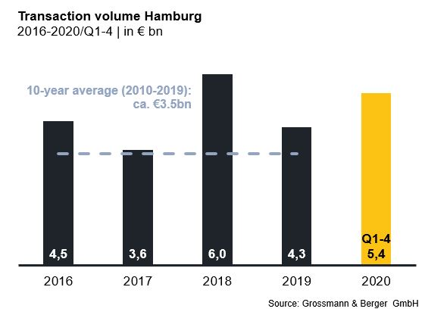
Investment market | Hamburg | 2020 | Q1-4
Transaction volume [€ millions] | 5,370
against prior yr [%] | +24
Share of trading in CBD [%] | 43
Proportion of international investors [%] | 38
Prime net yield, offices [%] | 2.80
against prior yr [percentage points] | ±0.00
Prime net yield, commercial buildings [%] | 2.70
against prior yr [percentage points] | ±0.00
Prime net yield, logistics properties [%] | 4.00
against prior yr [percentage points] | -0.25
Strongest asset class | Offices
Strongest asset class [%] | 53

Selected top transactions | investments in Hamburg | 1st to 4th quarters 2020
Project/property  Street no. | Sub-market | Asset class | Buyer/investor | Vendor | Purchase price*  [approx. €m]
“Johann Kontor”,  Klosterwall 6-8 | City | Mixed use | Captiva / HanseMerkur / Aug. Prien Family Office | Aug. Prien | > 300
Gruner + Jahr publishing house, Am Baumwall 11 | City | Offices | Tishman Speyer | Gruner + Jahr | 300
“Karstadt”,  Mönckebergstrasse 16 | City | Retail | Signa Holding | Quantum Immobilien | 260
“EDGE ElbSide”,  Amerigo-Vespucci-Platz | HafenCity | Offices | HanseMerkur | EDGE Technologies | > 220
“HCOB-Zentrale / Perle”,  Gerhart-Hauptmann-Platz 50 | City | Mixed use | Signa Holding | Hamburg Commercial Bank (HCOB) | confidential
*The purchase prices stated are based on publicly available data, where none is available an estimate is made; transactions occurring in the quarter dealt with in this report are highlighted

The complete market survey will soon be available and can be downloaded from our website.

About Grossmann & Berger
Grossmann & Berger GmbH is one of the leading service providers for selling and letting commercial and residential properties in North Germany. Headquartered in Hamburg, the Company has a branch office in Berlin, a total of fourteen property shops, and over 190 employees who cover the entire North German market. With over 85 years of experience in the business, Grossmann & Berger offers a complete package of real estate expertise. Grossmann & Berger is a member of the HASPA Group of Companies, which also includes Germany's largest savings bank, Hamburger Sparkasse (Haspa). Moreover, the Company is a founding member of the nation-wide commercial property network German Property Partners (GPP) and the working group of brokers associated with banks and building societies, Arbeitsgemeinschaft ImmobilienVermittler Banken Bausparkassen e.V. (IVBB).

Please consult our website for Grossmann & Berger’s data privacy policy. Here you will also be able to access our press kit and the associated Terms of Use. If in future you would prefer not to receive any more information from our press office, please e-mail us at presse@grossmann-berger.de quoting as reference "Abmeldung aus Presseverteiler” / “Unsubscribe from press mailing list”.

