Hamburg: Investment market, 1st-4th quarters of 2021
Supply trailing behind demand

Hamburg, 3rd January 2022 – Whereas commercial properties continued to be traded in 2020 as if there were no COVID pandemic, the market had lost much of its momentum by the end of 2021. The volume of transactions totalled some €3.2bn and was thus 40 % below the prior year’s value (some €5.37bn). Following a weak 1st half year, the market revived in the 3rd quarter and closed the year with a customary 4th-quarter rally. However, with total property trading of €1.1bn in the final three months, it was the weakest 4th quarter on record since 2015. Moreover, the total transaction volume in 2021 was below the ten-year average of €3.8bn. “The lockdown restrictions and political measures at the start of the year made owners noticeably reluctant to sell. And so there are hardly any properties on the market at the moment,” explains Sandra Ludwig, managing director of Grossmann & Berger, member of Germany Property Partners (GPP). “Because of the shortage of properties and renewed interest in office space, investors are now supplementing their core holdings with value-add real estate which can be turned into, e.g., space for new work-place concepts,” remarks Ludwig. Grossmann & Berger expects the year 2022 to develop satisfactorily overall, although it is likely to begin slowly as practically nothing is left in the pipeline, unlike the early part of 2021.

Market details:
- In the whole of 2021, only seven transactions were noted in the price bracket of €100m or more: less than half the figure noted in 2020 (15).
- Investors have shown even greater interest in office real estate and accordingly this class of asset accounted for 66 % of the market by the end of 2021 (2020: 53 %). Logistics properties were also far more popular in 2021, comprising 14 % of the market volume (2020: 2 %).
- Hamburg East sub-market posted 22 transactions and 24 % of the volume traded, pulling ahead of City (17 %) and St. Georg (12 %).
- Portfolio trades made up 13 % of the market, a year on year decline of over 50 %.
- By the close of 2021 open-ended property mutual funds (27 %) had become the biggest group of buyers, pushing developers down to third place in the ranking (19 %). Fund managers occupied second position (22 %). Corporates/owner-occupiers comprised the biggest group of vendors (21 %) followed by fund managers (20 %)
- By the end of the 4th quarter of 2021 international buyers comprised 24 % of the total market, thus remaining below their 38 % share a year before; however, international vendors featured in 24 % of total sales volume in both years.
- Prime yields are currently settling at low levels, having, for the most part, fallen year on year. The prime yield on office properties has contracted by 0.20 percentage points to 2.60 % and on industrial and logistics properties by 0.50 percentage points to 3.50 %. On commercial buildings the prime yield remained unchanged at 2.70 %.
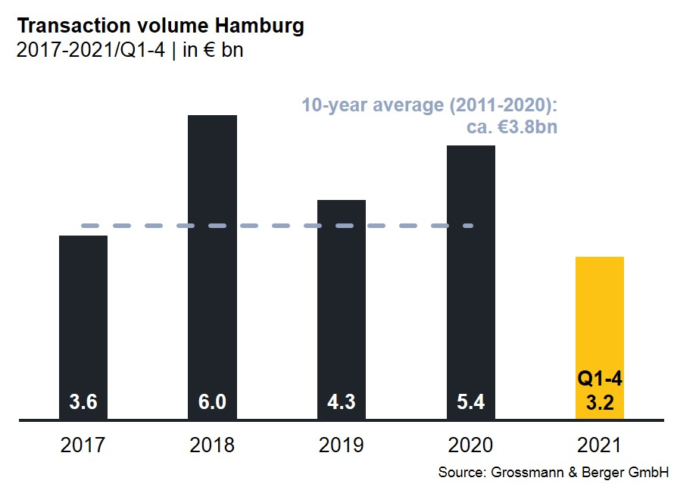
Investment market | Hamburg | 2021 | Q1 -4
Transaction volume [€ millions] | 3,200
against prior yr [%] | -40
Share of trading in CBD [%] | 17
Proportion of international investors [%] | 24
Prime net yield, office [%] | 2.60
against prior yr [percentage points] | -0.20
Prime net yield, commercial buildings [%] | 2.70
against prior yr [percentage points] | ±0.00
Prime net yield, logistics properties [%] | 3.50
against prior yr [percentage points] | -0.50
Strongest asset class | Offices
Strongest asset class [%] | 66

Selected top transactions | investments in Hamburg | 1st-4th quarters of 2021
Project / property  Street no. | Sub-  market | Asset class | Buyer / investor | Vendor | Purchase price*  [approx. €m]
“Spectrum”  Amandus-Stubbe-Strasse 10 | Hamburg East | Ware-house/  logistics | DWS Group | Fiege Deutschland | 189
“Multimedia Centre Rotherbaum”, Rothenbaumchaussee 76-80 | Alster West | Offices | Values Real Estate | Vermögensverwaltung Jahr | 170
“Hamburg Süd House”,  Willy-Brandt-Strasse 59-63 | City | Offices | Union Investment. | Dr. August Oetker Nahrungsmittel | > 150
Norderstrasse 101 | St. Georg | Offices | B & L Gruppe | Commerz Real | 150
Headquarters “Marquard & Bahls”, Koreastrasse 7 | HafenCity | Offices | JP Morgan Asset Management | Marquard & Bahls | confidential
*The purchase prices stated are based on publicly available data, where none is available an estimate is made; transactions occurring in the quarter dealt with in this report are highlighted.

The complete investment market survey will soon be available and can be downloaded from our website.

About Grossmann & Berger
Grossmann & Berger GmbH is one of the leading service providers in the business of selling and letting commercial and residential properties in North Germany. In addition to its main office in Hamburg, the company has 20 local offices. This allows Grossmann & Berger to cover the entire North German market. In May 2021 the company was augmented by E & G Real Estate and
E & G Private Immobilien, so that Grossmann & Berger also operates in the two South German metropolitan areas of Stuttgart and Munich. Drawing on their comprehensive expertise in the real estate business, some 250 employees provide the full range of relevant services. They also benefit from the company’s more than 85 years standing in the industry. Grossmann & Berger belongs to the HASPA Group and is a founding member of the national commercial real estate network German Property Partners (GPP).

Please consult our website for Grossmann & Berger’s data privacy policy. Here you will also be able to access our press kit and the associated Terms of Use. If in future you would prefer not to receive any more information from our press office please e-mail us at presse@grossmann-berger.de quoting as reference "Abmeldung aus Presseverteiler” / “Unsubscribe from press mailing list”.

