Hamburg: Investment market, 1st-3rd quarters of 2021
Volume of transactions gaining fresh momentum

Hamburg, 1st October 2021 – In the 3rd quarter of the year almost as many commercial properties were traded in Hamburg as in the first two quarters of 2021 together. Obviously, the market picked up considerably more speed in the 3rd quarter, although the trading total of €2.1bn was 42 % below the strong result of the previous year (€3.64bn). “At the end of the second lockdown, the third quarter has seen the market for investments in Hamburg real estate surge ahead,” notes Sandra Ludwig, managing director of Grossmann & Berger, member of German Property Partners (GPP). “Overall, however, a huge shortage of properties persists, especially when it comes to core real estate. Because the market for office properties has revived and is thriving, investors are now turning their attention to other classes of risk too,“ adds Ludwig. Grossmann & Berger expects the market to continue its upward trajectory for the rest of the year and post a robust end-of-year trading result.

Market details:
- In the first three quarters of 2021 four transactions priced at over €100m accounted for 32 % of the volume traded. These included the sale of the “Multimedia Centre Rotherbaum” for which Values Real Estate paid Vermögensverwaltung Jahr some €170m – the largest agreement concluded between July and September.
- Comprising 62 % of the volume, office real estate was the most sought-after asset class up to the end of the 3rd quarter of 2021 and investors still believe in its future despite changing work patterns. Logistics real estate lost ground, making up 12 % of the total (Q3/2020: 20 %), and the proportion of mixed-use properties remained stable at 11 % of the total volume.
- Hamburg East sub-market accounted for some 27 % of the total volume traded (17 transactions), thus finishing ahead of City (15 %) and St. Georg (15 %).
- Portfolio trades made up 19 % of the market, a year on year decline of around 50 %.
- Fund managers (29 %), developers (23 %) and open-ended property retail funds (19 %) were the biggest groups of buyers. Fund managers were also the biggest group of vendors (21 %), closely followed by corporates/owner-occupiers and developers, each with a 20 % share of the market.
- Overseas buyers accounted for 17 % of the volume traded, remaining well below their share a year ago (41 %). The proportion of international vendors remained at a steady 19 %.
- High demand continues to compress prime yields on office and logistics properties. Year on year yields on office properties dropped by 7 % to 2.60 %, and on industrial and logistics real estate by 17 % to 3.50 %. The prime yield on commercial buildings remained stable at 2.70 %.
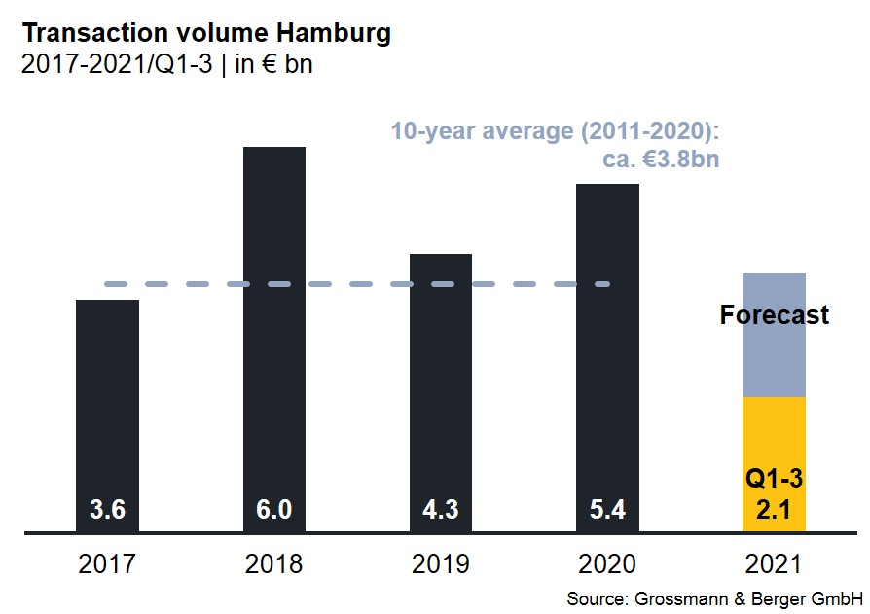
Investment market | Hamburg | 2021 | Q 1-3
Transaction volume [€ millions] | 2,100
against prior yr [%] | -42
Share of trading in CBD [%] | 15
Proportion of international investors [%] | 17
Prime net yield, office [%] | 2.60
against prior yr [percentage points] | -0.20
Prime net yield, commercial buildings [%] | 2.70
against prior yr [percentage points] | ±0.00
Prime net yield, logistics properties [%] | 3.50
against prior yr [percentage points] | -0.70
Strongest asset class | Offices
Strongest asset class [%] | 62

Selected top transactions | investments in Hamburg | 1st-3rd quarters of 2021
Project / property  Street no. | Sub-market | Asset class | Buyer / investor | Vendor | Purchase price*  [approx. €m]
“Spectrum”  Amandus-Stubbe-Strasse 10 | Hamburg East | Ware-house /  logistics | DWS Group | Fiege Deutschland | 189
“Multimedia Centre Rotherbaum”, Rothenbaumchaussee 76-80 | Alster West | Offices | Values Real Estate | Vermögensverwaltung Jahr | 170
“Hamburg Süd House”,  Willy-Brandt-Strasse 59-63 | City | Offices | Union Investment. | Dr. August Oetker Nahrungsmittel | > 150
Norderstrasse 101 | St. Georg | Offices | B & L Gruppe | Commerz Real | 150
*The purchase prices stated are based on publicly available data, where none is available an estimate is made; transactions occurring in the quarter dealt with in this report are highlighted.

The complete investment market survey will soon be available and can be downloaded from our website.

About Grossmann & Berger
Grossmann & Berger GmbH is one of the leading service providers in the business of selling and letting commercial and residential properties in North Germany. In addition to its main office in Hamburg, the company has 20 local offices. This allows Grossmann & Berger to cover the entire North German market. In May 2021 the company was augmented by E & G Real Estate and E & G Private Immobilien, so that Grossmann & Berger also operates in the two South German metropolitan areas of Stuttgart and Munich. Drawing on their comprehensive expertise in the real estate business, some 250 employees provide the full range of relevant services. They also benefit from the company’s more than 85 years standing in the industry. Grossmann & Berger belongs to the HASPA Group and is a founding member of the national commercial real estate network German Property Partners (GPP).

Please consult our website for Grossmann & Berger’s data privacy policy. Here you will also be able to access our press kit and the associated Terms of Use. If in future you would prefer not to receive any more information from our press office please e-mail us at presse@grossmann-berger.de quoting as reference "Abmeldung aus Presseverteiler” / “Unsubscribe from press mailing list”.

