Hamburg: Investment market 1st quarter of 2021
Shortage of properties holding market back

Hamburg, 6th April 2021 - After the strong trading activity of 2020 it came as no surprise that the market for investments in commercial properties in Hamburg was quieter than it had been. In the first three months, the volume of transactions totalled €700m. Compared with the exceptionally strong 1st quarter of 2020 (€970m) this is equivalent to a drop of 28 %. In the context of ten-year cycles, the sales volume was close to the average of €734m.

“A large number of transactions noted are trades that were initiated last year and completed in the early part of 2021. Currently, the key characteristic of the market is an acute shortage of core real estate,” remarks Sandra Ludwig, managing director of Grossmann & Berger, member of Germany Property Partners (GPP). “Investors are still eager to buy. Due to great demand the benchmark asking price for office properties in excellent locations continues to rise, further squeezing yields,” adds Ludwig. In view of the substantial shortage of available properties for investors in Hamburg, Grossmann & Berger does not expect any new record figures in 2021.

Market details:
- In the 1st quarter of 2021, some 46 % of transactions by volume related to properties in the City sub-market. The sale of the “D10 Domkontor” played a role here, sold by Savills Investment Management to Caleus Capital Investors.
- Once again, office buildings were the most sought after class of assets, accounting for 60 % of total sales and regaining the top ranking they had ceded to mixed-use real estate in the prior year. The latter comprised 13 % of total trades in the 1st quarter of 2021, moving down to third place. Retail shop properties were just ahead with 14 % of the market volume.
- Single property transactions totally dominated the 1st quarter. No portfolios were traded.
- Dr. August Oetker Nahrungsmittel sold the “Hamburg Süd House” to Union Investment for over €150m - the only property traded for more than €100m. The most prevalent price category was that between €51m and €100m; 44 % of total trading fell into this category.
- Fund managers were the biggest group of buyers (36 %), followed by specialist funds. The most active group of vendors consisted of corporates/owner-occupiers (33 %).
- Compared with previous years, international investors barely featured on the Hamburg market in the 1st quarter of 2021 (3 % of the total volume). National buyers were more often successful in the bidding process because they urgently need to invest funds. In addition, being physically close to the market they are better able to judge the local effects of Covid-19 than investors from abroad.
- Due to great demand the prime yields on office and logistics properties continued to fall year on year; on office properties yields dropped from 2.80 % to 2.70 %, and on logistics real estate from 4.20 % to 3.90 %. The prime yield on commercial buildings remained stable at 2.70 %.
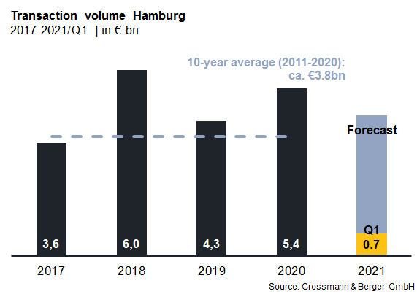
Investment market | Hamburg | 2021 | Q1
Transaction volume [€ millions] | 700
against prior yr [%] | -28
Share of trading in CBD [%] | 46
Proportion of international investors [%] | 0
Prime net yield, office [%] | 2.70
against prior yr [percentage points] | -0.10
Prime net yield, commercial buildings [%] | 2.70
against prior yr [percentage points] | ±0.00
Prime net yield, logistics properties [%] | 3.90
against prior yr [percentage points] | -0.30
Strongest asset class | Offices
Strongest asset class [%] | 60

Selected known top transactions | investments in Hamburg | 1st quarter of 2021
Project/property  Street no. | Sub-market | Asset class | Buyer/investor | Vendor | Purchase price*  [approx. €m]
“Hamburg Süd House”,  Willy-Brandt-Strasse 59-63 | City | Offices | Union Investment. | Dr. August Oetker Nahrungsmittel | > 150
“Campus Stapelwerk”, Meiendorfer Strasse 205 | Hamburg East | Mixed use | Warburg-HIH Invest | AURELIUS Equity Opportunities | 76
“Krohnstieg Centre”, Krohnstieg 41-43 | Hamburg East | Retail | Hahn Immobilien Beteiligung | HBB Hanseatische Betreuungs- und Beteiligungsgesellschaft | 65
“D10 Domkontor”,  Domstrasse 10 | City | Offices | Caleus Capital Investors | Savills Investment Management | 64
“The Bank”  Hohe Bleichen 17 | City | Offices | May & Co. Wohn- und Gewerbebau | RFR Holding | 51
* The purchase prices stated are based on publicly available data, where none is available an estimate is used instead

The complete investment market survey Hamburg will soon be available for download from our website.

About Grossmann & Berger
Grossmann & Berger GmbH is one of the leading service providers for selling and letting commercial and residential properties in North Germany. Headquartered in Hamburg, the Company has a branch office in Berlin, fourteen property shops, and some 190 employees who cover the entire North German market. With over 85 years of experience in the business, Grossmann & Berger offers a complete package of real estate expertise. Grossmann & Berger is a member of the HASPA Group of Companies, which also includes Germany's largest savings bank, Hamburger Sparkasse (Haspa). Moreover, the Company is a founding member of the nation-wide commercial property network German Property Partners (GPP) and the working group of brokers associated with banks and building societies, Arbeitsgemeinschaft ImmobilienVermittler Banken Bausparkassen e.V. (IVBB).

Please consult our website for Grossmann & Berger’s data privacy policy. Here you will also be able to access our press kit and the associated Terms of Use. If in future you would prefer not to receive any more information from our press office please e-mail us at presse@grossmann-berger.de quoting as reference "Abmeldung aus Presseverteiler” / “Unsubscribe from press mailing list”.

