Hamburg: Investment market, 1st quarter of 2022
Record result thanks to outlier trade

Hamburg, 1st April 2022 – When the Canadian asset manager Brookfield Properties took over alstria office, an office-building management firm, it led to the highest 1st-quarter investment trading result ever recorded on the Hamburg market for commercial properties. The total volume traded in the first three months was some €1.9bn or 171 % higher than in the same quarter a year before. This take-over meant that in Hamburg alone more than 30 properties valued at some €1.5bn changed hands. Without this outlier trade the transaction volume would have been some €440m and thereby well below the prior year’s figure of €700m, largely because no trades had been left in the pipeline for completion in 2022. In her forecast for the remainder of the year Sandra Ludwig, managing director of Grossmann & Berger, member of German Property Partners (GPP), says, “At present there are many products on the market and the transaction pipeline is already well filled. Some big-ticket office trades are scheduled for completion in the second quarter. Demand, especially for ESG-compliant core real estate remains high, despite the political question marks raised by the Ukraine war. However, over the course of the year rising interest rates are likely to affect the prices buyers will pay and act as a brake on the rally.”

Market details:
- Accounting for 86 % of the volume, office properties were the most traded class of commercial property asset. Their sky-high share of trades is attributable to the outlier described earlier. Trailing far behind, commercial building land and industrial/logistics properties placed second and third with a share of about 4 % each.
- The relative activity of different buyer groups also showed an unusual pattern: fund managers were significantly ahead of other groups with a share of some 82 %. If the alstria effect is discounted, developers were the biggest group of buyers with 44 % of the market.
- As far as sellers of property are concerned, listed real estate investment AGs/REITs formed the biggest group. Here too, their high share of 84 % was generated by the alstria take-over. Discounting this outlier, developers were the biggest group of sellers with 32 % of the market.
- International buyers accounted for 87 % of the total trading volume. Without the alstria transaction, their share would have been 30 %.
- Whereas year on year the prime yield on commercial buildings remained at its low of 2.7 %, on office properties it sank by 0.1 percentage points to 2.6 %. Strongly increased demand for industrial and logistics properties resulted in considerable yield compression in this segment: year on year the prime yield shrank by 0.6 percentage points to 3.3 %.

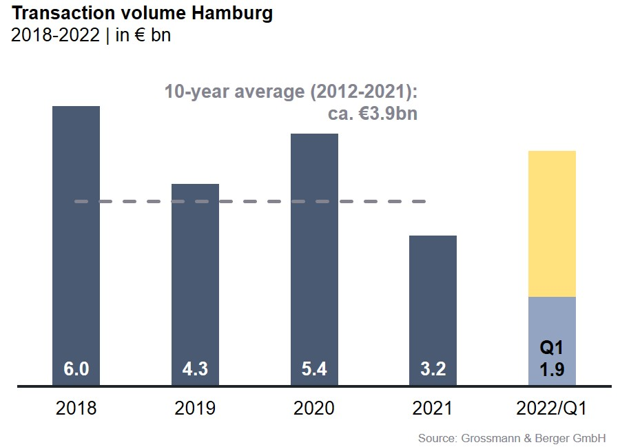
Investment market | Hamburg | 2022 | Q1
Transaction volume [€ millions] | 1,900
against prior yr [%] | +171
Proportion of international investors [%] | 87
Prime net yield, office [%] | 2.60
against prior yr [percentage points] | -0.10
Prime net yield, commercial buildings [%] | 2.70
against prior yr [percentage points] | ±0.00
Prime net yield, logistics properties [%] | 3.30
against prior yr [percentage points] | -0.60
Strongest asset class | Office Letting
Strongest asset class [%] | 85.8

Selected top transactions | investments in Hamburg | 1Q2022
Project/property  Street no. | Sub-market | Asset class | Buyer/investor | Vendor | Purchase price*  [approx. €m]
“alstria office” portfolio | Hamburg | Offices | Brookfield Properties | alstria office REIT | 1,500
Building land Seehafenstrasse | Hamburg South | Commercial building land | Project developers | Corporate | 70
“Peute Dock” (section of site), Oberwerder Damm 11-21 | Hamburg East | Industry / logistics | German real estate-AG | Family Value Management | 45
“Karstadt”, Osterstrasse 119 | Eimsbüttel | Retail | Imvest Projektentwicklung | Signa Holding | 38
* The purchase prices stated are based on publicly available data, where none is available an estimate is used instead.

The market survey property investment Hamburg 2022/Q1 will soon be available to download from our website.

About Grossmann & Berger
Grossmann & Berger GmbH is one of the leading service providers in the business of selling and letting commercial and residential properties in North Germany. In addition to its main office in Hamburg, the company has 20 local offices. This allows Grossmann & Berger to cover the entire North German market. In May 2021 the company was augmented by E & G Real Estate and
E & G Private Immobilien, so that Grossmann & Berger also operates in the two South German metropolitan areas of Stuttgart and Munich. Drawing on their comprehensive expertise in the real estate business, some 250 employees provide the full range of relevant services. They also benefit from the company’s more than 85 years standing in the industry. Grossmann & Berger belongs to the HASPA Group and is a founding member of the national commercial real estate network German Property Partners (GPP).

Please consult our website for Grossmann & Berger’s data privacy policy. Here you will also be able to access our press kit and the associated Terms of Use. If in future you would prefer not to receive any more information from our press office, please e-mail us at presse@grossmann-berger.de quoting as reference "Abmeldung aus Presseverteiler” / “Unsubscribe from press mailing list”.

