Berlin: Investment market 1st - 4th quarters of 2020
Transaction volume strong but below record set in 2019

Berlin, 14 January 2021 - As had been expected, in 2020 the volume of commercial real estate traded on the investment market in Germany’s capital, Berlin, fell short of the record set in 2019. By the end of the 4th quarter the total trading volume stood at €7.36bn, or 34 % below the prior year’s figure. After the strongest start to a year seen to date, the coronavirus pandemic led to weak year-on-year trading figures in the next two quarters and the revival seen in the 4th quarter was insufficient to make up all the losses. Holger Michaelis, managing director of Grossmann & Berger, member of German Property Partners (GPP) says, “Overall, the pandemic caused investors to act with much greater caution and they continued to focus on core real estate let to highly credit-worthy tenants.” Michaelis adds that, “In view of the ongoing rate of infection we expect sales activity to remain sluggish in the next three quarters, especially in the retail and hotel property segment. When large swathes of the population have been vaccinated, people will start to travel and shop on the high streets again, and this segment will become more attractive to investors. Therefore investment trades in Berlin are likely to gain more momentum towards the end of 2021 and lead to an overall result similar to that of 2020.”

Market details:
- 2020 ended with a good result on the market for investment in Berlin real estate due to the 1st-quarter sale of some 80 % of the TLG portfolio to Aroundtown. The total is well above the ten-year average of €5.9bn, despite the effects of coronavirus on the market.
- In view of the current pandemic investors focussed on core real estate and the absolute number of trades in 2020 was thus appreciably smaller (119) than in 2019 (146).
- The steepest plunge was noted for hotel real estate transactions (-50 %), followed by commercial/industrial (-38 %) and office properties (-37 %). In consequence, offices, although remaining the most-traded asset class, saw their share of the transaction volume fall to 62 % (2019: 70 %).
- 22 sales of property costing over €100m were posted, 17 of which took place in the 1st and 4th quarters. This reflects investor reticence in the two middle quarters. Overall, transactions in this price bracket declined by 29 % year on year. In contrast, the number of transactions in the €26m to €50m segment increased by 67 %.
- Prime yields on offices and commercial buildings remained at the same low levels as the prior year at 2.7 % and 2.8 % respectively. The prime yield on logistics properties softened to 3.7 % (2019: 3.8 %). “We do not expect premium yields on office real estate to rise in the months to come as many investors are urgently seeking core properties,” says Ulrich Denk, investment consultant and researcher at Grossmann & Berger Berlin.

Investment market | Berlin | 2020 | Q1-4
Transaction volume [€ millions] | 7,360
against prior yr [%] | -34
Share of trading in CBD [%] | 9
Proportion of international investors [%] | 54
Prime net yield, office [%] | 2.7
against prior yr [percentage points] | ±0.0
Prime net yield, commercial buildings [%] | 2.8
against prior yr [percentage points] | ±0.0
Prime net yield, logistics properties [%] | 3.7
against prior yr [percentage points] | -0.1
Strongest asset class | Offices
Strongest asset class [%] | 62
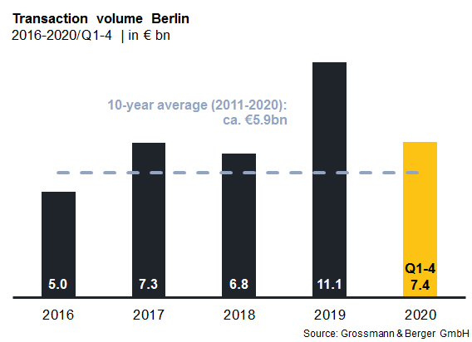

Selected top transactions | investments in Berlin | 1st to 4th quarters 2020
Project/property  Street no. | Sub-market | Asset class | Buyer/investor | Vendor | Purchase price*  [approx. €m]
“Chaussee23”, Chausseestrasse 23 | Mitte | Offices | Credit Suisse | Barings Real Estate Advisers | 220
“Spreeturm Berlin”,  Am Postbahnhof 17 | Friedrichshain | Offices | Talanx Immobilen Management | NAS Investment | 195
Quartier Schützenstrasse,  Zimmerstrasse 67-69 | Mitte 1a | Offices | Henderson Park | Caleus Capital Partners for GIC | 194
“Impulse”,  Stresemannstrasse 69-71 | Kreuzberg | Offices | Corpus Sireo for Swiss Life | Blackrock Investment Management (for Eurozone Core Property Fund) | 179
“Bricks”,  Hauptstrasse 27-29 | Schöneberg | Mixed use | CBRE Global Investors | Trockland Management | 150
Hallen am Borsigturm,  Am Borsigturm 2-14, 53 | Reinickendorf | Mixed use | ECE Preferred Equity Fund | ECE European Prime Shopping Center Fund | confidential
Zalando Headquarters, Edith-Kiss-Strasse 1 | Friedrichshain | Offices | HIH Real Estate | HIH Projektentwicklung | confidential
*The purchase prices stated are based on publicly available data, where none is available an estimate is made; new transactions or those occurring in the quarter dealt with in this report are highlighted.

The complete market survey will soon be available and can be downloaded from our website.

About Grossmann & Berger
Grossmann & Berger GmbH is one of the leading service providers for selling and letting commercial and residential properties in North Germany. Headquartered in Hamburg, the Company has a branch office in Berlin, a total of fourteen property shops, and over 190 employees who cover the entire North German market. With over 85 years of experience in the business, Grossmann & Berger offers a complete package of real estate expertise. Grossmann & Berger is a member of the HASPA Group of Companies, which also includes Germany's largest savings bank, Hamburger Sparkasse (Haspa). Moreover, the Company is a founding member of the nation-wide commercial property network German Property Partners (GPP) and the working group of brokers associated with banks and building societies, Arbeitsgemeinschaft ImmobilienVermittler Banken Bausparkassen e.V. (IVBB).

Please consult our website for Grossmann & Berger’s data privacy policy. Here you will also be able to access our press kit and the associated Terms of Use. If in future you would prefer not to receive any more information from our press office, please e-mail us at presse@grossmann-berger.de quoting as reference "Abmeldung aus Presseverteiler” / “Unsubscribe from press mailing list”.

