Berlin: Investment market 1st-3rd quarters of 2021
Germany’s capital city a magnet for investors in commercial real estate

Berlin, 15th October 2021 – At the end of September the volume of transactions in Berlin totalled €6.4bn – the second highest result ever noted at this stage of the year. Obviously, this owed much to the sale of the “Fürst”, formerly known as the “Ku’damm Karree”, in the preceding quarter for which more than €1.0bn changed hands, and of the “Victoriastadt Lofts” for €425m; these outlier trades impacted all of the categories in this report. Year on year moreover, there were also four more trades at prices higher than €100m. Between July and September, commercial properties were traded for a total of €2.1bn. “The enormous transaction volume is due to the high capital value of the real estate, not to a higher number of commercial properties sold,” comments Holger Michaelis, managing director of Grossmann & Berger, a member of German Property Partners (GPP). “Since the Berlin market remains highly liquid and talks are already in progress on a large number of big-ticket properties that should be sold by the end of the year, we have increased our forecast for 2021 to 8.5 billion euros.”

Market details:
- As a result of trades such as the “Fürst” and “Victoriastadt Lofts” the price category of €100m or over comprised 69 % of the total (3Q2020: 44 %). The next two price categories, €51m to €100m and €26m to €50m, played marginal roles only, taking 16 % and 10 % of the market respectively. These figures represent half of their market share in the 3rd quarter of 2020.
- Another effect of the “Fürst” transaction was to reduce the proportion of portfolio transactions from 55 % to 14 % within the space of one year.
- In terms of asset classes, mixed use accounted for 39 % of the volume of transactions (3Q2020: 17 %), and thus slightly more than office properties, normally the front-runners, whose share was 38 % (3Q2020: 57 %). The market share of mixed use buildings would have been higher but for the “Victoriastadt Lofts” trade in the 3rd quarter, the biggest office block sale of the year.
- Accounting for 38 % of the market, fund managers were the most prominent group of buyers (3Q2020: 9 %), ahead of developers with a share of 18 %, insurance companies with 13 % and specialist funds with 10 %. As vendors, both developers and non-listed property companies were each behind one quarter of the transactions.
- International investors were less active in Berlin than a year ago, both on the buying side of the equation, (62 % of the market, 3Q2020: 65 %) and on the selling side (52 % share, 3Q2020: 66 %).
- Long-running leases signed with public institutions continued to keep prices at all-time highs and depressed the prime yield on office properties to 2.65 %.
- ‘Ku’damm plus sides roads’ was the predominant sub-market, accounting for about a third of the total, ahead of Periphery East and Friedrichshain with 12 % and 10 % respectively. Here too the reason was the sale of the “Fürst”.

Investment market | Berlin | 2021 | Q 1-3
Transaction volume [€ millions] | 6,400
against prior yr [%] | +35
Share of trading in CBD [%] | 39
Proportion of international investors [%] | 62
Prime net yield, office [%] | 2.65
against prior yr [percentage points] | -2.00
Prime net yield, commercial buildings [%] | 2.80
against prior yr [percentage points] | ±0.00
Prime net yield, logistics properties [%] | 3.5
against prior yr [percentage points] | -8.00
Strongest asset class | Mixed use
Strongest asset class [%] | 39
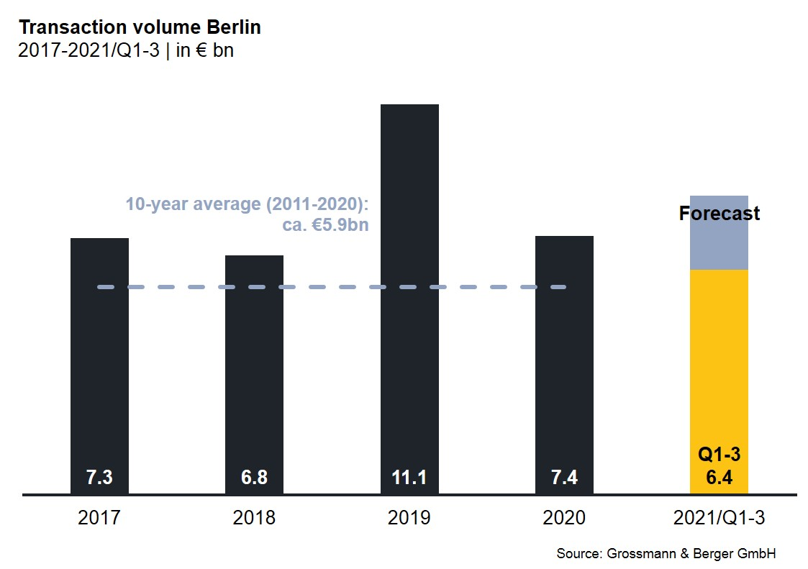

Selected top transactions | investments in Berlin | 1st-3rd quarters of 2021
Project/property  Street no. | Sub-market | Asset class | Buyer/investor | Vendor | Purchase price*  [approx. €m]
“Fürst”,  Kurfürstendamm 206-209 | Ku’damm plus side-roads | Mixed use | Aggregate Holdings | Vivion | > 1,000
“Victoriastadt Lofts”,  Schreiberhauerstrasse 30 | Periphery East | Offices | Signa Real Estate | Schroder Properties for Illmarinen | 425
“Quartier 206”,  Friedrichstrasse 71 | Mitte 1a | Mixed use | Kölnstrasse 89 GmbH & Co. KG (Jagdfeld-Gruppe) | Bank consortium headed by Credit Suisse | 225
Landsberger Allee 52 | Friedrichshain | Offices | Values | Centrum Grundstücksgesellschaft | 200
“Alte Post”,  Karl-Marx-Strasse 97-99 | Periphery south | Industry/ commerce | Ivanhoé Cambridge | Commodus Real Estate | confidential
*The purchase prices stated are based on publicly available data, where none is available an estimate is made; transactions occurring in the quarter dealt with in this report are shaded grey

The complete investment market survey Berlin will soon be available and can be downloaded from our website.

About Grossmann & Berger
Grossmann & Berger GmbH is one of the leading service providers in the business of selling and letting commercial and residential properties in North Germany. In addition to its main office in Hamburg, the company has 20 local offices. This allows Grossmann & Berger to cover the entire North German market. In May 2021 the company was augmented by E & G Real Estate and
E & G Private Immobilien, so that Grossmann & Berger also operates in the two South German metropolitan areas of Stuttgart and Munich. Drawing on their comprehensive expertise in the real estate business, some 250 employees provide the full range of relevant services. They also benefit from the company’s more than 85 years standing in the industry. Grossmann & Berger belongs to the HASPA Group and is a founding member of the national commercial real estate network German Property Partners (GPP).

Please consult our website for Grossmann & Berger’s data privacy policy. Here you will also be able to access our press kit and the associated Terms of Use. If in future you would prefer not to receive any more information from our press office, please e-mail us at presse@grossmann-berger.de quoting as reference "Abmeldung aus Presseverteiler” / “Unsubscribe from press mailing list”.

