Berlin: Investment market 1st-4th quarters of 2021
Strongest-ever 4th quarter leads to superb result

Berlin, January 2022 – At the end 2021 the market for investment in commercial properties in Berlin rallied to a degree never seen before. Posting a 4th-quarter transaction volume of €4.1bn, Germany’s capital returned the highest-ever trading total for a single quarter. Accordingly, the total volume of transactions in 2021 totalled €10.5bn, second only to the record set in the year 2019. A very weak start to the year was already evened out by the “Fürst” transaction in the 2nd quarter; subsequently a large number of other big-ticket trades contributed to this superb result. “The bottom line, however, is that this result is not due to the large number of transactions with high price-tags, but to the increase in capital values based on high rental rates and price to earnings ratios. 31 transactions were completed in the price category of €100m or more, generating a total turnover of €6.6bn,” says Holger Michaelis, managing director of Grossmann & Berger, a member of German Property Partners (GPP). In view of the exceptionally high volume of trading in 2021, Grossmann & Berger expects the result in 2022 to be somewhat lower, at an estimated €9bn.

Market details:
- With no sign of the pandemic abating, investors continued to prefer safe asset classes such as offices (56 %) and mixed used real estate (28 %), avoiding hotels and shops.
- The high volume of trading in properties costing over €100m was reflected in the fact that this price category comprised 68 % of the total market in 2021.
- Thanks to the 2nd-quarter “Fürst” transaction, fund managers accounted for 22 % of the market, closing the year as major buyer group. Next in line were private equity funds/opportunity funds and developers who took 15 % of the total volume each.
- The biggest vendor groups were developers (28 %) followed by non-listed property companies (15 %).
- Investor interest continued to focus on office properties let long-term, preferably to public-sector tenants. Properties could command price to annual rental income ratios of up to 38.5, squeezing the prime yield to 2.6 % by the end of 2021. Prime yields on industrial and logistics real estate slipped appreciably, dropping 0.4 percentage points year on year to 3.4 %. The prime yield on commercial buildings also slipped a little to 2.75 %.
- Slightly more international buying activity was noted compared with the previous year; these actors’ share of total trading rose to 58 %, still a low figure for the national capital.

Investment market | Berlin | 2021 | Q1 -4
Transaction volume [€ millions] | 10,500
against prior yr [%] | +43
Share of trading in CBD [%] | 28
Proportion of international investors [%] | 58
Prime net yield, office [%] | 2.6
against prior yr [percentage points] | -0.1
Prime net yield, commercial buildings [%] | 2.75
against prior yr [percentage points] | -0.05
Prime net yield, logistics properties [%] | 3.4
against prior yr [percentage points] | -0.4
Strongest asset class | Offices
Strongest asset class [%] | 56
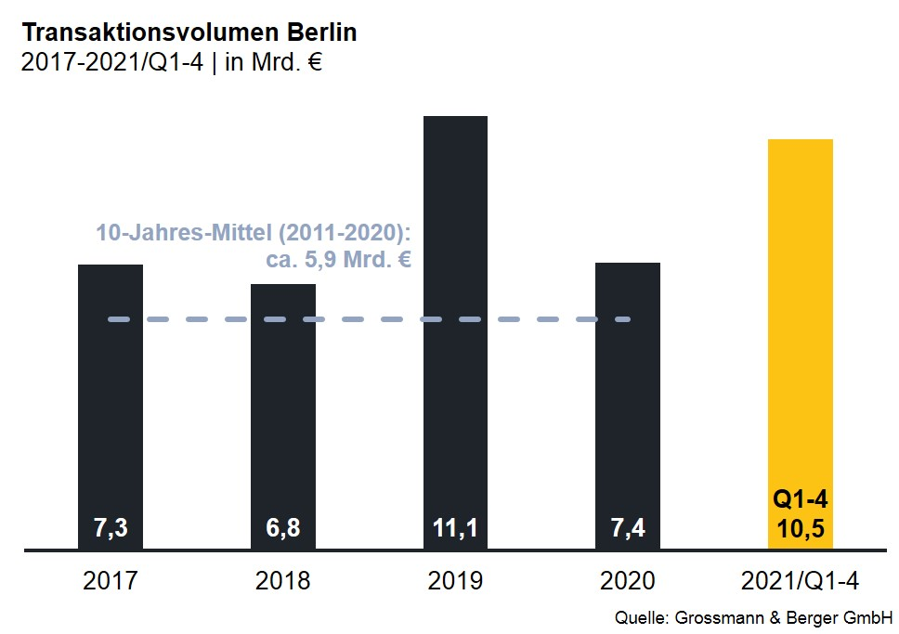

Selected top transactions | investments in Berlin | 1st-3rd quarters of 2021
Project/property  Street no. | Sub-market | Asset class | Buyer/investor | Vendor: | Purchase price*  [approx. €m]
“Fürst”  Kurfürstendamm 206-209 | Ku’damm plus side-roads | Mixed use | Aggregate Holdings | Vivion | 1,250
“Victoriastadt Lofts”  Schreiberhauerstrasse 30 | Periphery East | Offices | Signa Real Estate | Schroder Properties for Illmarinen | 425
“Boulevard Berlin Wertheim / Karstadt”,  Schlossstraße 7-10, 11-15 | Periphery south | Retail | York Capital Management/ Dunman Capital Partners | Klépierre | 250
“Quartier 206”,  Friedrichstrasse 71 | Mitte 1a | Mixed use | Kölnstrasse 89 (Jagdfeld-Gruppe) | Bank consortium headed by Credit Suisse | 225
“Berlin Criminal Investigation Office”  Ringbahnstrasse 132 | Periphery south | Offices | REInvest | Paribus | 150
*The purchase prices stated are based on publicly available data, where none is available an estimate is made; new transactions or those occurring in the quarter dealt with in this report are highlighted.

The complete office market survey Berlin will soon be available and can be downloaded from our website.

About Grossmann & Berger
Grossmann & Berger GmbH is one of the leading service providers in the business of selling and letting commercial and residential properties in North Germany. In addition to its main office in Hamburg, the company has 20 local offices. This allows Grossmann & Berger to cover the entire North German market. In May 2021 the company was augmented by E & G Real Estate and
E & G Private Immobilien, so that Grossmann & Berger also operates in the two South German metropolitan areas of Stuttgart and Munich. Drawing on their comprehensive expertise in the real estate business, some 250 employees provide the full range of relevant services. They also benefit from the company’s more than 85 years standing in the industry. Grossmann & Berger belongs to the HASPA Group and is a founding member of the national commercial real estate network German Property Partners (GPP).

Please consult our website for Grossmann & Berger’s data privacy policy. Here you will also be able to access our press kit and the associated Terms of Use. If in future you would prefer not to receive any more information from our press office, please e-mail us at presse@grossmann-berger.de quoting as reference "Abmeldung aus Presseverteiler” / “Unsubscribe from press mailing list”.

