Berlin: Investment Market, 1st Quarter of 2022
German capital remains a magnet for investment

Hamburg, 7 April 2022 – Having closed the year 2021 with strong trading in commercial properties, the market in Berlin continued on its upward trajectory in the new year. At €2.3bn the volume of transactions was 171 % higher than in the same quarter of the prior year (€850m). This is the second-highest figure for the first three months of a year that Grossmann & Berger (G&B) has ever recorded in Berlin. Eight trades priced at more than €100m each played a role in boosting the result, as did the take-over of the alstria office REIT by Brookfield Properties, an asset management firm from Canada. The sale of this portfolio containing numerous properties around Germany added some €400m to the total in Berlin. However, the war in Ukraine, rising inflation, volatile interest rates and the ongoing Covid pandemic are all destabilizing market factors. G&B experts are already seeing the effects: “Loans, especially for forward deals, are already more expensive than four months ago because banks have started to charge risk premiums,” explains Holger Michaelis, managing director of Grossmann & Berger, a member of German Property Partners (GPP). He predicts that, “When central banks raise interest rates as anticipated, investors will increasingly reconsider their alternatives. This will affect selling prices and curb further increases.”

Market details:
- Accounting for 59 % of the volume, office properties were the most traded class of commercial property asset. Four of the eight trades costing more than €100m were in this segment. Second and third places went to mixed-use properties (17 %) and hotels (13 %).
- When sorting transactions by size, the dominance of large-volume trades in the €100m-plus bracket is apparent (67 % of total). In the same quarter of 2021 this category accounted for only 31 % of total trading.
- Accounting for 45 % of the volume traded, fund managers were the biggest single group of buyers. This unusual circumstance is due to the alstria portfolio sale.
- On the selling side of the equation, listed real estate investment AGs/REITs formed the biggest group with 27 % - likewise a result of the alstria trade. Developers (20 %) and insurance companies (14 ) followed.
- International buyers were strikingly active investors in Berlin, taking 83 % of the total volume traded (Q1 2021: 29 %).
- Prime yields remained low because investors have so few alternatives. On commercial buildings it remained unchanged at 2.8 %. The prime yield on offices slipped back 0.10 percentage points year on year to 2.6 %, on logistics properties it contracted by 0.35 percentage points to 3.4 %.

Investment market | Berlin | 2022 | Q1
Transaction volume [€ millions] | 2,300
against prior yr [%] | +171
Proportion of international investors [%] | 83
Prime net yield, office [%] | 2.6
against prior yr [percentage points] | -0.10
Prime net yield, commercial buildings [%] | 2.8
against prior yr [percentage points] | ±0.00
Prime net yield, logistics properties [%] | 3.4
against prior yr [percentage points] | -0.35
Strongest asset class | Offices
Strongest asset class [%] | 59
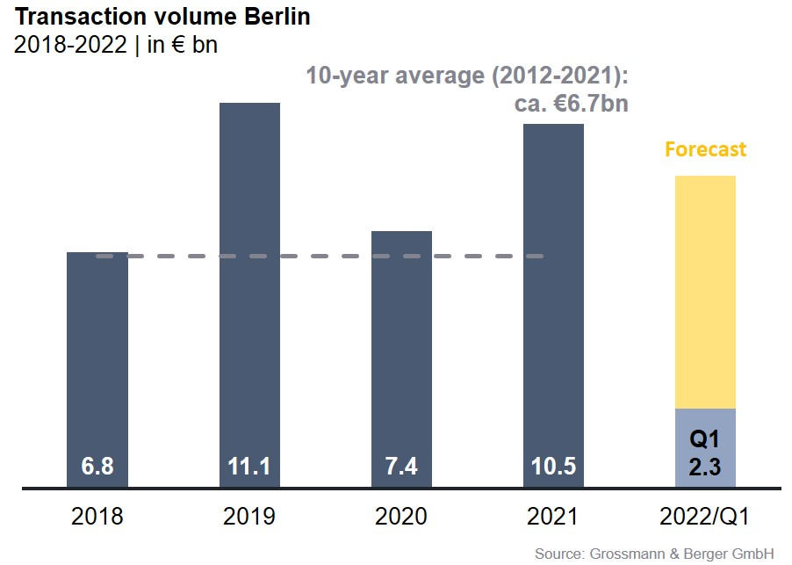

Selected top transactions | investments in Berlin | 1st quarter of 2022
Project/property  Street no. | Sub-market | Asset class | Buyer/investor | Vendor | Purchase price*  [approx. €m]
“Sheraton Berlin Grand Hotel”, Lützowufer 15 | Kreuzberg | Hotel | Deutsche Finance International (DFI) | Archer Hotel Capital | 116
“Galerie Lafayette Quartier 207”, Friedrichstraße 76, 78 | Berlin-Mitte | Offices | Tishman Speyer | Allianz Real Estate | confidential
“Rosi”,  Rosenthaler Straße 44 | Berlin-Mitte | Mixed use | BVK-Values-Immobilienfonds-CBD | Values Real Estate | confidential
Darwinstrasse 14 - 18 | Charlottenburg | Offices | Brookfield Properties | alstria office REIT | confidential
Mehringdamm 32-34 | Kreuzberg | Offices | Brookfield Properties | alstria office REIT | confidential
* The purchase prices stated are based on publicly available data, where none is available an estimate is used instead

The market survey property investment in Berlin 2022/Q1 will soon be available to download from our website.

About Grossmann & Berger
Grossmann & Berger GmbH is one of the leading service providers in the business of selling and letting commercial and residential properties in North Germany. In addition to its main office in Hamburg, the company has 20 local offices. This allows Grossmann & Berger to cover the entire North German market. In May 2021 the company was augmented by E & G Real Estate and
E & G Private Immobilien, so that Grossmann & Berger also operates in the two South German metropolitan areas of Stuttgart and Munich. Drawing on their comprehensive expertise in the real estate business, some 250 employees provide the full range of relevant services. They also benefit from the company’s more than 85 years standing in the industry. Grossmann & Berger belongs to the HASPA Group and is a founding member of the national commercial real estate network German Property Partners (GPP).

Please consult our website for Grossmann & Berger’s data privacy policy. Here you will also be able to access our press kit and the associated Terms of Use. If in future you would prefer not to receive any more information from our press office, please e-mail us at presse@grossmann-berger.de quoting as reference "Abmeldung aus Presseverteiler” / “Unsubscribe from press mailing list”.

