Berlin: Investment market 1st-3rd quarters of 2020
Investors choose core real estate
Berlin, 5 October 2020 – By the end of the 3rd quarter commercial properties with a total value of €4.75bn had been traded in Berlin, a year on year decline of 42 %. However, this massive change owes much to the exceptionally high trading volume in 2019. Nevertheless, “Investors are more hesitant and are especially wary of assets that have been badly affected by the pandemic such as hotels and certain properties in the retail sector. A large number of risk-averse investors are seeking offices that have been let long-term to highly credit-worthy tenants, and these properties are selling at high prices,” notes Holger Michaelis, managing director of Grossmann & Berger, a member of German Property Partners (GPP). He is optimistic about the further course of the year, saying “Between July and September spending was around 230 million euros higher than in the second quarter, so the market is moving in the right direction. Since investors are under pressure to acquire investments and several large transactions are close to completion we expect the year to end well.”

Market details:
- In the first nine months of 2020 there were “only” twelve trades with price tags of more than €100m. A year before, 22 transactions had involved such sums.
- Offices, the most sought-after asset class, accounted for 57 % of total trading (Q3 2019: 68 %).
- Prime yields on offices (2.7 %), commercial buildings (2.8 %) and logistics properties (3.8 %) softened slightly year on year.
- Thanks to a good 1st quarter and with several large trades nearing completion, Grossmann & Berger expects the year to close with a transaction volume of some €7bn. This would be well above the ten-year average of €5.5bn, despite the effects of coronavirus on the market.
Investment market | Berlin | 2020 | Q 1-3
Transaction volume [€ millions] | 4,750
against prior yr [%] | -42
Share of trading in CBD [%] | 9
Proportion of international investors [%] | 65
Prime net yield, office [%] | 2.7
against prior yr [percentage points] | -0.2
Prime net yield, commercial buildings [%] | 2.8
against prior yr [percentage points] | -0.1
Prime net yield, logistics properties [%] | 3.8
against prior yr [percentage points] | -0.4
Strongest asset class | Offices
Strongest asset class [%] | 57
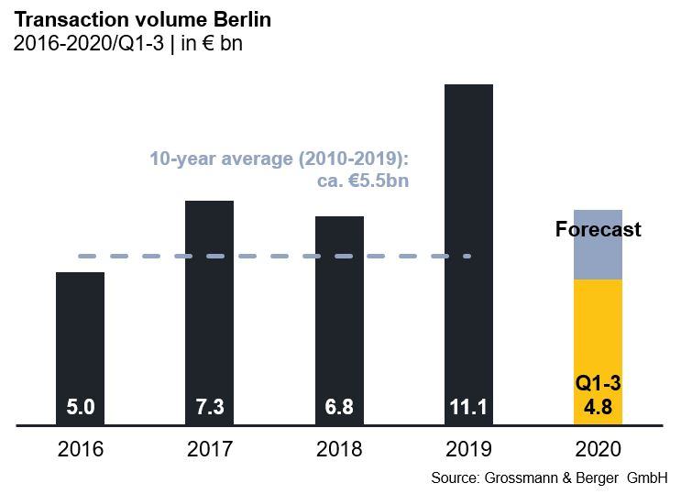

Selected top transactions | investments in Berlin | 1st to 3rd quarters 2020
Project/property  Street no. | Sub-market | Asset class | Buyer/investor | Vendor | Purchase price*  [approx. €m]
“Chaussee23”, Chausseestrasse 23 | Mitte | Offices | Credit Suisse | Barings Real Estate Advisers | 220
Quartier Schützenstrasse,  Zimmerstrasse 67-69 | Mitte 1a | Offices | Henderson Park | Caleus Capital Partners for GIC | 194
“The Grid”,  Prinzenstraße 34 | Kreuzberg | Offices | DWS | Pandion | 129
“Enter“”  Max-Urich-Strasse 2 | Periphery North | Offices | DEKA Immobilien | Townscape One | 120
Zalando Headquarters, Edith-Kiss-Strasse 1 | Friedrichshain | Offices | HIH Real Estate | HIH Projektentwicklung | confidential
Hallen am Borsigturm,  Am Borsigturm 2-14, 53 | Reinickendorf | Mixed use | ECE Preferred Equity Fund | ECE European Prime Shopping Center Fund | confidential
“Linden-Center”,  Prerower Platz 1 | Periphery East | Retail | ECE Preferred Equity Fund | ECE European Prime Shopping Center Fund | confidential
*The purchase prices stated are based on publicly available data, where none is available an estimate is made; new transactions or those occurring in the quarter dealt with in this report are highlighted.

The complete market survey will soon be available and can be downloaded from our website.

About Grossmann & Berger
Grossmann & Berger GmbH is one of the leading service providers for selling and letting commercial and residential properties in North Germany. Headquartered in Hamburg, the Company has a branch office in Berlin, a total of fourteen property shops, and over 190 employees who cover the entire North German market. With over 85 years of experience in the business, Grossmann & Berger offers a complete package of real estate expertise.

Grossmann & Berger is a member of the HASPA Group of Companies, which also includes Germany's largest savings bank, Hamburger Sparkasse (Haspa). Moreover, the Company is a founding member of the nation-wide commercial property network German Property Partners (GPP) and the working group of brokers associated with banks and building societies, Arbeitsgemeinschaft ImmobilienVermittler Banken Bausparkassen e.V. (IVBB).

Please consult our website for Grossmann & Berger’s data privacy policy. Here you will also be able to access our press kit and the associated Terms of Use. If in future you would prefer not to receive any more information from our press office, please e-mail us at presse@grossmann-berger.de quoting as reference "Abmeldung aus Presseverteiler” / “Unsubscribe from press mailing list”.

