Berlin: Investment market 1st and 2nd quarters of 2020
Trading volume down due to unease and fewer big-ticket transactions
Berlin, 8 July 2020 – Following a strong start to the year when Aroundtown bought a major shareholding in TLG, the market for commercial investment properties in Berlin slowed appreciably in the 1st half of 2020. Between January and June 2020 the transaction volume totalled €3.46bn or 28 % less than the same period a year before. “The Corona lockdown made investors more cautious about buying Berlin real estate in the second quarter. Overall, fewer trades were finalized. The number of property trades costing 100 million euros or more was also well below the previous year’s level,” says Holger Michaelis, managing director of Grossmann & Berger, a member of German Property Partners (GPP). Grossmann & Berger is confident that more properties will be put on the market in the second half of the year. “In view of ongoing unease regarding how the economy will develop, properties that have been let long-term to highly creditworthy tenants, such as government departments, are in demand,” Michaelis remarks.

Market details:
- A comparison of half-year figures for the Berlin commercial property market shows that the total posted was second only to the 1st-half record set I n 2019. Mainly, this was due to Aroundtown’s purchase of some 80 % of shares in TLG in the 1st quarter of 2020.
- Apart from this portfolio transaction, only five properties were traded for more than €100m in the 1st half of 2020. In the same period a year ago, 13 transactions passed the €100m mark.
- Once again, office properties were the most sought-after class of assets, taking 67 % of the market (Q2 2019: 75 %).
- Prime yields on offices (2.7 %), commercial buildings (2.8 %) and logistics properties (3.8 %) have become more stable.
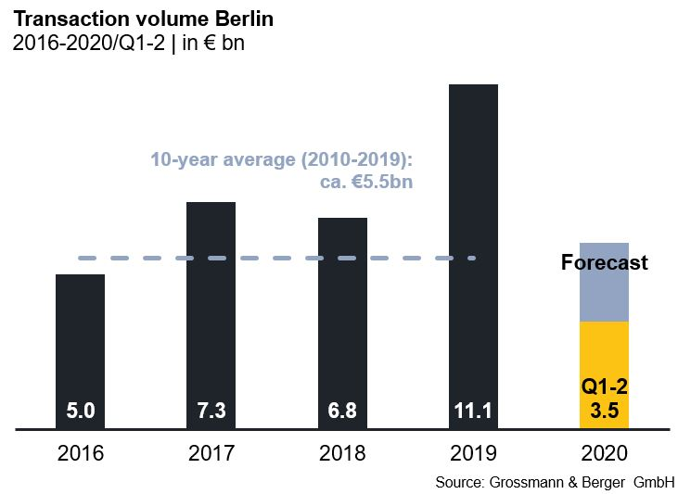
Investment market | Berlin | 2020 | Q 1-2
Transaction volume [€ millions] | 3,460
against prior yr [%] | -28
Share of trading in CBD [%] | 10
Proportion of international investors [%] | 74
Prime net yield, office [%] | 2.7
against prior yr [percentage points] | -0.2
Prime net yield, commercial buildings [%] | 2.8
against prior yr [percentage points] | -0.1
Prime net yield, logistics properties [%] | 3.8
against prior yr [percentage points] | -0.4
Strongest asset class | Offices
Strongest asset class [%] | 67

Selected top transactions | investments in Berlin | 1st and 2nd quarters 2020

Project/property  Street no. | Sub-market | Asset class | Buyer/investor | Vendor | Purchase price*  [approx. €m]
Quartier Schützenstrasse | Mitte 1a | Offices | Henderson Park | Caleus Capital Partners for GIC | 194
“The Grid” | Kreuzberg | Offices | DWS | Pandion | 129
“Enter” | Periphery North | Offices | DEKA Immobilien | Townscape One | 120
Kabel-Deutschland,  Germaniastrasse 14-17 | Periphery South | Offices | Colcap | Signature Capital Limited | 70
“Mebeshaus”  Charlottenstrasse 82 | Mitte 1a | Offices | KanAm for Leading Cities Invest fund | Quest Investment Partners | 55
*The purchase prices stated are based on publicly available data, where none is available an estimate is made; new transactions or those occurring in the quarter dealt with in this report are highlighted.

The complete market survey will soon be available and can be downloaded from our Website.

About Grossmann & Berger
Grossmann & Berger GmbH is one of the leading service providers for selling and letting commercial and residential properties in North Germany. Headquartered in Hamburg, the Company has a branch office in Berlin, a total of fourteen property shops, and over 190 employees who cover the entire North German market. With over 85 years of experience in the business, Grossmann & Berger offers a complete package of real estate expertise.

Grossmann & Berger is a member of the HASPA Group of Companies, which also includes Germany's largest savings bank, Hamburger Sparkasse (Haspa). Moreover the Company is a founding member of the nation-wide commercial property network German Property Partners (GPP) and the working group of brokers associated with banks and building societies, Arbeitsgemeinschaft ImmobilienVermittler Banken Bausparkassen e.V. (IVBB).

Please consult our website for Grossmann & Berger’s data privacy policy. Here you will also be able to access our press kit and the associated Terms of Use. If in future you would prefer not to receive any more information from our press office, please e-mail us at presse@grossmann-berger.de quoting as reference "Abmeldung aus Presseverteiler” / “Unsubscribe from press mailing list”.

