Hamburg: Investment market 1st-4th quarters of 2019
Portfolio trades keep Hamburg’s market afloat

Hamburg, 7 January 2020 - A very sluggish 1st half year on Hamburg’s market for investment in commercial real estate gave way to remarkably brisk trading in the second half. The year’s total of 120 transactions generated sales of some €4.3bn, a good 27 % lower than the result in 2018; however, the €3.2bn invested in properties in the 2nd half year was only slightly below the record set in the prior-year period. “The record year of 2018 had left the market almost drained of investment opportunities by the start of 2019. It was July before the market began to pick up, thanks to several big-ticket portfolio sales. After a huge surge in activity, the year thus ended with a good result,” remarks Axel Steinbrinker, managing director of Grossmann & Berger, a member of German Property Partners (GPP). With the age of zero interest rates set to continue, demand for investment-grade real estate in Hamburg remained high but the limited supply of large individual properties hampered the market. In particular, owners of core properties were less willing to sell. “Although there was still an enormous run on real estate in Hamburg, in 2019 the number of transactions with price-tags in excess of 100 million euros was only about half of the volume seen the year before,” adds Steinbrinker.

Market details:
- Portfolio transactions generated €1.8bn and thus 40 % of the total traded, a far higher proportion than a year ago (2018: 27 %). This is partly due to the sale of portfolios such as the Millennium, Dream Global and Omega, which included several properties in Hamburg.
- Once again, office properties were by far the most sought-after asset class, accounting for 75 % of the total (2018: 55 %). In 2019 properties in the City district remained those preferred by investors, generating 42 % of the volume traded (2018: 29 %).
- Accounting for 23 % of the volume traded, the biggest single group of vendors were listed real estate investment AGs/REITs. In large part this is due to Blackstone’s acquisition of the Canadian REIT Dream Global. Developers followed in second place with some 20 % of the market. Forward trades totalling around €474m contributed to the latters’ result. On the buying side of the equation, open-ended mutual property investment funds were in the lead with a share of 26 %.
- As the year closed, sales were evenly distributed across all price categories. Properties in the €51m plus and €100m plus brackets each comprised a third of the total. However, in the whole of 2019 not a single investment property sold for more than €200m.
- Prime yields on offices, commercial buildings and logistics properties remained practically unchanged at the low levels noted at the end of 2018.
- A combination of zero interest rates, a lack of alternative investments and maturing government bonds will result in fresh capital flooding into Hamburg’s investment market and, in view of short supply, lead to rising purchase prices. Yields are likely to contract further in the new year.
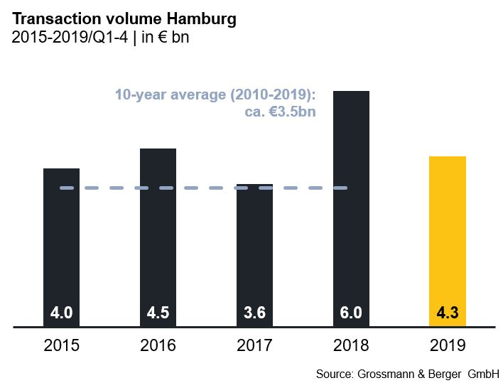
Investment market | Hamburg | 2019 | Q1 - 4
Transaction volume [€ millions] | 4,340
against prior yr [%] | -27
Share of trading in CBD [%] | 42
Proportion of international investors [%] | 37
Prime net yield, office [%] | 2.80
against prior yr [percentage points] | ±0.00
Prime net yield, commercial buildings [%] | 2.70
against prior yr [percentage points] | ±0.00
Prime net yield, logistics properties [%] | 4.25
against prior yr [percentage points] | -0.25
Strongest asset class | Offices
Strongest asset class [%] | 75

Selected top transactions | investments in Hamburg | 1st to 4th quarters 2019
Project/property  Street no. | Sub-market | Asset class | Buyer/investor | Vendor | Purchase price*  [approx. €m]
“Euler Hermes Campus”, Gasstrasse 25+29 | Bahrenfeld | Offices | HanseMerkur | Quantum Immobilien | 166
“Bleichenhof”, Bleichenbrücke 9-11 | City | Mixed use | Niedersächsische Ärzteversorgung | Stenprop Limited | 160
“Edge HafenCity”, Amerigo-Vespucci-Platz | HafenCity | Offices | Allianz Real Estate Germany GmbH | Edge Technologies | 160
“Economic Quarter”, Heidenkampsweg 96+98 | City South | Offices | LaSalle Investment Management | Blackrock Investment Management | 140
*The purchase prices stated are based on publicly available data, where none is available an estimate is made; new transactions or those occurring in the quarter dealt with in this report are highlighted.

The complete market survey will soon be available and can be downloaded from our Website.

About Grossmann & Berger
Grossmann & Berger GmbH is one of the leading service providers for selling and letting commercial and residential properties in North Germany. The Company has ten offices in Hamburg, and one each in Berlin, Ahrensburg, Lüneburg, Norderstedt and on the Island of Sylt, permitting comprehensive coverage of the North German market. With over 85 years of experience in the business, the Company offers a complete package of real estate expertise. Grossmann & Berger belongs to the HASPA Group and is a founding member of the national commercial real estate network German Property Partners (GPP).

Please consult our website for Grossmann & Berger’s data privacy policy. Here you will also be able to access our press kit and the associated Terms of Use. If in future you would prefer not to receive any more information from our press office, please e-mail us at presse@grossmann-berger.de quoting as reference "Abmeldung aus Presseverteiler” / “Unsubscribe from press mailing list”.

