Hamburg: Industrial and logistics property market, 1st-4th quarters of 2020
Owner-occupier construction starts feature heavily in 2020

Hamburg, 28 January 2020 – The trends observed in the 3rd quarter of 2020 on the market for industrial and logistics properties in Hamburg and its environs continued into the last quarter of the year. By the end of 2020, despite the coronavirus pandemic, take-up of space had grown by more than a third compared with the close of 2019. The result for the year was 480,000 m². Owner-occupiers were the mainstay of the market, their share of take-up rose from just 15 % to 51 % within the space of one year. Commenting the result Felix Krumreich, consultant for industrial and logistics real estate at Grossmann & Berger, a member of German Property Partners (GPP), explains that, “It is pure coincidence and a consequence of lengthy lead times that so many owner-occupiers in Hamburg and its environs started their building projects in 2020. As the year closed, the classic letting business was still lagging behind. This is reflected in the fact that only 237,500 square metres of space was let during the whole year. Since the pandemic is not yet over, many companies have adopted a wait and see attitude.”

Market details:
- Four agreements for large premises were signed in the 3rd quarter, followed by three more for over 10,000 m² of space in the 4th quarter. 2020 thus closed with a total of nine agreements in this segment of the market (2019: 3). Consequently, this size category dominated the market with 53 % of take-up for the year (2019: 15 %). Six of the nine agreements for space in excess of 10,000 m² were construction starts for owner-occupiers.
- Omnitrade Handelsgesellschaft signed the largest new contract of the 4th quarter. This wholesaler launched its expansion project to add 30,550 m² to its premises in the Jacobsrade trading estate in Siek (North East Environs).
- The biggest construction project started in the year 2020 is an 86,500-square-metre logistics and administrative centre for REWE in Henstedt-Ulzburg (North West Environs). In the 1st quarter Mickeleit, a forwarding company, signed the biggest lease of the year, taking 28,400 m² of space at Altenwerder Kirchtal 1-5 (Hamburg South).
- Unlike the prior year logistics firms were not the main players on the market in 2020, and relinquished their former top slot (2019: 57 %; 2020: 29 %) to trading companies (34 %).
- There was a pronounced shift from the city to the environs, where the proportion of total take-up rose from 38 % to 55 %. This was due to the fact that six of the nine high-volume agreements related to sites in the environs. The REWE construction start boosted the market share of North West Environs to a quarter; this sub-market was followed by Hamburg South, where the other three large agreements pushed its market share to one fifth.
Industrial, logistics |  Hamburg and environs | 2020 | Q1-4
Space take-up [m²] | 480,000
against prior yr [%] | +35
Ratio of owner-occupiers [%] | 51
against prior yr [percentage points] | +36
Premium rent [€/m²/month net of services] | 6.30
against prior yr [%] | ±0.0
Average rent [€/m²/month net of services] | 5.20
against prior yr [%] | +2.0
Most popular sub-market | North-West Environs
Most popular sub-market [%] | 25
Industry with highest turnover | Trade/retail
Industry with highest turnover [%] | 34
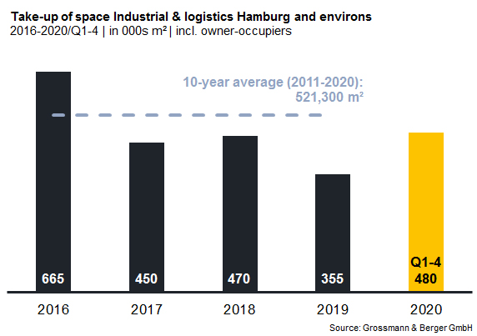

Selected top transactions | industrial and logistics market Hamburg and environs |
1st-4th quarters of 2020
City | Road/street | Property/project | Tenant/owner-occupier | Floor area:  [ca. m²]
Henstedt-Ulzburg | Rudolf-Diesel-Strasse | Logistics and administrative centre (construction start) | REWE Region North (owner-occupier) | 86,500
Hamburg | Am Genter Ufer | New build (construction start) | Airbus (owner-occupier) | 30,600
Siek | Jacobsrade 86 | Production and warehouse facilities (building start) | Omnitrade Handelsgesellschaft (owner-occupier) | 30,550
Hamburg | Am Altenwerder Kirchtal 1-5 | Existing building | Spedition Mickeleit | 28,400
Neu Wulmstorf | Gottlieb-Daimler-Strasse | New build (construction start) | Kroop & Co. Transport + Logistik (owner-occupier) | 22,500
Transactions occurring in the quarter covered by this report are highlighted.

The detailed market survey will be available from our website soon.

About Grossmann & Berger
Grossmann & Berger GmbH is one of the leading service providers for selling and letting commercial and residential properties in North Germany. Headquartered in Hamburg, the Company has a branch office in Berlin, a total of fourteen property shops, and over 190 employees who cover the entire North German market. With over 85 years of experience in the business, Grossmann & Berger offers a complete package of real estate expertise. Grossmann & Berger is a member of the HASPA Group of Companies, which also includes Germany's largest savings bank, Hamburger Sparkasse (Haspa). Moreover, the Company is a founding member of the nation-wide commercial property network German Property Partners (GPP) and the working group of brokers associated with banks and building societies, Arbeitsgemeinschaft ImmobilienVermittler Banken Bausparkassen e.V. (IVBB).

Please consult our website for Grossmann & Berger’s data privacy policy. Here you will also be able to access our press kit and the associated Terms of Use. If in future you would prefer not to receive any more information from our press office, please e-mail us at presse@grossmann-berger.de quoting as reference "Abmeldung aus Presseverteiler” / “Unsubscribe from press mailing list”.

