Hamburg: Industrial and logistics property market, 1st-3rd quarters of 2021
Logistics firms boost letting business

Hamburg, 21 October 2021 – 2021 will probably be a year in which six-figure letting results for industrial and logistics space in Hamburg are posted in each of the four quarters. Lettings and new owner-occupancies totalled 135,000 m² and 205,000 m² in the first two quarters of the year followed by 156,000 m² in the 3rd quarter; moreover, several agreements are now close to conclusion. Figures collated by Grossmann & Berger, a member of German Property Partners (GPP), show that to date the take-up of space totals 496,000 m² and is thus already higher than the five-year average of 484,000 m².

“Apart from 2011, which was exceptional in that by the end of September 612,000 square metres had been let or absorbed in construction starts, no higher result has been posted in any other third quarter. The large proportion of let space is remarkable, because in 2020 the market was dominated by the start of construction work for owner-occupiers,” remarks Felix Krumreich, consultant for industrial and logistics properties at Grossmann & Berger. Lettings comprised 85 % of the take-up of space, a figure similar to the result in the same period in 2019.

Market details:
- Between July and September an additional four agreements for more than 10,001 m² of space were signed. The number of agreements in this size category doubled within the space of a year to twelve. Contracts involving over 10,001 m² accounted for 45 % of the market (3Q2020: 54 %) and the next-smaller category, 5,001 to 10,000 m², comprised 33 % of the total (3Q2020: 18 %).
- Despite the low proportion of owner-occupiers, three of the nine large-volume agreements mentioned earlier were construction starts. For example, building started on a new computer centre for akquinet, a sale brokered by Grossmann & Berger in 2020, on the VICTORIA PARK HAMBURG industrial estate in Rahlstedt, to provide 10,300 m² of hall space and 3,600 m² of office space.
- Most agreements fell into two price groups; rents of over €5.51/m²/month made up 32 % of the market, and rates between €4.51/m²/month and €5.00/m²/month accounted for 26 %. Accordingly, the premium rent rose to a new high of €6.50/m²/month, while the average rent remained unchanged at €5.20/m²/month.
- Since ten of the twelve large-volume contracts were signed by logistics & forwarding companies (8) and wholesale/retail enterprises (2) these two sectors of industry accounted for 84 % of the take-up of space. Logistics firms accounted for a share of 52 % and wholesale/retail for 32 %.
- Year on year, a trend towards locating within city limits has become apparent and market activity here has risen from 44 % to 63 %. The sub-market Hamburg East accounted for 36 % of take-up due to two new contracts, which have brought its total of large-volume agreements to four. Hamburg South and the North West Environs followed with about a fifth of the market each.
Industrial & logistics | Hamburg & Environs | 2021 | Q1-Q3
Space take-up [m²] | 496,000
against prior yr [%] | +36
Ratio of owner-occupiers [%] | 15
against prior yr [percentage points] | -38
Premium rent [€/m²/month net of services] | 6.50
against prior yr [%] | +3.2
Average rent [€/m²/month net of services] | 5.20
against prior yr [%] | ±0.0
Most popular sub-market | Hamburg East
Most popular sub-market [%] | 36
Industry with highest turnover | Logistics & forwarding
Industry with highest turnover [%] | 52
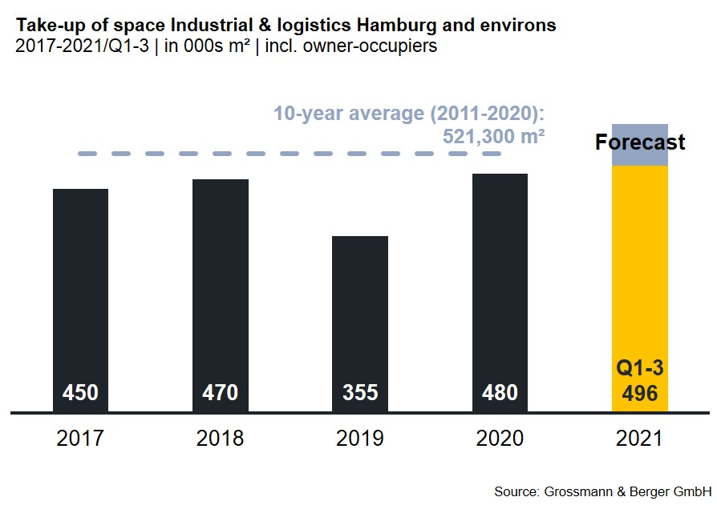

Selected top transactions | industrial & logistics | Hamburg & environs | 1st-3rd quarters of 2021
City | Road/street | Property/project | Tenant/owner-occupier | Floor area  [ca. m²]
Nützen | Kirchenweg 12 | “Panattoni Park Hamburg North”, new-build logistics halls | Riess-Ambiente | 37,700
Hamburg | Vollhöfner Weiden 19 | Existing logistics facility | GREIWING logistics for you | 29,200
Hamburg | Pinkertweg 5 | New build logistics centre | Group7 (pwner-occupier) | 26,000
Wenzendorf | Otto-Lilienthal-Strasse 1a-d | “Logistikpark Eurolog Rade”, Logistics hall | confidential | 15,500
New agreements are colour-marked

Our next Market Survey Industrial, Hamburg will be available at the end of the 4th quarter of 2021 as download in PDF format.

About Grossmann & Berger
Grossmann & Berger GmbH is one of the leading service providers in the business of selling and letting commercial and residential properties in North Germany. In addition to its main office in Hamburg, the company has 20 local offices. This allows Grossmann & Berger to cover the entire North German market. In May 2021 the company was augmented by E & G Real Estate and
E & G Private Immobilien, so that Grossmann & Berger also operates in the two South German metropolitan areas of Stuttgart and Munich. Drawing on their comprehensive expertise in the real estate business, some 250 employees provide the full range of relevant services. They also benefit from the company’s more than 85 years standing in the industry. Grossmann & Berger belongs to the HASPA Group and is a founding member of the national commercial real estate network German Property Partners (GPP).

Please consult our website for Grossmann & Berger’s data privacy policy. Here you will also be able to access our press kit and the associated Terms of Use. If in future you would prefer not to receive any more information from our press office, please e-mail us at presse@grossmann-berger.de quoting as reference "Abmeldung aus Presseverteiler” / “Unsubscribe from press mailing list”.

