Hamburg: Industrial and logistics property market, 1st-2nd quarters of 2021
Half year result a resounding success

Hamburg, 14 July 2021 - It is as if the market for industrial and logistics properties in Hamburg had decided to leap into action after a long period of slumber; it could explain why take-up of space doubled within a year to close the 1st half of 2021 at 340,000 m². Only once before, in the absolutely exceptional year 2011, was more space leased or taken up by owner-occupiers in a 2nd quarter; in 2011 the total was 235,000 m², ten years later 205,000 m². “Many talks that had been put on ice due to the uncertainties of the pandemic have been resumed and agreements finalized between April and June,” says Felix Krumreich, consultant for industrial and logistics properties at Grossmann & Berger, a member of GPP. “In the first half year 23 leases were signed for premises offering 5,000 square metres of space or more. Last year, when the coronavirus first hit, only seven such leases were concluded.”

Market details:
- Whereas 44 % of the take-up of space (2Q2020: 35 %) involved leases for over 10,000 m² of space, the next-largest size segment, 5,001 to 10,000 m², also accounted for the second-largest share of the market at 33 % (2Q2020: 23 %). “Leases for large amounts of space constitute over three quarters of total take-up,” Krumreich remarks.
- Considering that the owner-occupier ratio was 11 %, rental take-up was very high at 302,600 m².
- The two agreements for the biggest amounts of space previously noted were built-to-suit properties - similar to owner-occupier transactions - and a new contract in this category is at the same time the largest-volume lease to date. In Nützen, near Kaltenkirchen, Panattoni is developing two halls providing 37,700 m² of space and 3,750 m² of offices on behalf of Riess-Ambiente, an online retailer of designer furniture.
- The average rent paid by corporate clients for industrial and logistics space in Hamburg and the environs is €5.20/m²/month. This rate is 10 cents/m²/month higher than a year ago. The premium rent rose by the same amount to €6.40/m²/month.
- As in 2020, logistics and forwarding companies were still the predominant market players at the end of June 2021. Their share of take-up rose from 42 % to 55 %. In view of the Riess-Ambiente agreement, retail/wholesale accounted for 26 % of take-up, dislodging the manufacturing/industrial/craft trades sector (15 %) from second place.
- Unlike the situation a year before, take-up was fairly evenly spread across the three most popular sub-markets. Hamburg East posted 30 % of take-up, North-West Environs and Hamburg South had similar shares of 24 % and 22 % respectively. This distribution also owed much to the two new, large-volume agreements. The share of take-up registered in the environs grew appreciably from 33 % to 44 %.

Industrial, logistics | Hamburg and Environs | 2021 | Q1-Q2
Space take-up [m²] | 340,000
against prior yr [%] | +100
Ratio of owner-occupiers [%] | 11
against prior yr [percentage points] | -14
Premium rent [€/m²/month net of services] | 6.40
against prior yr [%] | +1.6
Average rent [€/m²/month net of services] | 5.20
against prior yr [%] | +2.0
Most popular sub-market | Hamburg East
Most popular sub-market [%] | 30
Industry with highest turnover | Logistics/forwarding
Industry with highest turnover [%] | 55
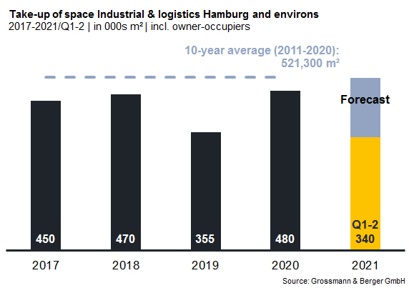

Selected top transactions | industrial & logistics | Hamburg & environs | Q1-2, 2021
City | Road/street | Property/project | Tenant/owner-occupier | Floor area  [ca. m²]
Nützen | Kirchenweg 12 | “Panattoni Park Hamburg North”, new-build logistics halls | Riess-Ambiente | 37,700
Hamburg | Vollhöfner Weiden 19 | Existing logistics facility | GREIWING logistics for you | 29,200
Wenzendorf | Otto-Lilienthal-Strasse 1a-d | “Logistikpark Eurolog Rade”, Logistics hall | Confidential | 15,500
Henstedt-Ulzburg | Rudolf-Diesel-Strasse 11-13 | Distribution centre | Boeing Distribution Services | 15,400
Hamburg | Bredowstrasse 6 | New build | Heinrich Dehn Internationale Spedition | 15,300
New agreements are colour-marked

The complete industrial market survey will soon be available and can be downloaded from our website.

About Grossmann & Berger
Grossmann & Berger GmbH is one of the leading service providers in the business of selling and letting commercial and residential properties in North Germany. In addition to its main office in Hamburg, the company has 20 local offices. This allows Grossmann & Berger to cover the entire North German market. In May 2021 the company was augmented by E & G Real Estate and E & G Private Immobilien, so that Grossmann & Berger also operates in the two South German metropolitan areas of Stuttgart and Munich. Drawing on their comprehensive expertise in the real estate business, some 250 employees provide the full range of relevant services. They also benefit from the company’s more than 85 years standing in the industry. Grossmann & Berger belongs to the HASPA Group and is a founding member of the national commercial real estate network German Property Partners (GPP).

Please consult our website for Grossmann & Berger’s data privacy policy. Here you will also be able to access our press kit and the associated Terms of Use. If in future you would prefer not to receive any more information from our press office, please e-mail us at presse@grossmann-berger.de quoting as reference "Abmeldung aus Presseverteiler” / “Unsubscribe from press mailing list”.

