Hamburg: Industrial, warehouse and logistics property market,
1st-3rd quarters of 2020
Building starts for large developments boost quarterly result

Hamburg, 14 October 2020 - Proving many fears unfounded, take-up of space for industrial, storage and logistics purposes in Hamburg and its environs closed the 3rd quarter of 2020 with a huge rise of 48 %. Nevertheless, the total of 365,000 m² is not a sign that significantly more rental agreements are being concluded. Five of the six contracts involving more than 10,000 m² of space were construction starts for owner-occupier developments. Accordingly, the ratio of owner-occupiers was an impressive 53 %. “Initial planning work started on most of these developments in 2019 or 2018, and thus long before the coronavirus pandemic,” says Felix Krumreich, consultant for industrial, warehouse and logistics properties at Grossmann & Berger, a member of German Property Partners (GPP). “Due to the coronavirus, letting activity remained slow after the summer holidays, unlike the pattern in previous years. However, certain industries, such as trade/retail displayed a fair amount of activity and properties of less than 5,000 square metres were popular.”

Market details:
- Four agreements for premises offering more than 10,000 m² of space boosted the quarterly result to 195,000 m². This was higher than any other 3rd-quarter result apart from in 2011 and 2012. In contrast, not one single large-volume agreement was signed in the same quarter a year ago. Accordingly, the size sector of 10,000 m² or more accounted for the largest slice of the market, 54 %.
- One single agreement for 86,500 m² dominated the quarterly result, comprising more than a quarter of total take-up of space. This transaction was the long-planned construction start of a logistics and administrative centre for REWE in Henstedt-Ulzburg, which will be the company’s base to supply food retailers in Hamburg and Schleswig-Holstein. Moreover, in terms of space, this development is the second-largest deal ever undertaken in Hamburg and its environs.
- In contrast with the previous year, trade/retail was the predominant industry, accounting for 38 % of take-up and ousting logistics and forwarding companies from the top slot; their share fell to 30 % (2019: 51 %).
- So far, as a result of the REWE project now under construction, North-West Environs was the strongest sub-market with 30 % of the volume of take-up. For the same reason there was a marked shift in the focus of marketing activities in the 3rd quarter towards the environs, whose share of the market rose from 31 % to 56 % year on year.

Industrial, warehouse, logistics |  Hamburg and Environs | 2020 | Q1-3
Space take-up [m²] | 365,000
against prior yr [%] | +48
Ratio of owner-occupiers [%] | 53
against prior yr [percentage points] | 35
Premium rent [€/m²/month net of services] | 6.30
against prior yr [%] | ±0.0
Average rent [€/m²/month net of services] | 5.20
against prior yr [%] | +4.0
Most popular sub-market | North-West Environs
Most popular sub-market [%] | 30
Industry with highest turnover | Trade/retail
Industry with highest turnover [%] | 38
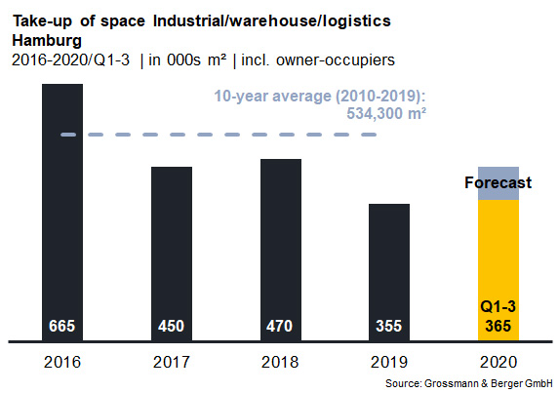

Selected top agreements | industrial, warehousing, logistics properties in Hamburg and Environs |
1st to 3rd quarters of 2020
City | Road/street | Property/project | Tenant/owner-occupier | Floor area  [ca. m²]
Henstedt-Ulzburg | Rudolf-Diesel-Strasse | Logistics and administrative centre (construction start) | REWE Region North (owner-occupier) | 86,500
Hamburg | Am Genter Ufer | New build (construction start) | Airbus (owner-occupier) | 30,600
Hamburg | Am Altenwerder Kirchtal 1-5 | Existing building | Spedition Mickeleit | 28,400
Neu Wulmstorf | Gottlieb-Daimler-Strasse | New build (construction start) | Kroop & Co. Transport + Logistik (owner-occupier) | 22,500
Bad Oldesloe | Bergkoppel 4 | Central warehouse (construction start) | Asklepios Kliniken  (owner-occupier) | 14,400
Transactions occurring in the quarter covered by this report are highlighted

The next comprehensive market survey will be published in the 4th quarter on our website.

About Grossmann & Berger
Grossmann & Berger GmbH is one of the leading service providers for selling and letting commercial and residential properties in North Germany. Headquartered in Hamburg, the Company has a branch office in Berlin, a total of fourteen property shops, and over 190 employees who cover the entire North German market. With over 85 years of experience in the business, Grossmann & Berger offers a complete package of real estate expertise. Grossmann & Berger is a member of the HASPA Group of Companies, which also includes Germany's largest savings bank, Hamburger Sparkasse (Haspa). Moreover, the Company is a founding member of the nation-wide commercial property network German Property Partners (GPP) and the working group of brokers associated with banks and building societies, Arbeitsgemeinschaft ImmobilienVermittler Banken Bausparkassen e.V. (IVBB).

Please consult our website for Grossmann & Berger’s data privacy policy. Here you will also be able to access our press kit and the associated Terms of Use. If in future you would prefer not to receive any more information from our press office, please e-mail us at presse@grossmann-berger.de quoting as reference "Abmeldung aus Presseverteiler” / “Unsubscribe from press mailing list”.

