Hamburg: Industrial, warehouse and logistics property market 1st-4th quarter 2019
Annual take-up falls to level last seen in 2008 and 2009

Hamburg 20 January 2020 - In 2019 take-up of industrial, warehouse and logistics space in Hamburg and its environs started to revive a little and posted gradual growth. With take-up of 109,000 m² of space, the 4th quarter was the busiest in the past year. Despite this, for the first time since 2009 take-up of space dipped below 400,000 m² to 355,000 m². Compared with 2018 the market slumped by 24 %. “All three agreements for over 10,000 square metres were concluded in the fourth quarter. For the first time in many years, this size category did not comprise the biggest share of take-up,” reports Felix Krumreich, consultant for industrial, warehouse and logistics properties at Grossmann & Berger, a member of German Property Partners (GPP). “We expect this year’s market to resemble the one in 2019.”
Market details:
- The 5,001 to 10,000 m² segment of the market made up 35 % of the total, ahead of the 3,001 to 5,000 m² size category with a share of 25 %. Leases for premises larger than 10,001 m² accounted for 15 % and thus only the fourth-highest share of total take-up (2018: 38 %).
- In 2018 nine agreements in this sector were signed, in 2019 only three. ULD United Logistics & Distribution concluded the largest rental agreement of 2019, taking 30,000 m² of space on Dradenaustrasse, Waltershof. Construction work started on the new head office for WISKA Hoppmann, a shipbuilding & industrial supplier and owner-occupier of the new build on Grashofstrasse in Kaltenkirchen. This was the biggest owner-occupier transaction of the year, the 1st building phase will deliver some 8,800 m² of logistics and manufacturing space.
- In 2019, 42 % of space taken up was let for more than €5.51/m²/month (2018: 34 %). Thus both premium and average rents rose, reaching €6.30/m²/month and €5.10/m²/month.
- The focus on properties within Hamburg city limits grew even stronger, rising from 61 % of total take-up at the end of 2018 to 73 % in 2019. Accordingly, the three most popular sub-markets were in Hamburg: Hamburg South accounted for 34 %, Hamburg East for 14 % and Hamburg North East for 12 %. Nine of the 20 agreements for more than 5,001 m² related to properties in Hamburg South.
- The logistics/communications/forwarding sector returned a very similar result, changing year on year from 55 % to 57 % of the total.
Industrial, warehouse, logistics | Hamburg | 2019 | Q1 -4
Space take-up [m²] | 355,000
against prior yr [%] | -24
Ratio of owner-occupiers [%] | 15
against prior yr [percentage points] | -0.5
Premium rent  [€/m²/month net of services] | 6.30
against prior yr [%] | +5
Average rent  [€/m²/month net of services] | 5.10
against prior yr [%] | +2
Most popular sub-market | Hamburg South
Most popular sub-market [%] | 34
Industry with highest turnover | Logistics/  communications/  forwarding
Industry with highest turnover [%] | 57
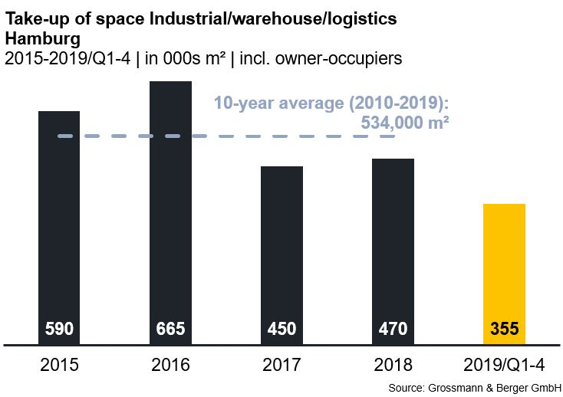

Selected top transactions | industrial, warehouse and logistics properties | Hamburg | Q1-4/2019
City | Road/street | Property/project | Tenant/owner-occupier | Floor area  [ca. m²]
Hamburg | Dradenaustrasse 20 | Logistics facility | ULD United Logistics & Distribution | 30,000
Bad Oldesloe | Teichkoppel | New logistics building | E-commerce logistics firm | 12,150
Kaltenkirchen | Kirchenweg | New logistics building | E-commerce logistics firm | 11,350
Hamburg | Vollhöfner Weiden 17 | Logistics estate (high-bay warehouse) | Nutwork Handelsgesellschaft | 9,700
Bad Oldesloe | Rögen 19-27 | Logistics facility | Hertling Hamburg | 9,000
Bold print indicates new transactions or those occurring in the quarter in this report.

The next comprehensive market survey will shortly be published on our website

About Grossmann & Berger
Grossmann & Berger GmbH is one of the leading service providers for selling and letting commercial and residential properties in North Germany. The Company has ten offices in Hamburg, and one each in Berlin, Ahrensburg, Lüneburg, Norderstedt and on the Island of Sylt, permitting comprehensive coverage of the North German market. With over 85 years of experience in the business, the Company offers a complete package of real estate expertise. Grossmann & Berger belongs to the HASPA Group and is a founding member of the national commercial real estate network German Property Partners (GPP).

Please consult our website for Grossmann & Berger’s data privacy policy. Here you will also be able to access our press kit and the associated Terms of Use. If in future you would prefer not to receive any more information from our press office, please e-mail us at presse@grossmann-berger.de quoting as reference "Abmeldung aus Presseverteiler” / “Unsubscribe from press mailing list”.

