Hamburg: Industrial and logistics property market, 1st quarter of 2021
Stable quarterly result to start the year

Hamburg, 21 April 2021 – Take-up of industrial and logistics space in Hamburg and its environs totalled 135,000 m² in the 1st quarter of 2021 - the third time in succession that the quarterly result has consistently remained at pre-Covid levels. In fact, the result was 13 % higher than the 1st quarter of 2020. This emerges from figures compiled by Grossmann & Berger, a member of German Property Partners (GPP). “On the one hand, talks that had already started some time ago finally led to agreements in the first quarter of 2021. On the other hand, just three contracts for large amounts of space accounted for a third of total take-up,” says Felix Krumreich, consultant for industrial and logistics properties at Grossmann & Berger, commenting on the good start to the year. However, because it is hard to predict what the pandemic might still have in store, many companies are biding their time. Conversely, firms in the e-commerce, pharmaceutical and food sectors require more space to deal with the extra business generated by the pandemic. “Demand definitely exists. Moreover, several owner-occupiers intend to start their building work in 2021. And on the supply side of the market, new-build logistics space is currently available to rent. Therefore we expect the year to close with take-up totalling 450,000 square metres,” says Krumreich, looking ahead.

Market details:
- Properties in the 5,001 to 10,000 m² size category accounted for 28 % of the strong take-up figures (Q1/2020: 14 %).
- Having comprised 28 % of the market in the same quarter a year earlier, owner-occupiers played a minor role in the 1st quarter of 2021 with a share of 10 % of take-up. However, the two agreements for the greatest amount of space were built-to-suit properties developed for Boeing and Heinrich Dehn. They are comparable to owner-occupier projects, because the construction is tailored to the needs of the future corporate tenant.
- Both the premium rent and average rent remained unchanged from the prior quarter, but rose slightly year on year by 1.6 % and 2.0 % respectively.
- A comparison of tenants by sector of industry shows that by the end of March 2021 logistics firms and forwarders had increased their share of the market from 49 % to 56 %. Apart from the largest agreement signed, tenants active in this sector accounted for the other five contracts for more than 7,000 m² of space. Trading/retail firms doubled their share of the total volume of take-up of space to 18 %.
- The focus of take-up shifted away from Hamburg South sub-market (previously 57 %) to Hamburg East with a share of 56 %. Seven of the ten biggest agreements were signed for space in Hamburg East. The North West Environs were the next-biggest hotspot on the market, accounting for 22 % of take-up. Within the space of one year the market share in the environs climbed from 22 % to 36 %.

Industrial, logistics | Hamburg, environs | 2021 | Q1
Space take-up [m²] | 135,000
against prior yr [%] | +12.5
Ratio of owner-occupiers [%] | 10
against prior yr [percentage points] | -18
Premium rent [€/m²/month net of services] | 6.40
against prior yr [%] | +1.6
Average rent [€/m²/month net of services] | 5.20
against prior yr [%] | +2.0
Most popular sub-market | Hamburg East
Most popular sub-market [%] | 56
Industry with highest turnover | Logistics/ forwarding
Industry with highest turnover [%] | 56
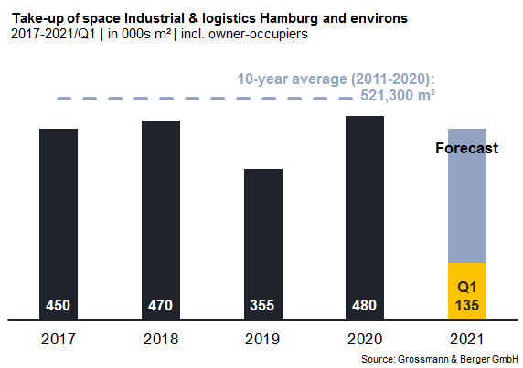

Selected top transactions | industrial, logistics | Hamburg, environs | 1st quarter of 2021
City | Road/street | Property/project | Tenant/owner-occupier (oo) | Floor area  [ca. m²]
Henstedt-Ulzburg | Rudolf-Diesel-Strasse 11-13 | Distribution centre | Boeing Distribution Services | 15,400
Hamburg | Bredowstrasse 6 | New build | Heinrich Dehn Internationale Spedition | 15,300
Hamburg | Bredowstrasse 20 | Existing building | Teamwork Instore Services | 13,500
Wenzendorf | Otto-Lilienthal-Strasse 1 | Existing building | DSV Solutions | 9,500
Hamburg | Pinkertweg 20 | Existing building | TSIT | 8,000

The next detailed market survey Industrial Properties Hamburg will be published at the end of the 1st half of 2021.

About Grossmann & Berger
Grossmann & Berger GmbH is one of the leading service providers for selling and letting commercial and residential properties in North Germany. Headquartered in Hamburg, the Company has a branch office in Berlin, fourteen property shops, and some 190 employees who cover the entire North German market. With over 85 years of experience in the business, Grossmann & Berger offers a complete package of real estate expertise. Grossmann & Berger is a member of the HASPA Group of Companies, which also includes Germany's largest savings bank, Hamburger Sparkasse (Haspa). Moreover, the Company is a founding member of the nation-wide commercial property network German Property Partners (GPP) and the working group of brokers associated with banks and building societies, Arbeitsgemeinschaft ImmobilienVermittler Banken Bausparkassen e.V. (IVBB).

Please consult our website for Grossmann & Berger’s data privacy policy. Here you will also be able to access our press kit and the associated Terms of Use. If in future you would prefer not to receive any more information from our press office, please e-mail us at presse@grossmann-berger.de quoting as reference “Abmeldung aus Presseverteiler” / “Unsubscribe from press mailing list”.

