PRESS RELEASE
Merger of two major real estate players
Grossmann & Berger pools resources with E & G companies

- Grossmann & Berger (G&B) and the two E & G companies E & G Real Estate and E & G Private Immobilien (private properties) merging
- Nationwide presence to expand

Stuttgart 11 May 2021 – Starting on 5 May 2021 the long-established real estate service providers Grossmann & Berger, E & G Real Estate and E & G Private Immobilien are pooling their resources. Together they intend to expand their nationwide activities, extend their services portfolios and offer clients an even better customer experience. The new union will serve clients from offices in Hamburg, Berlin, Stuttgart and Munich.

Existing partnership and shared values
In the context of the merger, Grossmann & Berger is taking a majority share in the E & G companies; at the same time, E & G shareholders are acquiring a stake in Grossmann & Berger. “For many years the two property firms have been engaged in successful collaboration in the commercial real estate sector. It is the logical next step to pool resources and act jointly across regional borders,” comments Frank Brockmann, chairman of the supervisory board of Grossmann & Berger. In 2013, Grossmann & Berger and E & G Real Estate’s predecessor company founded the commercial properties network German Property Partners (GPP). The merger covers all corporate units, including the brokerage of private homes. What these firms have in common is not only their long history and banking background but also identical values and philosophy. “Our shared basic tenets such as honesty, continuity, reliability and loyalty already provide the joint foundation. We would like to build on that, to become more visible on the national stage and gain new customers,” says Andreas Rehberg, spokesperson for the management board of Grossmann & Berger.

Strategic development and changes in top management
The managing partner of the E & G companies, Björn Holzwarth, is convinced that “Our strategic collaboration will help us to make further progress with the growth programme we have initiated and create a sustainable future for the business.” All companies retain their present structures, and customers will still deal with the consultants and contacts they already know. There will be changes at management level:
- Andreas Rehberg, spokesperson for the management board of Grossmann & Berger, coordinates the pan-regional business of letting commercial property and retains responsibility for the new-build housing business in Hamburg.
- Björn Holzwarth remains managing partner of E & G Real Estate and E & G Private Immobilien in Stuttgart and Munich and will also join the management board of G&B. His area of responsibility will be to coordinate the national investment business.
- Holger Michaelis will continue to be responsible for commercial property investment and new-build housing in Berlin.
- Sandra Ludwig likewise continues her task of managing investments in commercial real estate and buy-to-let residential properties in Hamburg.
- Lars Seidel, to date the managing director responsible for residential stock, letting and business affairs for G&B in Hamburg and Berlin, will join the management board of the two E & G companies, taking responsibility for business management.
- Mario Caroli will retire from management duties after over 20 years in charge of commercial real estate and on the board of E & G Real Estate and join the supervisory board of Grossmann & Berger.
- Alexander Zigan, to date manager of the Munich office of E & G Real Estate, will become managing director of the company in the context of the merger.
- Kerstin Schmid will remain managing director at E & G Private Immobilien with responsibility for the residential property business in Stuttgart.

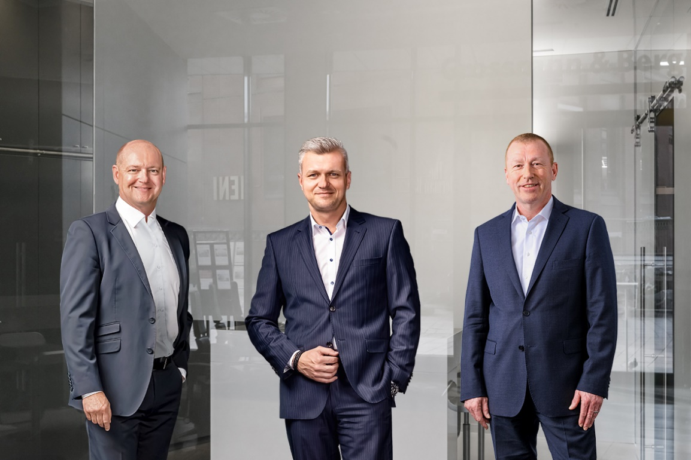
Photo: In future the management board of E & G Real Estate will consist of three people (from left to right): Björn Holzwarth, Alexander Zigan und Lars Seidel.
Source of image: E & G Real Estate GmbH, Morris Mac Matzen / Grossmann & Berger GmbH, Ingo Boelter
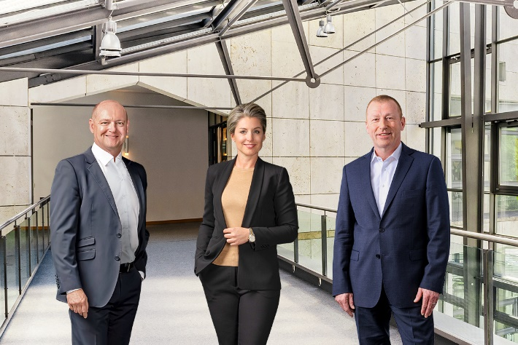
Photo: In future the management board of E & G Private Immobilien will consist of three people (from left to right): Björn Holzwarth, Kerstin Schmid und Lars Seidel.
Source of image: E & G Private Immobilien GmbH, Morris Mac Matzen / Grossmann & Berger GmbH
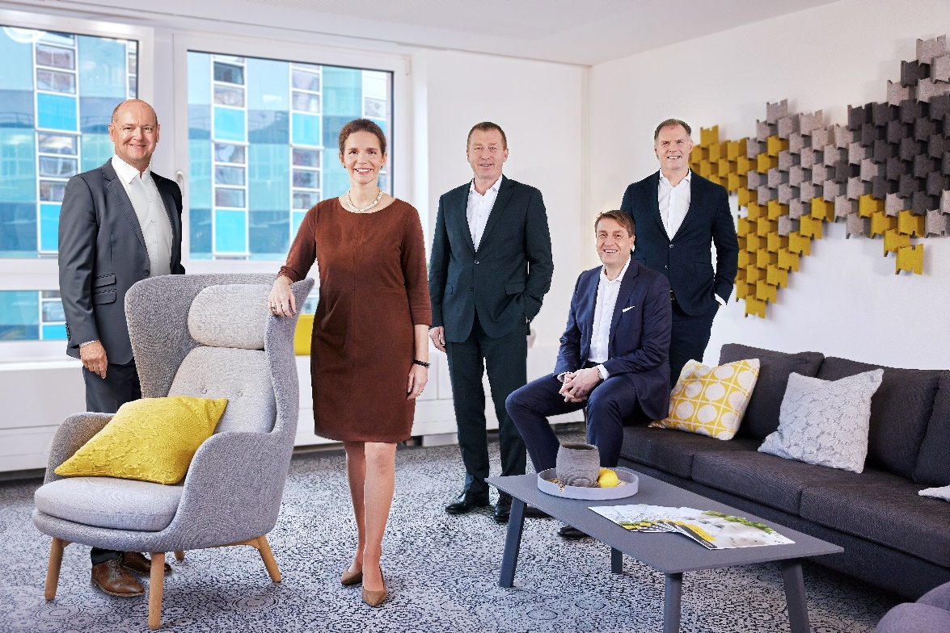
Photo: In future the management board of Grossmann & Berger will consist of five people (from left to right): Björn Holzwarth, Sandra Ludwig, Lars Seidel, Holger Michaelis and Andreas Rehberg.
Source of image: Morris Mac Matzen / Grossmann & Berger GmbH, E & G Real Estate GmbH

About E & G Real Estate
E & G Real Estate stands for personal, customized consultancy in Baden-Württemberg and Bavaria in the field of commercial and residential property transactions. The more than 50 employees at the head office in Stuttgart and the Munich branch office can draw on over 80 years of skilled work in the real estate business, offering clients services in all matters relating to buying, selling or letting properties. For the teams of experts at E & G Real Estate it goes without saying that they prepare their tailored offers for their clients on the basis of excellent knowledge of the market, a superior service ethic, and absolute discretion and independence. As a member of German Property Partners (GPP) E & G Real Estate is part of a nationwide network offering specialist services in the commercial property sectors of Germany’s top 7 cities.

About E & G Private Immobilien
For more than 80 years E & G Private Immobilien GmbH has been one of the region’s leading specialists in the private property sector. With an expanded network of property shops in centres around the state capital, the company has become a greater force in the region’s sub-markets. In Stuttgart and the region the men and women working at E & G Private Immobilien GmbH are acknowledged experts in the professional marketing of residential real estate. The team has excellent knowledge of the regional property market. Possessing many years of experience in the property brokerage field, team members are equipped to advise on all issues pertaining to residential property; clients are assured of discretion and competence at all times.

About Grossmann & Berger
Grossmann & Berger GmbH is one of the leading service providers for selling and letting commercial and residential properties in North Germany. Headquartered in Hamburg, the Company has a branch office in Berlin, a total of fourteen property shops, and some 190 employees who cover the entire North German market. With over 85 years of experience in the business, Grossmann & Berger offers a complete package of real estate expertise. Grossmann & Berger is a member of the HASPA Group of Companies, which also includes Germany's largest savings bank, Hamburger Sparkasse (Haspa). Moreover, the Company is a founding member of the nation-wide commercial property network German Property Partners (GPP) and the working group of brokers associated with banks and building societies, Arbeitsgemeinschaft ImmobilienVermittler Banken Bausparkassen e.V. (IVBB).

Press contact
E & G Real Estate GmbH
Sarah Danielle Hein
Tel: +49 (0)711/20702-700
Mail: Sarah.Hein@eug-re.de

Grossmann & Berger GmbH
Berit Friedrich
Tel: +49 (0)40/350802-620
Mail: b.friedrich@grossmann-berger.de

