Hamburg: Residential | Buy-to-let investments 2020 / 2021
Despite coronavirus pandemic buy-to-let real estate continues to rise in price

Hamburg, 24 September 2020 - The market for buy-to-let residential properties in Hamburg is weathering the Covid-19 crisis extremely well. Although transactions ground to a halt during the lockdown, the market has now resumed business as usual. Prices are rising in line with the trend seen before the start of the pandemic. The key parameters for apartment blocks, the price/earnings ratio* and the purchase price per square metre, have moved in the way Grossmann & Berger predicted in 2019. “For a short while during the lockdown banks were reluctant to commit to any form of real estate funding. In view of this hiatus in capital spending, plus the shortage of alternative investment options that already existed before the pandemic, the market is awash with cash. Despite projections that indicate declining returns, many investors consider rental apartments a relatively inflation-proof option,” says Axel Steinbrinker, managing director of Grossmann & Berger, a member of German Property Partners (GPP). “The period of uncertainty has ended. We definitely expect to see the prices of residential buy-to-let properties increase.” Grossmann & Berger has compiled information and forecasts for 2021 on how the market for rental apartments in Hamburg is developing in its market survey of “Rental Apartment Houses/Buy-to-let investments, Hamburg 2020/2021” which will be published soon.

Price to earnings multiples set to rise even higher
Residential properties in Hamburg continue to be an attractive investment, and this is reflected in the changing price/earnings ratios* now attainable for standard properties**. As forecast, the maximum ratio has risen from 40 in 2019 to its current level of 42. Grossmann & Berger expect further increases in 2021, although the growth curve might flatten a little. According to the G&B Price Trend report it is likely that maximum prices of 43 times the annual net rent excluding services will be paid in 2021 for properties in Hamburg’s prime locations on the Alster Lake and in HafenCity. The minimum ratio will probably continue its upwards trajectory too. Currently this figure is 22 (2019: 21) and in the coming year it is estimated to rise to 23 times the annual net rent excluding services. This category includes rental apartment blocks in less desirable locations south of the River Elbe

Maximum purchase prices rising more steeply
The maximum price per square metre of living space attainable for rental apartments also continues to rise, and in 2020 it reached the €6,000/m² mark for the first time. In its Price Trend G&B forecasts that maximum purchase prices will rise by 8.3% in 2021 to €6,500/m² of living space, a rate of increase well above that seen in the two preceding years. Minimum purchase prices leapt by 14.3% beyond their 2019 level (€2,100/m² of living space) to reach €2,400/m² in 2020. Grossmann & Berger estimates that the minimum square-metre price will rise to €2,500/m² in 2021. Over a five-year period (2016-2020) the minimum purchase price rose by 41.2 %, during which time the maximum purchase price grew by 33.3 %. As Steinbrinker remarks, “The fact that the price of buy-to-let apartments is rising despite the coronavirus pandemic serves to emphasize the stability of the market for residential real estate. For those thinking of parting with property, this is an excellent time to sell.”

* Price/earnings multiple: quotient of the purchase price divided by annual net rent, equivalent to the gross initial yield.

** Standard property: Property in a normal state of repair (not a new build) containing at least five residential units and fully let at customary market rates.

The complete market survey is soon available and may be downloaded (in German) from our Website.

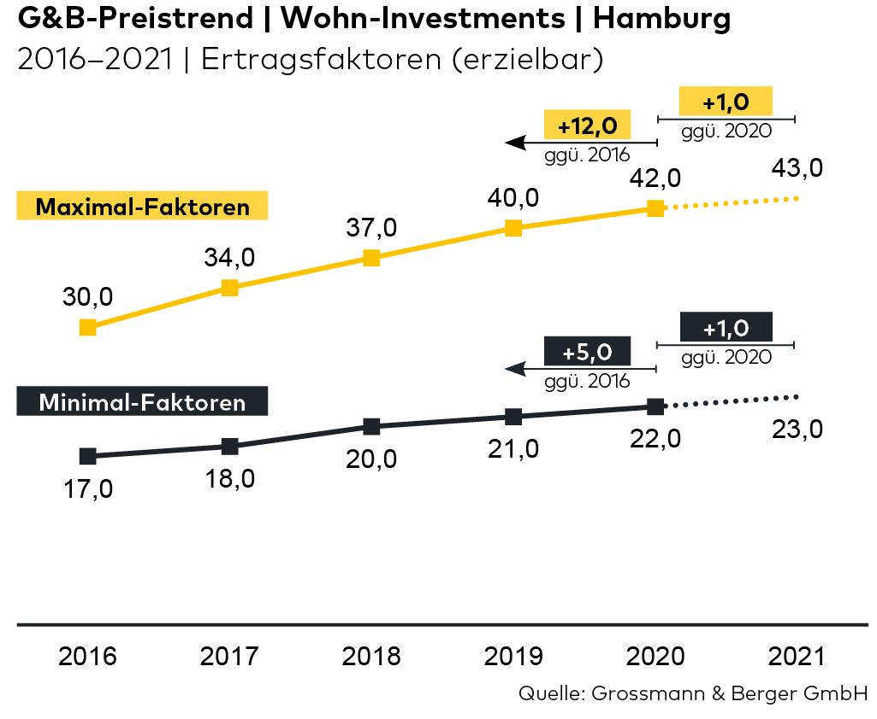
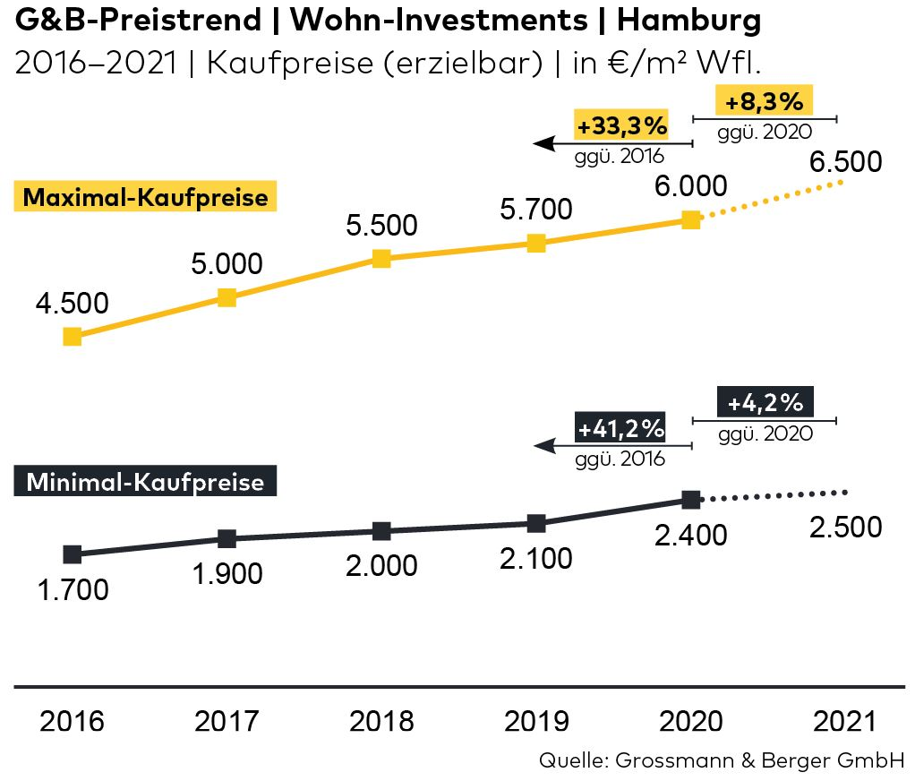
Material

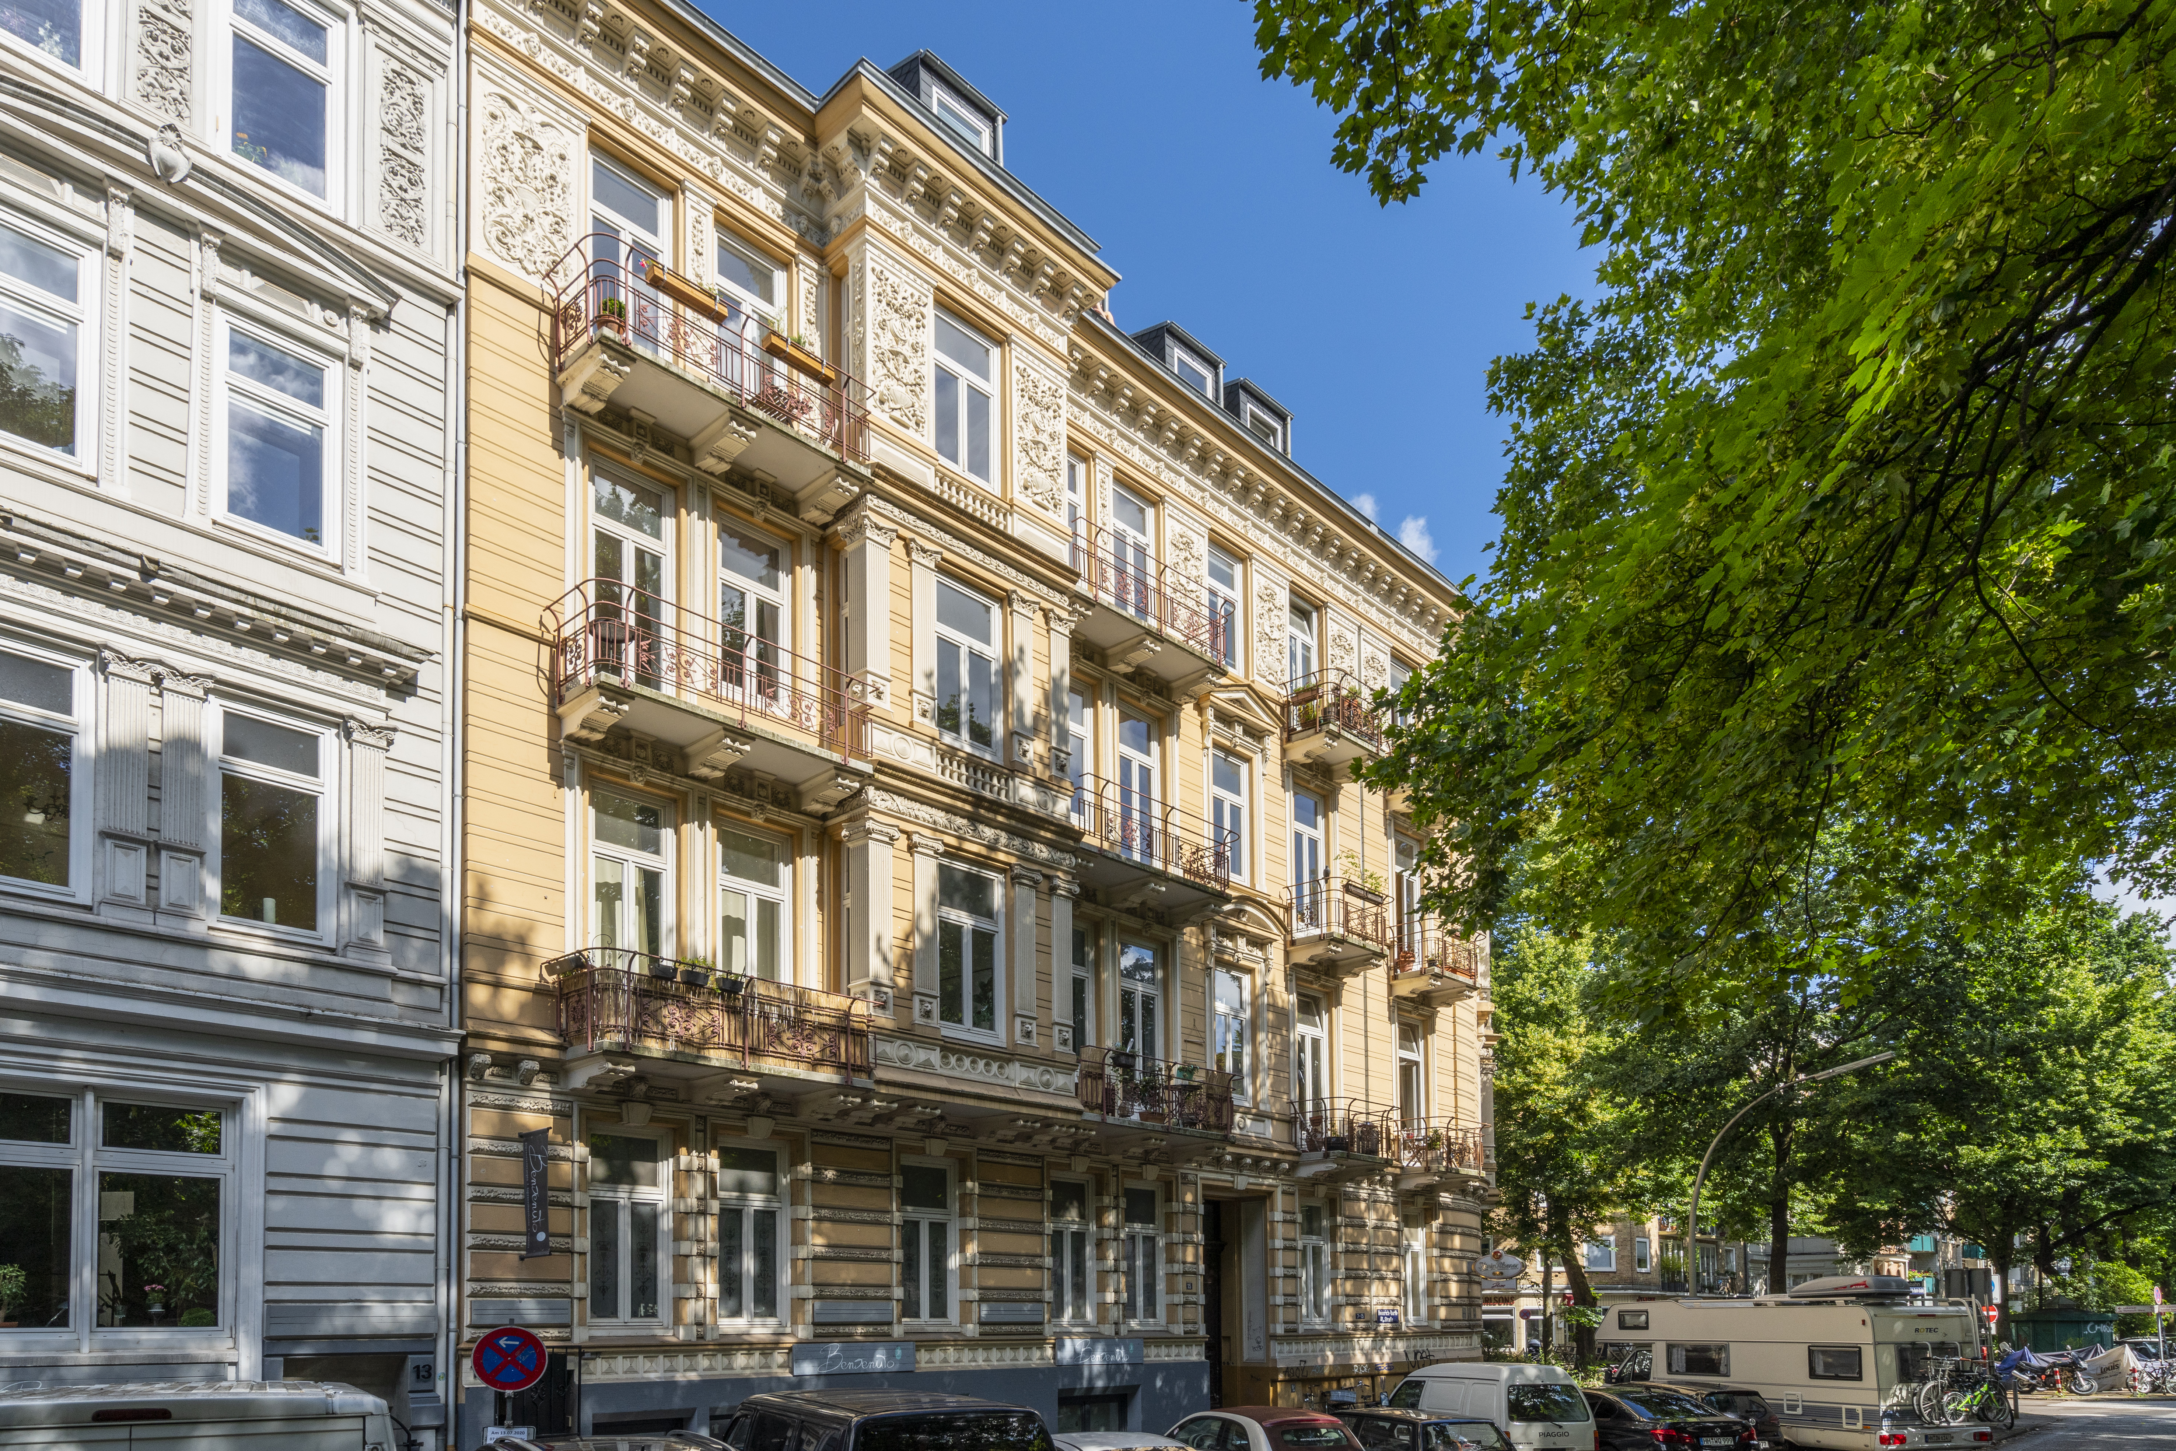
Photo:

Houses with sitting tenants such as this one in Hamburg-Rotherbaum command high price/earnings ratios.

Source, photo: Jenner-Egberts GbR Fotografie / Grossmann & Berger
About Grossmann & Berger
Grossmann & Berger GmbH is one of the leading service providers for selling and letting commercial and residential properties in North Germany. Headquartered in Hamburg, the Company has a branch office in Berlin, a total of fourteen property shops, and over 190 employees who cover the entire North German market. With over 85 years of experience in the business, Grossmann & Berger offers a complete package of real estate expertise. Grossmann & Berger is a member of the HASPA Group of Companies, which also includes Germany's largest savings bank, Hamburger Sparkasse (Haspa). Moreover the Company is a founding member of the nation-wide commercial property network German Property Partners (GPP) and the working group of brokers associated with banks and building societies, Arbeitsgemeinschaft ImmobilienVermittler Banken Bausparkassen e.V. (IVBB).

Please consult our website for Grossmann & Berger’s data privacy policy. Here you will also be able to access our press kit and the associated Terms of Use. If in future you would prefer not to receive any more information from our press office, please e-mail us at presse@grossmann-berger.de quoting as reference "Abmeldung aus Presseverteiler” / “Unsubscribe from press mailing list”.

