TOP 7 INVESTMENT MARKETS Q2/2021
PRESS CONTACT
Berit Friedrich
Telephone: +49 (0)40 / 350 80 2-620
E-Mail: presse@germanpropertypartners.de
PRESS RELEASE
Market activity varies VERY widely
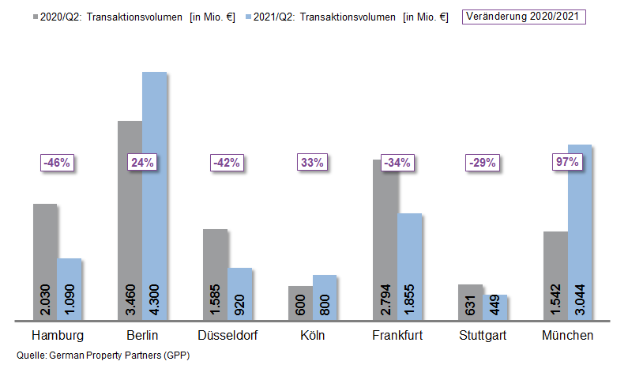

02 July 2021, Hamburg. Overall, the market for investments in commercial properties located in Germany’s top 7 cities was back on an even keel by the end of the 2nd quarter of 2021 and transactions totalled €12.5bn. The result for the half year is thus only 1 % below the figure for 2020. However, a very uneven picture emerges if the cities - Hamburg, Berlin, Düsseldorf, Cologne, Frankfurt, Stuttgart and Munich - are viewed separately. Reviewing totals traded, German Property Partners, a network of service providers in the commercial real estate sector consisting of Grossmann & Berger, Anteon Immobilien, GREIF & CONTZEN Immobilien, blackolive and E & G Real Estate, found that results ranged from -46 % in Hamburg to +97 % in Munich.

Trading dynamics vary following weak start to the year

In Cologne Proximus and Quantum sold fairly large ensembles such as “The Corner Cologne” and “The Spikes” to a Hines fund for some €100m, thus boosting trading totals by 33 %. Additionally, some retail shop properties also changed hands. In Berlin Vivion sold the “Fürst” at Kurfürstendamm 206-209 to Aggregate Holdings for more than €1bn; this outlier transaction helped boost the total volume traded by 24 %. Munich also posted an unusual volume of expensive trades with the sale of three properties with price tags higher than €500m. The result in the Bavarian state capital thus shot up by a record 97 %. Düsseldorf’s market stabilized in the 2nd quarter of 2021. Due to the all-time low noted at the beginning of the year, the volume of transactions in the first half of 2021 was, however, 42 % lower than the same period of 2020. By contrast the weak market at the start of 2021 persisted in Hamburg (-46 %), Frankfurt (-34 %) and Stuttgart (-29 %), because the ongoing shortage of core real estate acted against high transaction volumes. “Such a wide range of market activity in a second quarter is very unusual in the commercial real estate investment sector. As one can see from the outlier transactions in Berlin and Munich, there is unabated demand for core real estate and when attractive properties come onto the market, new benchmarks are set,” remarks Oliver Schön, spokesperson for German Property Partners. Overall, the proportion of sales that involved portfolios remained low at 11 % in the first half of 2021. Their share of the total topped 20 % only in Cologne and Stuttgart.

International investors more eager to buy

Year on year international investors were far less prominent in the 1st quarter of 2021 but by the end of the 2nd quarter of 2021 their numbers had grown to 37 % of the market. In 4 of the top 7 cities international buyers played a less active role than in the same period of the prior year. Despite international participation in the huge “Fürst” transaction, foreign actors were less prominent in Berlin year on year. The latter transaction, however, resulted in the mixed-use category of real estate (51 % of market) displacing office buildings (35 %) as the best-selling asset in the German capital. In all other top 7 cities the majority of transactions involved office buildings, above all in Munich where they accounted for 83 % of the total traded in the first two quarters of 2021. The big-ticket transactions previously noted were partly responsible for the high proportion of office block sales. “These outlier transactions do not reflect usual market activity, so that it is to be expected that over the further course of the year key market figures will return to more normal levels,” says Oliver Schön, putting the results into context. Prime yields have altered very little in the 1st half of 2021 compared with the same period of 2020. Due to great demand for core real estate, the average prime yield on offices was practically unchanged at 2.88 % (-0.05 percentage points). Prime yields were compressed furthest in Hamburg, dropping 0.20 percentage points to 2.60 %, the lowest prime yield in any top 7 city. Prime yields on industrial and logistics real estate slipped appreciably, averaging a loss of 0.31 percentage points against the 1st half of 2020 and falling to 3.75 %. Cologne and Stuttgart posted the highest decline at -0.50 percentage points.

FORECAST: LARGE TRANSACTIONS REVITALIZE THE MARKET

German Property Partners expect to see further recover on the markets in some of the cities. In Hamburg, Cologne and Frankfurt in particular, some big-ticket transactions should produce an acceptable overall result for the year. “Generally speaking and compared with pre-coronavirus levels there are still very few properties on the market. At the same time investors are desperately keen to find attractive real estate. This is likely to keep yields under pressure in the near future,” concludes Schön.

Top 10 known agreements | top 7 locations | 1st-2nd quarters of 2021
City | Project/property | Buyer/investor | Vendor: | Pur. price*  (about €m)
BER | “Fürst”, Kurfürstendamm 206-209 | Aggregate Holdings | Vivion | > 1,000
MUC | “Highlight Towers”  Mies-van-der-Rohe-Strasse 6 | Imfarr + SN | Commerz Real | 650
MUC | “Media Works”,  Rosenheimer Strasse 145a-i / Anzinger Straße 1-17 | Union Investment and Hines | Officefirst | 650
MUC | “O2 Tower”  Georg-Brauchle-Ring | DIC Asset | GIC | 570
FFM | Ludwig-Erhard Strasse 7, Eschborn | Deutsche Gesellschaft für Internationale Zusammenarbeit (Fed. int. aid org.) | PHOENIX Real Estate Development | 220
BER | “Quartier 206”,  Friedrichstrasse 71 | RFR Holding | Bank consortium headed by Credit Suisse | 220
FFM | “Westend Carrée”,  Grüneburgweg 14-18 | Ardian Real Estate | publity | > 200
BER | Landsberger Allee 52 | Values | Centrum Grundstücksgesellschaft | 200
DUS | “Trinkhaus Galerie”,  Königsallee 21-23 | Momeni, Wirtgen Invest and Black Horse Investments | HSBC | > 155
FFM | “Sparda Bank Tower”  Europa Allee 68 | Sparda-Bank Hessen | Gustav Zech Stiftung | confidential
Transactions occurring in the quarter covered by this report are highlighted. Source: German Property Partners (GPP)

Top 7 cities | 1st-2nd quarters of 2021
 | HAM | BER | DUS | CGN | FFM | STU | MUC | Top 7
Transaction volume  In €m | 1,090 | 4,300 | 920 | 800 | 1,855 | 449 | 3,044 | 12,458
Change  against prior yr in % | -46 | +24 | -42 | +33 | -34 | -29 | +97 | -1
Prime yield*, offices  in % | 2.60 | 2.65 | 2.90 | 3.00 | 2.90 | 3.10 | 3.00 | 2.88
against prior yr in percentage points | -0.20 | -0.05 | -0.05 | 0.00 | -0.05 | 0.00 | 0.00 | -0.05
Prime yield*, logistics in % | 3.80 | 3.50 | 3.75 | 3.60 | 3.60 | 4.00 | 4.00 | 3.75
against prior yr in percentage points | -0.40 | -0.30 | -0.25 | -0.50 | -0.20 | -0.50 | 0.00 | -0.31
Strongest  Asset class | Offices | Mixed use | Offices | Offices | Offices | Offices | Offices | -
Strongest  asset class in % | 51 | 51 | 65 | 41 | 68 | 36 | 83 | -
* Net initial yield; Source: German Property Partners (GPP)

ABOUT GERMAN PROPERTY PARTNERS
German Property Partners is a national network of property service providers; they are all leaders in their local markets. Membership now consists of Grossmann & Berger, Anteon Immobilien, GREIF & CONTZEN Immobilien, blackolive and E & G Real Estate. The network is remarkable for the members’ intimate knowledge of local markets, the experience of the partner firms’ long-standing property consultants and the personal dedication of the owners and directors. In Germany’s top 7 cities - Hamburg, Berlin, Düsseldorf, Cologne | Bonn, Frankfurt, Stuttgart and Munich - network partners have their own offices offering services in the field of property investment, commercial letting, corporate real estate management (CREM), property valuation and research. Rounding off the range of skills are banking, finance and administration services. Currently, more than 430 property specialists work for the network. Nationwide, German Property Partners brokered lets in 2020 involving 462,800 m² of commercial property, and managed investment transactions totalling €2.45bn.

