TOP-7-INVESTMENT MARKETS Q4/2020
PRESS CONTACT
Berit Friedrich
Telephone: +49 (0)40 / 350 80 2-620
E-Mail: presse@germanpropertypartners.de
PRESS RELEASE
Coronavirus slows some markets
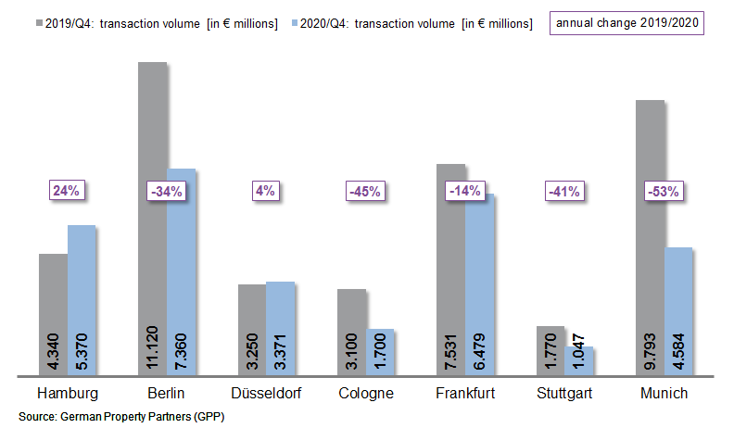
04 January 2021, Hamburg. At the end of this extraordinary year 2020 brisk trading in investment-grade commercial properties returned to Germany’s top 7 cities. A third of the transaction volume (TAV) of €29.9bn was generated in the 4th quarter. Nevertheless, trading volumes in Hamburg, Berlin, Düsseldorf, Cologne, Frankfurt, Stuttgart and Munich were a full 27 % below the level reached in the record year of 2019 (€40.9bn). Whereas the coronavirus pandemic considerably slowed trading in most cities, Hamburg and Düsseldorf weathered the crisis well thanks to their diversified economies. These findings are contained in surveys compiled by German Property Partners (GPP), the brokers’ association formed by Grossmann & Berger, Anteon Immobilien, GREIF & CONTZEN Immobilien, blackolive and E & G Real Estate.

Despite the decline, transaction volume close to average

Overall, the real estate investment markets remain stable in Germany’s top 7 cities. “2018 and 2019 were two exceedingly strong years, when trading volumes set new records. Compared with the average of the past five years, the volume of transactions recorded in the top 7 cities in 2020 was about 10 per cent lower. In addition, some transactions have been delayed by the pandemic and postponed until next year,” says GPP spokesperson Oliver Schön. Properties in Hamburg were especially in demand; here most investors opted to buy core real estate in the City district. Accordingly, the volume traded in Hamburg rose by 24 % year on year to €5.37bn. Brisk activity was also noted on the Düsseldorf market, which proved to be very resilient in the face of the current pandemic, posting a slight increase of 4 % (€3.37bn). In Frankfurt the downturn was likewise fairly moderate thanks to the sale of the Silberturm tower for a price of €630m, a transaction completed shortly before the end of the year. The decline in transaction volumes was more marked in the other top 7 cities and was steepest in Munich where trades fell by 53 % to €4.56bn. However, Munich, capital of Bavaria, had posted an exceptionally high record in 2019 when investment volumes rose by 57 % compared with 2018. 27 % of the trading volume in the top 7 cities involved portfolios (2019: 21 %).

Aversion to risk squeezes prime yields

Investors’ focus on core real estate became even more pronounced at the end of 2020. “Some cities were flooded by capital seeking properties in attractive locations let to good tenants, and several buildings sold at record prices. Most investors continue to give a wide berth to hotels and riskier properties in B and C locations,” says Schön. Office properties remained the strongest asset class, accounting for 65 % of the volume traded, even if their share of the market has declined in most of the top 7 cities. Development sites comprised a larger proportion of sales (up from 5 to 9 %). Investors also turned their interest to industrial and logistics real estate. High demand for this asset class is reflected in the prime yield, which has contracted to 3.84 % (2019: 3.99 %) Due to great demand for core real estate, the prime yield on offices dropped slightly to 2.86 % (2019: 2.88 %). The general crisis of inner-city retail shops, which has only been aggravated by the coronavirus pandemic, led to an increase in prime yields on commercial buildings to 2.97 % (2019: 2.82 %). Travel restrictions due to the pandemic reduced the proportion of foreign investors to 41 % (2019: 46 %).

FORECAST

GPP spokesman Oliver Schön comments that, “The current trends on the market are to minimize risk and focus on core quality properties; these are likely to prevail for most of the year to come. Some transactions still in the pipeline will be completed in 2021 and boost the market. Whereas attractive office real estate will remain of interest, commercial buildings and hotels will feel the effects of the coronavirus pandemic for some time yet.” For the year 2021 the brokers’ network German Property Partners expects the transaction volume in Germany’s top 7 cities to rise slightly above the 2020 results.

Top 10 known agreements | top 7 locations | 1st-4th quarters of 2020
City | Project/property | Buyer/investor | Vendor: | Pur. price*  (about €m)
FFM | “Silberturm”, Jürgen-Ponto-Platz 1 | Imfarr und SN Beteiligungen Holding AG | Samsung SRA Asset Management | 630
FFM | “Grand Campus”, Mainzer Landstrasse 151-157 | Arminius Gruppe for Junson Capital | Commerz Real AG | 560
MUC | “Neue Balan, Haus 27”, St.-Martin-Str. / Balanstraße | Union Investment. | Allgemeine Südboden | 320
HAM | “Johann Kontor”, Klosterwall 6-8 | Captiva/HanseMerkur/Aug. Prien Family Office | Aug. Prien | > 300
HAM | Gruner+Jahr publishing house  Am Baumwall 11 | Tishman Speyer | Gruner + Jahr | 300
MUC | "Weisses Quartier", St.-Martin-Strasse | Deka Immobilien | InfraRed Capital Partners, Allgemeine Südboden | 280
DUS | “MIZAL”, Plockstrasse | R+V Versicherung (insurance) | Codic | 260
HAM | “Karstadt”, Mönckebergstrasse 16 | Signa Holding | Quantum Immobilien | 260
FFM | “Future DEKA headquarters”, Lyoner Strasse 13 | DIC Asset AG | Lang & Cie | Confiden-tial
FFM | Borsigallee 1-7 | AGC Equity Partners | Iron Mountain Incorporated | Confiden-tial
Transactions occurring in the quarter covered by this report are highlighted. Source: German Property Partners (GPP)

Top 7 cities | 1st-4th quarters of 2020
 | HAM | BER | DUS | CGN | FFM | STU | MUC | Top 7
Transaction volume  In €m | 5,370 | 7,360 | 3,371 | 1,700 | 6,479 | 1,047 | 4,584 | 29,911
Change  against prior yr in % | +24 | -34 | +4 | -45 | -14 | -41 | -53 | -27
Prime yield*, offices  in % | 2.80 | 2.70 | 2.90 | 3.00 | 2.90 | 2.90 | 2.80 | 2.86
against prior yr in percentage points | 0.00 | 0.00 | -0.10 | -0.10 | -0.05 | -0.10 | 0.20 | -0.02
Prime yield*, logistics in % | 4.00 | 3.70 | 3.75 | 3.80 | 3.80 | 4.20 | 3.60 | 3.84
against prior yr in percentage points | -0.25 | -0.10 | -0.25 | -0.10 | -0.10 | 0.00 | -0.10 | -0.16
Strongest  Asset class | Offices | Offices | Offices | Offices | Offices | Offices | Offices | -
Strongest  asset class in % | 53 | 62 | 76 | 56 | 74 | 70 | 64 | -
* Net initial yield; Source: German Property Partners (GPP)

ABOUT GERMAN PROPERTY PARTNERS
German Property Partners is a national network of property service providers; they are all leaders in their local markets. Membership now consists of Grossmann & Berger, Anteon Immobilien, GREIF & CONTZEN Immobilien, blackolive and E & G Real Estate . The network is remarkable for the members’ intimate knowledge of local markets, the experience of the partner firms’ long-standing property consultants and the personal dedication of the owners and directors. In Germany’s top 7 cities - Hamburg, Berlin, Düsseldorf, Cologne | Bonn, Frankfurt, Stuttgart and Munich - network partners have their own offices offering services in the field of property investment, commercial letting, corporate real estate management (CREM), property valuation and research. Rounding off the range of skills are banking, finance and administration services. Currently, more than 430 property specialists work for the network. Nationwide, German Property Partners brokered lets in 2019 involving 452,800 m² of commercial property, and managed investment transactions totalling €2.14bn.

