TOP-7-INVESTMENT MARKETS Q3/2020
PRESS CONTACT
Ms Corinna Fühner
Telephone: +49 (0)40 / 350 80 2-588
E-Mail: presse@germanpropertypartners.de
PRESS RELEASE
CORONAVIRUS DEPRESSES TRADING
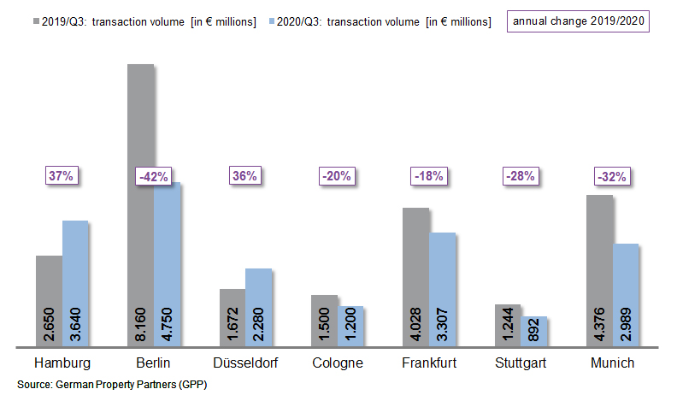
1st October 2020, Hamburg. Year on year the volume of transactions recorded in Germany’s top 7 cities fell by 19 % in the 3rd quarter of 2020. During the first nine months of 2020 commercial properties located in Hamburg, Berlin, Düsseldorf, Cologne, Frankfurt, Stuttgart and Munich changed hands for a total of €19.06bn. Only two cities posted growth, Hamburg and Düsseldorf. This emerges from the latest calculations by the estate agents/brokers’ network German Property Partners (GPP).

Trading volume down apart from in Hamburg and Düsseldorf

By the end of the 3rd quarter the trading volume in Hamburg totalled €3.64bn, well above the prior year’s figure (+37 %). First and foremost, this increase stems from ten transactions with price tags in excess of €100m (2019: 6). Düsseldorf likewise posted growth; its trading volume rose by 36 % to €2.28bn, much of which was, however, generated in the strong 1st quarter of 2020. The other five top 7 cities saw declining volumes of transactions; Berlin’s total fell by a massive 42 % to €4.75bn, largely due to the capital city’s strong result in the previous year.
35 % of the trading volume in the top 7 cities involved portfolios (2019: 21 %).
“It is noticeable that the market is indeed reviving a little in some cities: In the third quarter alone a total of 6.5 billion euros was spent on real estate in the top 7 cities, some 1.8 billion euros more than in the second quarter. However, restrictions on personal meetings and investors’ ongoing need for increased consultancy are a poor match. Transactions thus take longer to negotiate and there are delays before agreements are finalized - if they are completed at all,” reports GPP spokesman Oliver Schön.

RUN ON CORE PROPERTIES CONTINUES

Investors are finding it increasingly difficult, in view of the economic imponderables, to obtain funding, especially for higher-risk properties in B and C locations. Oliver Schön remarks, “Core properties are the front runners. Investor demand in the third quarter focussed on top real estate let long-term to credit-worthy tenants.” He adds that this puts additional downwards pressure on the prime yields in the the top 7 cities, noting that the 3rd-quarter decline was most pronounced for logistics properties, on which the prime yield dropped to 3.96 % (2019: 4.25 %). Office properties located in the top 7 cities took the lion’s share of trading activity (60 %) whereas hotels, whose business was badly hit by the crisis, were avoided (4 %). Despite the fallout from the coronavirus, sales of retail properties rose from 5 to 9 % of the total. However, the sale of two huge “Karstadt” buildings in Hamburg was instrumental in producing this result. Foreign investors continued to trade in the top 7 cities, accounting for 43 % of the total (2019: 43 %), even though travel restrictions made cross-border transactions more difficult.

FORECAST

Oliver Schön says, “Cash needs to be invested. Pent-up investor demand and the low interest rates are likely to boost market activities in the top 7 cities by the end of the year, although interest will concentrate on low-risk types of real estate. There is currently no appetite for higher risk assets. Because there is great demand for a limited supply of core properties, no price reductions are to be expected.” GPP forecasts a volume of transactions totalling some €27.60bn by the end of the 4th quarter - well below the five-year average of €33.12bn.
Top 10 known agreements | top 7 locations | 1st-3rd quarters of 2020
City | Project/property | Buyer/investor | Vendor | Pur. price*  (about €m)
HAM | “Johann Kontor”, Klosterwall 6-8 | Captiva/HanseMerkur/Aug. Prien Family Office | Aug. Prien | > 300
HAM | Gruner+Jahr publishing house  Am Baumwall 11 | Tishman Speyer | Gruner + Jahr | 300
MUC | "Weisses Quartier", St.-Martin-Strasse | Deka Immobilien | InfraRed Capital Partners, Allgemeine Südboden | 280
DUS | “MIZAL”, Plockstrasse | R+V Versicherung (insurance) | Codic | 260
HAM | “Karstadt”, Mönckebergstrasse 16 | Signa Holding | Quantum Immobilien | 260
MUC | "Perlach Plaza" Hanns-Seidel-Platz | KGAL | Concrete Capital, BHB Bauträger | 250
BER | “Chaussee23”, Chausseestrasse 23 | Credit Suisse | Barings Real Estate Advisers | 220
MUC | Neumarkter Strasse 28 | Allianz | Random House | 214
FFM | “Ma’ro”, Neue Mainzer Strasse 74-80 | Luwin for Versorgungswerk der Architektenkammer Ba.-Wü. (pension fund) | Invesco Real Estate | 200
FFM | “Westend Carée”, Grüneburgweg 14-18 | publity AG | InfraRed Capital Partners | < 200
Transactions occurring in the quarter covered by this report are highlighted. Source: German Property Partners (GPP)

Top 7 cities | 1st-3rd quarters of 2020
 | HAM | BER | DUS | CGN | FFM | STU | MUC | Top 7
Transaction volume  In €m | 3,640 | 4,750 | 2,280 | 1,200 | 3,307 | 892 | 2,989 | 19,058
Change  against prior yr in % | +37 | -42 | +36 | -20 | -18 | -28 | -32 | -19
Prime yield*, offices  in % | 2.80 | 2.70 | 2.95 | 3.00 | 2.95 | 2,80 | 3.00 | 2.89
against prior yr in percentage points | 0.00 | -0.20 | -0.05 | -0.20 | 0.00 | -0.20 | 0.30 | -0.05
Prime yield*, logistics in % | 4.20 | 3.80 | 4.00 | 3.80 | 3.70 | 4.20 | 4.00 | 3.96
against prior yr in percentage points | -0.30 | -0.40 | -0.35 | -0.40 | -0.30 | -0.30 | 0.00 | -0.29
Strongest  Asset class | Offices | Offices | Offices | Offices | Offices | Offices | Offices | -
Strongest  asset class in % | 53 | 57 | 81 | 56 | 62 | 70 | 55 | -
* Net initial yield; Source: German Property Partners (GPP)

ABOUT GERMAN PROPERTY PARTNERS
German Property Partners is a national network of property service providers; they are all leaders in their local markets. Membership now consists of Grossmann & Berger, Anteon Immobilien, GREIF & CONTZEN Immobilien, blackolive and E & G Real Estate . The network is remarkable for the members’ intimate knowledge of local markets, the experience of the partner firms’ long-standing property consultants and the personal dedication of the owners and directors. In Germany’s top 7 cities - Hamburg, Berlin, Düsseldorf, Cologne | Bonn, Frankfurt, Stuttgart and Munich - network partners have their own offices offering services in the field of property investment, commercial letting, corporate real estate management (CREM), property valuation and research. Rounding off the range of skills are banking, finance and administration services. Currently, more than 430 property specialists work for the network. Nationwide, German Property Partners brokered lets in 2019 involving 452,800 m² of commercial property, and managed investment transactions totalling €2.14bn.

