TOP-7-INVESTMENT MARKETS Q1/2021
PRESS CONTACT
Berit Friedrich
Telephone: +49 (0)40 / 350 80 2-620
E-Mail: presse@germanpropertypartners.de
PRESS RELEASE
Slowest ever start to a year
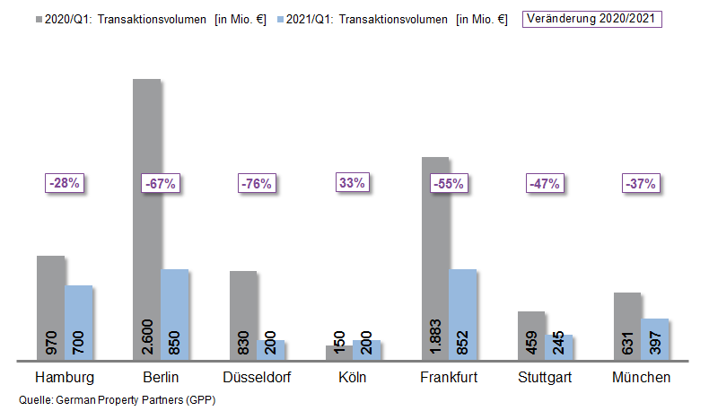
08 April 2021, Hamburg. Following the strong rally at the end of 2020 it came as no surprise that in the 1st quarter of 2021 there was an enormous shortage of investment-grade commercial properties for sale in Germany’s top 7 cities. The transaction volume was thus correspondingly low and totalled €3.4bn, which translates into a year on year decrease of 54 %. Property transactions in Hamburg, Berlin, Düsseldorf, Cologne, Frankfurt, Stuttgart and Munich thus fell well below the five-year average of €5.8bn. Cologne was the only city to post a higher trading volume; here the retail shop segment returned a comparatively high result. These findings are contained in surveys compiled by German Property Partners (GPP), the commercial real estate network formed by Grossmann & Berger, Anteon Immobilien, GREIF & CONTZEN Immobilien, blackolive and E & G Real Estate.

Lack of available products and reticence holding the market back

“It is not unusual for trading in commercial real estate located in Germany’s top 7 cities to be rather sluggish at the beginning of the year. A large number of big-ticket transactions were completed at the end of 2020; consequently, few properties are currently on the market and many new sales processes are only just starting. Due to the coronavirus pandemic, however, in several cities both investors and property vendors are still hesitant to act. At the same time, there is enormous demand for core real estate,” says GPP spokesperson Oliver Schön, putting the market figures into perspective. In the 1st quarter of 2021 the volume of transactions in Düsseldorf reached an all-time low of €200m, equivalent to a 76 % decline against the same quarter a year before. Likewise, Berlin (€850m, -67 %) and Frankfurt (€852m, -55 %) also posted over 50 % lower sales of commercial real estate to investors. Cologne was the outlier, because several sales of retail shop properties, including some large commercial buildings in the City, contributed towards growth of 33 % and a transaction volume of €200m (Q1 2020: €150m.) At three of the top 7 locations no portfolio sales were noted in the 1st quarter of 2021, with the result that portfolios comprised 15 % of the total volume of transactions, less than half their share a year before.

Prime yields on logistics properties contract further

The proportion of international investors was reduced in the majority of the top 7 cities in the 1st quarter of 2021. Whereas in the same quarter of 2020 international players bought half of the volume traded, their share dropped to a mere 14 % in the past three months. “To date, this aspect reveals the impact of the coronavirus pandemic most plainly; on the one hand international investors find it difficult to assess the national effects of the pandemic and therefore hesitate to commit funds. Additionally, travel restrictions are a hindrance when viewing real estate,” says Schön. Office properties remain attractive to investors and accordingly, with the exception of Cologne, they comprise the strongest class of asset in the first quarter of 2021. However, their share of the transaction volume has shrunk appreciably year on year in Berlin, Düsseldorf and Munich. Increased demand combined with a shortage of properties has put further pressure on yields in most of the top 7 cities. Prime yields on the sought-after industrial and logistics property assets softened by -0.24 percentage points on average compared with the 1st quarter of 2020 and now stand at 3.77 %. Cologne posted the biggest decline, dropping -0.50 percentage points from 4.10 % to 3.60 %. In some cities the prime yield on office properties also contracted. Prime yields on commercial buildings rose by 0.20 percentage points in Düsseldorf and by 0.40 percentage points in Cologne. In the other cities the prime yield settled at a low level.

FORECAST: UPSWING IN THE SECOND HALF OF THE YEAR

The current shortage of commercial properties on the investment markets in most of the top 7 cities will dictate what happens on the market in the coming months. “In some of the top 7 cities we expect to see postponed transactions involving large investment sums to be completed. Therefore greater numbers of sales agreements are likely to be notarized in the quarters ahead,” forecasts Schön. German Property Partners is expecting to see the market revive soon, especially in the second half of the year. In view of heightened demand, yields are set to remain at the current low level in many cities.

Top 10 known agreements | top 7 locations | 1st quarter of 2021
City | Project/property | Buyer/investor | Vendor: | Pur. price*  (about €m)
FRA | Ludwig-Erhard Strasse 7, Eschborn | Deutsche Gesellschaft für Internationale Zusammenarbeit (Fed. int. aid org.) | PHOENIX Real Estate Development | 220
HAM | “Hamburg Süd-Haus”, Willy-Brand-Strasse 59-63 | Union Investment. | Dr. August Oetker Nahrungsmittel | > 150
FRA | “Cielo” (50 % holding), Theodor-Heuss-Allee 100-104 | DEMIRE Deutsche Mittelstand Real Estate | RFR Gruppe | 138
FRA | “Rocco Forte/Villa Kennedy”, Kennedyallee 70 | Conren Land Management | GEG German Estate Group | 95
HAM | “Campus Stapelwerk”,  Meiendorfer Strasse 205 | Warburg-HIH Invest | AURELIUS Equity Opportunities | 76
STG | “Zuckerle Areal”, Hofener Strasse | Quarterback Immobilien | Whitecrow Holding | 75
HAM | “Krohnstieg Centre”, Krohnstieg 41-43 | Hahn Immobilien Beteiligung | HBB Hanseatische Betreuungs- und Beteiligungsgesellschaft | 65
HAM | “D10 Domkontor”, Domstraße 10 | Caleus Capital Investors | Savills Investment Management | 64
MUC | “Bogner Zentrale”,  St.-Veit-Strasse 4 | UBM | Bogner | 55
BER | “Alte Post”, Karl-Marx-Strasse 97-99 | Ivanhoé Cambridge | Commodus Real Estate | Confiden-tial
Source: German Property Partners (GPP)

Top 7 cities | 1st quarter of 2021
 | HAM | BER | DUS | CGN | FFM | STU | MUC | Top 7
Transaction volume  In €m | 700 | 850 | 200 | 200 | 852 | 245 | 397 | 3,444
Change  against prior yr in % | -28 | -67 | -76 | +33 | -55 | -47 | -37 | -54
Prime yield*, offices  in % | 2.70 | 2.70 | 2.90 | 3.00 | 2.90 | 2.95 | 2.75 | 2.84
against prior yr in percentage points | -0.10 | 0.00 | -0.10 | 0.00 | -0.05 | -0.15 | +0.15 | -0.04
Prime yield*, logistics in % | 3.90 | 3.75 | 3.75 | 3.60 | 3.80 | 4.20 | 3.40 | 3.77
against prior yr in percentage points | -0.30 | -0.05 | -0.25 | -0.50 | -0.10 | -0.30 | -0.20 | -0.24
Strongest  Asset class | Offices | Offices | Offices | Retail | Offices | Offices | Offices | -
Strongest  asset class in % | 60 | 45 | 43 | 45 | 74 | 51 | 43 | -
* Net initial yield; Source: German Property Partners (GPP)

ABOUT GERMAN PROPERTY PARTNERS
German Property Partners is a national network of property service providers; they are all leaders in their local markets. Membership now consists of Grossmann & Berger, Anteon Immobilien, GREIF & CONTZEN Immobilien, blackolive and E & G Real Estate. The network is remarkable for the members’ intimate knowledge of local markets, the experience of the partner firms’ long-standing property consultants and the personal dedication of the owners and directors. In Germany’s top 7 cities - Hamburg, Berlin, Düsseldorf, Cologne | Bonn, Frankfurt, Stuttgart and Munich - network partners have their own offices offering services in the field of property investment, commercial letting, corporate real estate management (CREM), property valuation and research. Rounding off the range of skills are banking, finance and administration services. Currently, more than 430 property specialists work for the network. Nationwide, German Property Partners brokered lets in 2020 involving 462,800 m² of commercial property, and managed investment transactions totalling €2.45bn.

