TOP 7 OFFICE MARKETS Q2/2021
PRESS CONTACT
Berit Friedrich
Telephone: +49 (0)40 / 350 80 2-620
E-Mail: presse@germanpropertypartners.de
PRESS RELEASE
MARKET CONTINUES TO SEND MIXED MESSAGES
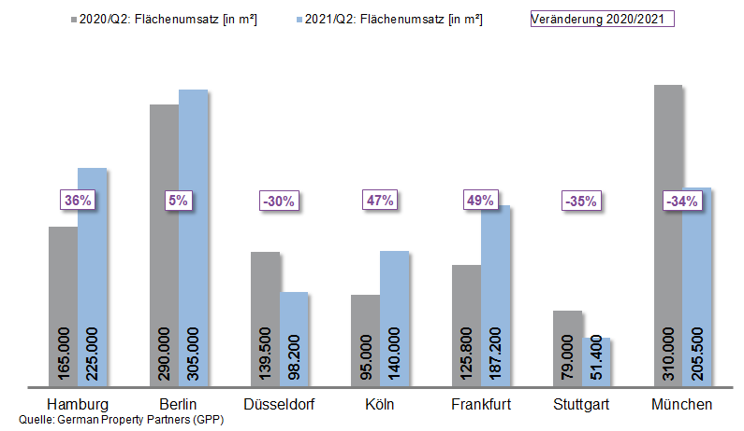

05 July 2021, Hamburg. Overall, in the 2nd quarter of 2021 take-up of office space in Germany’s top 7 cities remained largely unchanged year on year. In Hamburg, Berlin, Düsseldorf, Cologne, Frankfurt, Stuttgart and Munich some 1.21m square metres of office space was taken up, 1 % more than in the same period a year ago. “The market for office space in the top 7 cities still bears the scars of the coronavirus pandemic. Corporate reluctance to move to new premises is keeping the volume of new lets well below the average level,” remarks Oliver Schön, spokesperson for German Property Partners (GPP). Partner firms in the GPP commercial property network are Grossmann & Berger, Anteon Immobilien, GREIF & CONTZEN Immobilien, blackolive and E & G Real Estate.

FRESH ACTIVITY IN SOME OFFICE MARKETS

In the 2nd quarter of the year the pace of office letting in the top 7 markets continued to diverge considerably. Markets in Cologne and Frankfurt gathered fresh momentum and in each city take-up of space grew by about 50 %. There was also more movement on the Hamburg office market, where growth of 36 % in the first half of 2021 was primarily due to a strong start to the year. In Berlin the public sector was behind a respectable 5 % increase in take-up. By contrast, companies in Düsseldorf, Stuttgart and Munich hesitated to sign new leases and these office-letting markets dropped by -30 %, -35 % and -34 % respectively. “Düsseldorf posted no rental agreements for over 5,000 square metres for the second consecutive quarter; in Stuttgart the automotive industry generated no significant take-up and the public sector is also seeking appreciably less office space at present. In Munich a few isolated agreements for large premises were not yet sufficient to offset the overall decline on the market,” adds Schön.

HIGHER NUMBER OF COMPLETIONS AND SUB-LET SPACE

As expected, the amount of office space in all of Germany’s top 7 cities that is available at short notice grew during the first two quarters of 2021, on average by 1.1 %. The highest vacancy rate was reported in Frankfurt at 8.5 %. Since the outbreak of the coronavirus pandemic the amount of empty space in this centre of the financial industry has risen appreciably, especially in the peripheral locations. Taking the increase in sub-let space into account, Düsseldorf posted the second-highest vacancy rate in the 1st half of 2021 - 7.4 %. Empty space in Berlin rose by 1.2 % due to the high volume of new-builds adding 1.2m square metres to the market in 2021/2022. A similarly large volume of completions was last seen in 1997.

“Year on year most cities report that the volume of sub-let space has grown. It could well be that some firms will rethink their space requirements if more people continue to work from home, thus adding to the vacancy rates in some places. In addition, some locations are seeing a higher rate of building completions”, remarks Schön. However, rental rates have seen little change. In most major cities premium and average rents moved very slightly up or down during the 1st half of 2021. The cathedral city of Cologne was an exception, where the average rent rose by 15 % year on year to € 17.30/m²/month. This development owes much to several agreements for large office suites signed by the public sector and leases for higher-priced office space.

OVERALL, CAUTION PREVAILS ON THE LETTING MARKET

In most of the top 7 cities, the office-letting business is likely to revive in the second half of the year. The most dynamic market will probably be Cologne, where take-up of space is expected to reach pre-crisis levels by the end of the year. Demand for office space will remain muted in other cities and take-up of space will probably settle at the levels it reached a year ago. German Property Partners therefore predicts that in 2021, for the second year running, take-up of office space in all top 7 cities will remain well below the 10-year average of 3.39m square metres.

Major known agreements for 10,000 m² or more | Top 7 locations | Q1-2 2021
City | Project/property | Tenant/owner-occupier | Rental area (ca. m²)
BER | “Upbeat”, Heidestrasse | DKB Bank | 34,900
BER | “New Courts”, Gerichtstrasse 48-49 | Federal Office for Consumer Protection and Food Safety (BVL) | 20,000
FFM | “Kreisler”, Baseler Straße 46-48 | Nestlé Deutschland | 20,000
CGN | confidential | confidential | 19,000
MUC | Freisinger Landstrasse | SAP SE | 18,000
MUC | Gisela-Stein-Strasse | Wacker Chemie GmbH | 17.800
CGN | Josef-Lammerting-Allee 24-34 | Federal agency | 16,200
FFM | “The Move Blue”, Gateway Gardens,  De-Saint-Exupèry-Strasse 3, 5-7 | Siemens (owner-occupier | 15,000
BER | “Shed”, Sonnenallee 221 | SRH Berlin University of Applied Sciences | 13,000
CGN | “Ovum”, Stolberger Strasse | “BIMA” for a Federal agency | 12,000
HAM | “denk.mal Hannoverscher Bahnhof”,  Am Lohsepark 67-69 | Wintershall Dea | 11,400
BER | Rohrdamm 22 | Hochschule der Bundesrentenanstalt (Fed. univ.) | 10,300
Transactions occurring in the quarter covered by this report are highlighted. Source: German Property Partners (GPP)

Top 7 cities | 1st-2nd quarters of 2021
 | HAM | BER | DUS | CGN | FFM | STU | MUC | Top 7
Take-up of space  in m² | 225,000 | 305,000 | 98,200 | 140,000 | 187,200 | 51,400 | 205,500 | 1,212,300
Change  against prior yr in % | +36 | +5 | -30 | +47 | +49 | -35 | -34 | +1
Premium rent  in €/m²/month | 31.00 | 38.50 | 28.50 | 26.00 | 45.00 | 25.00 | 39.00 | -
Average rent [€/m²/month] | 17.90 | 27.40 | 16.50 | 17.30 | 21.90 | 16.30 | 22.30 | -
Stock of office space in millions m² | 13.95 | 20.15 | 7.33 | 8.00 | 11.69 | 8.23 | 23.37 | 92.71
Vacant space incl. sub-let space [m²] | 535,100 | 510,000 | 540,000 | 260,000 | 993,500 | 256,000 | 790,000 | 3,884,600
Vacancy rate incl. sub-let space [%] | 3.8 | 2.5 | 7.4 | 3.3 | 8.5 | 3.1 | 3.4 | 4.2
Completions  2021 + 2022 in m² | 331,000 | 1,196,100 | 240,700 | 200,000 | 468,200 | 241,700 | 645,000 | 3,323,000
Pre-let ratios 2021 + 2022 in % | 74 | 49 | 65 | 55 | 52 | 74 | 62 | 58
Source: German Property Partners (GPP)

ABOUT GERMAN PROPERTY PARTNERS
German Property Partners is a national network of property service providers; they are all leaders in their local markets. Membership now consists of Grossmann & Berger, Anteon Immobilien, GREIF & CONTZEN Immobilien, blackolive and E & G Real Estate. The network is remarkable for the members’ intimate knowledge of local markets, the experience of the partner firms’ long-standing property consultants and the personal dedication of the owners and directors. In Germany’s top 7 cities - Hamburg, Berlin, Düsseldorf, Cologne | Bonn, Frankfurt, Stuttgart and Munich - network partners have their own offices offering services in the field of property investment, commercial letting, corporate real estate management (CREM), property valuation and research. Rounding off the range of skills are banking, finance and administration services. Currently, more than 410 property specialists work for the network. Nationwide, German Property Partners brokered lets in 2020 involving 462,800 m² of commercial property, and managed investment transactions totalling €2.45bn.

