TOP 7 OFFICE MARKETS Q4/2020
PRESS CONTACT
Berit Friedrich
Telephone: +49 (0)40 / 350 80 2-620
E-Mail: presse@germanpropertypartners.de
PRESS RELEASE
A ray of hope in the new year
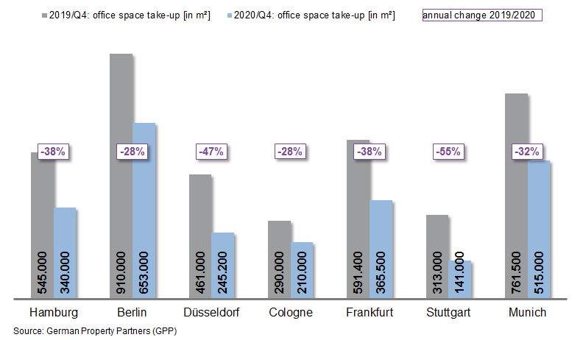

04 January 2021, Hamburg. In the 4th quarter of 2020 office-letting in Germany’s top 7 cities began to increase for the first time since the start of the pandemic. Thus the lowest quarterly decline was posted in the period between October and December with lettings down year on year by 22 %. Nevertheless the coronavirus pandemic had a huge impact on office markets, which saw business drop by more than a third in 2020. German Property Partners (GPP) recorded take-up of space in Hamburg, Berlin, Düsseldorf, Cologne, Frankfurt, Stuttgart and Munich totalling 2.47m m². That is the lowest figure since 2009. GPP membership comprises Grossmann & Berger, Anteon Immobilien, GREIF & CONTZEN Immobilien, blackolive and E & G Real Estate.

Take-up of space reflects uncertainty

“Without exception, take-up of space declined in all top 7 cities,” says GPP spokesperson Oliver Schön. The biggest slump was registered in Stuttgart where industry and the automotive sector were loath to sign large rental agreements, leading to figures 55 % below the prior year’s. Berlin and Cologne came through the last three months of the year relatively unscathed with totals down by 28 %. In the cathedral city of Cologne the office market benefited from three agreements for large amounts of new-build space which together comprised 23 % of take-up.

No rising tide of vacant space

In 2020 the coronavirus pandemic did not generate a tidal wave of tenants vacating space. The vacancy rate had risen moderately in all cities except Düsseldorf by the end of the year and now ranges between 2.1 % and 7.3 %. Accordingly, the vacancy rate across all top 7 cities increased year on year from 2.9 to 3.5 %. “Following a stretch of record low vacancy rates, supply and demand are becoming better matched than they have been for many years,” says Schön. “As no-one knows how the situation will develop, some firms are trying to save rental costs by sub-letting some of their space. However, many are postponing any definite long-term decisions about alterations, renting less space or moving to other premises. A paradigm shift in work patterns towards greater flexibility was already in motion before coronavirus hit. The pandemic is now forcing most companies to confront the issue and, as a result, question exactly what office space they need.”

In most cases the logical consequence of the coronavirus pandemic has been to halt the untrammelled growth of office rents seen over recent years. In Düsseldorf, Cologne and Frankfurt the premium rent is still high but stagnant. German Property Partners has noted low single-figure growth in the other four major cities. Changes in average rents ranged from -3 % in Düsseldorf to +9 % in Munich.

Cautious optimism about 2021

Over the next two years a total of 3.60m m² of new office space will be completed in the top 7 cities. Question marks about future business developments have already pushed the pre-let ratio down to 53 %, well below the 64 % of previous years. Whereas in some cities pre-let ratios were as high as 80 to 90 % in 2018 and 2019, in isolated cases rates had already halved by the end of 2020.

“The initial economic forecasts for the year 2021 permit cautious optimism. Industrial bosses are now far more optimistic about the future than they were in the third quarter, partly due to growth in China. However, to justify such optimism childcare must be assured, the borders kept open and supply chains maintained. Only then will confidence return to the labour and office markets of a country as dependent on exports as Germany,” says Schön. “The first quarter is usually less brisk and in view of the ongoing high rates of infection it is to be expected that the market will remain fairly quiet.”

Major known agreements for 15,000 m² or more | Top 7 locations | Q1-4 2020
City | Project/property | Tenant/owner-occupier | Rental area (ca. m²)
BER | “Cule”, An den Treptowers 3 | Deutsche Rentenversicherung Bund (state pensions) | 84,300
MUC | Lyonel-Feininger-Strasse/Anni-Albers-Strasse | Amazon | 34,000
MUC | “Optineo”, Friedenstrasse 10 | KPMG | 32,000
DUS | Neuenfelder Strasse 19 | Oberfinanzdirektion (tax & finance office) | 29,800
BER | “Gasometer”, Euref-Campus | Deutsche Bahn | 25,000
BER | Wagner-Reye-Allee | Berliner Sparkasse | 22,000
CGN | “Centraal”, Barmer Strasse | KPMG | 19,700
CGN | “QUADRA”, Lina-Bommer-Weg 9-11 | AOK Rheinland / Hamburg (health insurance) | 18,000
FFM | “Eschborn Gate”, Alfred-Herrhausen-Allee 1-5, Frankfurter Strasse 2-8, Eschborn | Samsung | 17,600
FFM | “MC 30”, Marie-Curie-Strasse 30 | LBIH | 17,000
FFM | “Four T1”, Grosse Gallusstrasse 10-14 | DekaBank. | 16,000
BER | Heilbronner Strasse 16 | Deutsche Rentenversicherung Bund (state pensions) | 15,600
Transactions occurring in the quarter covered by this report are highlighted. Source: German Property Partners (GPP)

Top 7 cities | 1st-4th quarters of 2020
 | HAM | BER | DUS | CGN | FFM | STU | MUC | Top 7
Take-up of space  in m² | 340,000 | 653,000 | 245,200 | 210,000 | 365,500 | 141,000 | 515,000 | 2,469,700
Change  against prior yr in % | -38 | -28 | -47 | -28 | -39 | -55 | -32 | -36
Premium rent  in €/m²/month | 30.50 | 39.50 | 28.50 | 26.00 | 45.00 | 25.50 | 38.50 | -
Average rent [€/m²/month] | 17.50 | 28.60 | 16.10 | 16.50 | 21.90 | 16.40 | 22.30 | -
Stock of office space in millions m² | 13.92 | 20.15 | 7.30 | 8.00 | 11.52 | 8.07 | 23.33 | 92.29
Vacancies  in m² | 468,000 | 420,000 | 504,600 | 230,000 | 845,400 | 249,000 | 530,000 | 3,265,000
Vacancy rate  in % | 3.5 | 2.1 | 6.9 | 2.9 | 7.3 | 3.1 | 2.3 | 3.5
Completions  2020 + 2021 in m² | 378,000 | 1,162,400 | 313,000 | 200,000 | 580,400 | 289,900 | 645,000 | 3,569,000
Pre-letting ratios 2020 + 2021 in % | 61 | 48 | 59 | 50 | 44 | 59 | 62 | 53
Source: German Property Partners (GPP)

ABOUT GERMAN PROPERTY PARTNERS
German Property Partners is a national network of property service providers; they are all leaders in their local markets. Membership now consists of Grossmann & Berger, Anteon Immobilien, GREIF & CONTZEN Immobilien, blackolive and E & G Real Estate. The network is remarkable for the members’ intimate knowledge of local markets, the experience of the partner firms’ long-standing property consultants and the personal dedication of the owners and directors. In Germany’s top 7 cities - Hamburg, Berlin, Düsseldorf, Cologne | Bonn, Frankfurt, Stuttgart and Munich - network partners have their own offices offering services in the field of property investment, commercial letting, corporate real estate management (CREM), property valuation and research. Rounding off the range of skills are banking, finance and administration services. Currently, more than 430 property specialists work for the network. Nationwide, German Property Partners brokered lets in 2019 involving 452,800 m² of commercial property, and managed investment transactions totalling €2.14bn.

