TOP 7 OFFICE MARKETS Q3/2020
PRESS CONTACT
Ms Corinna Fühner
Telephone: +49 (0)40 / 350 80 2-588
E-Mail: presse@germanpropertypartners.de
PRESS RELEASE
OFFICE LETS STILL SUFFERING FROM AFTERMATH OF LOCKDOWN
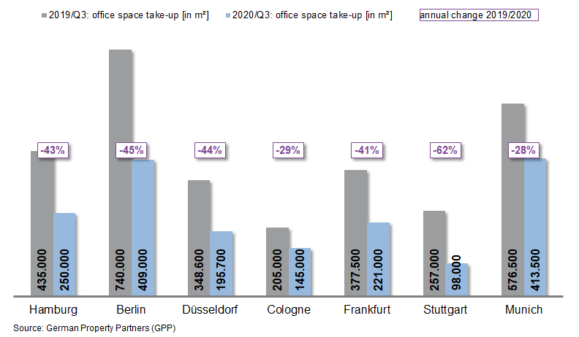
1st October 2020, Hamburg. The office-letting market is still in the grips of the coronavirus pandemic. Year on year, take-up of office space in Germany’s top 7 property markets in both the 1st (-25 %) and the 2nd quarters (-35 %) was already appreciably lower, and by the end of the 3rd quarter of 2020 it was down by 41 %. Take-up in Hamburg, Berlin, Düsseldorf, Cologne, Frankfurt, Stuttgart and Munich totalled 1.73m square metres. This is based on the latest figures compiled by German Property Partners (GPP).

Revived activity is not yet leading to rental agreements

Slowly, the market started to revive in the 3rd quarter, although greater activity has not yet translated into greater take-up. In many cases the rental process is subject to delays. All seven cities posted a considerable decline in take-up of space. Oliver Schön, spokesman for German Property Partners (GPP) says, “At present, many firms are very worried about the future. Company bosses in the industrial and technical sectors are especially likely to postpone rental decisions or are thinking about reducing their office space.”
LOW VACANCY RATES AND STAGNATING RENTS

To date, the pandemic has not made much difference to the amount of space standing empty. The vacancy rate in the top 7 markets was 3.2 %, slightly higher than the prior year’s 3.0 %. Only Düsseldorf posted a declining rate, from 7.3 to 6.8 %. GPP spokesman Oliver Schön comments, “It remains to be seen whether vacancies will rise in the coming months. In many places it will depend on what effects, if any, the pandemic has on various sectors of the economy. Companies with many employees able to work from home, or those more badly hit by the pandemic, are now more inclined to consider reducing their office space. This will continue to be an issue in coming months. Having recently reached an all-time low, the vacancy rate will rise and thus offer more options to potential tenants.”

As a result of several 1st-quarter agreements to rent large office suites in expensive properties or off-plan in new builds, office rents remain very high. With few exceptions, premium and average rents in the top 7 cities were in fact higher than in the same period of 2019. However, if the 3rd quarter of 2020 is compared with the first two quarters of the year, it is apparent that in all the cities premium and average rents are practically stagnant.

Forecast: Sluggish demand with take-up at all-time low

For 2020 and 2021 GPP estimates that 250 developments will deliver 3.22m m² of new office space. In view of how the coronavirus pandemic is affecting certain sectors of the economy, take-up of office space this year will be far below previous levels. Oliver Schön remarks, “We expect take-up of space in the top 7 cities to total some 2.5 million square metres by the end of the year. This is the second-lowest figure since the financial crisis of 2009. Demand for office space will continue to be slow during the next few months.”

Major known agreements for 10,000 m² or more | Top 7 locations | Q1-3 2020
City | Project/property | Tenant/owner-occupier | Rental area (ca. m²)
BER | “Cule”, An den Treptowers 3 | Deutsche Rentenversicherung Bund (state pensions) | 84,300
MUC | Lyonel-Feininger-Strasse/Anni-Albers-Strasse | Amazon | 34,000
MUC | “Optineo”, Friedenstrasse 10 | KPMG | 32,000
DUS | Neuenfelder Strasse 19 | Oberfinanzdirektion (tax & finance office) | 29,810
CGN | “QUADRA”, Lina-Bommer-Weg 9-11 | AOK Rheinland / Hamburg (health insurance) | 18,000
FFM | “Omniturm”, Grosse Gallusstrasse 10-14 | DekaBank. | 16,000
FFM | “Omniturm”, Grosse Gallusstrasse 10-14 | Freshfields Bruckhaus Deringer | 14,595
STU | Neuenfelder Strasse 98 | Bundesanstalt für Post & Telekommunikation (Fed. post & telecom) | 14,545
BER | “BHQ Z”, Valeska-Gert-Straße 4 | Zalando | 12,900
BER | “Pulse”, Stresemannstrasse 69-71 | Zukunft-Umwelt-Gesellschaft (ZUG) | 12,000
Transactions occurring in the quarter covered by this report are highlighted. Source: German Property Partners (GPP)

Top 7 cities | 1st-3rd quarters of 2020
 | HAM | BER | DUS | CGN | FFM | STU | MUC | Top 7
Take-up of space  in m² | 250,000 | 409,000 | 195,700 | 145,000 | 221,000 | 98,000 | 413,500 | 1,732,200
Change  against prior yr in % | -43 | -45 | -44 | -29 | -41 | -62 | -28 | -41
Premium rent  in €/m²/month | 30.50 | 39.00 | 28.50 | 26.00 | 45.00 | 25.50 | 38.50 | -
Average rent [€/m²/month] | 17.30 | 29.00 | 16.85 | 15.00 | 21.60 | 16.40 | 22.50 | -
Stock of office space in millions m² | 13.87 | 19.82 | 7.24 | 7.92 | 11.59 | 8.08 | 23.30 | 91.82
Vacancies  in m² | 463,500 | 290,000 | 489,400 | 210,000 | 881,600 | 166,000 | 420,000 | 2,920,500
Vacancy rate  in % | 3.3 | 1.5 | 6.8 | 2.7 | 7.6 | 2.1 | 1.8 | 3.2
Completions  2020 + 2021 in m² | 261,000 | 999,500 | 282,000 | 150,000 | 516,400 | 310,900 | 700,000 | 3,220,000
Pre-letting ratios 2020 + 2021 in % | 80 | 63 | 80 | 73 | 63 | 78 | 70 | 69
Source: German Property Partners (GPP)

ABOUT GERMAN PROPERTY PARTNERS
German Property Partners is a national network of property service providers; they are all leaders in their local markets. Membership now consists of Grossmann & Berger, Anteon Immobilien, GREIF & CONTZEN Immobilien, blackolive and E & G Real Estate . The network is remarkable for the members’ intimate knowledge of local markets, the experience of the partner firms’ long-standing property consultants and the personal dedication of the owners and directors. In Germany’s top 7 cities - Hamburg, Berlin, Düsseldorf, Cologne | Bonn, Frankfurt, Stuttgart and Munich - network partners have their own offices offering services in the field of property investment, commercial letting, corporate real estate management (CREM), property valuation and research. Rounding off the range of skills are banking, finance and administration services. Currently, more than 430 property specialists work for the network. Nationwide, German Property Partners brokered lets in 2019 involving 452,800 m² of commercial property, and managed investment transactions totalling €2.14bn.

