TOP 7 OFFICE MARKETS Q1/2021
PRESS CONTACT
Berit Friedrich
Telephone: +49 (0)40 / 350 80 2-620
E-Mail: presse@germanpropertypartners.de
PRESS RELEASE
BETWEEN BOOM AND BUST
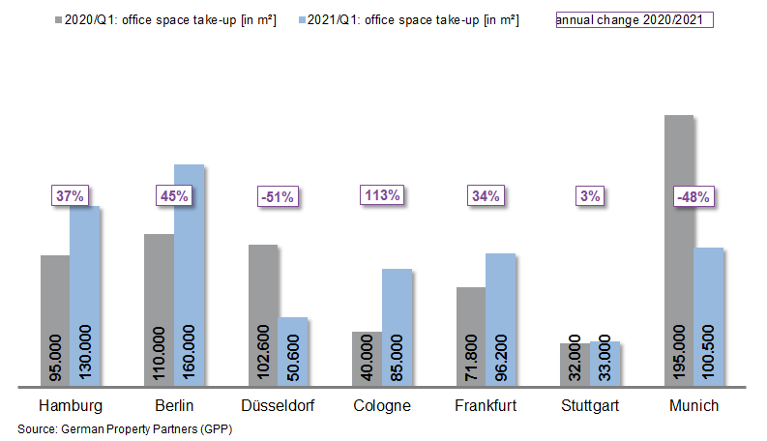
07 April 2021, Hamburg. At the close of the 1st quarter of 2021, despite the many uncertainties, take-up of office space in Germany’s top 7 cities remained stable, posting year on year growth of 1 %. A total of 655,300 m² of office space was taken in Hamburg, Berlin, Düsseldorf, Cologne, Frankfurt, Stuttgart and Munich. “It would seem that following the boom years between 2016 and 2019 take-up of office space in the top 7 cities is now settling at a low level,” says Oliver Schön spokesperson for German Property Partners (GPP) commenting on the data collected by the partners. Partner firms in the GPP commercial property network are Grossmann & Berger, Anteon Immobilien, GREIF & CONTZEN Immobilien, blackolive and E & G Real Estate.

Vast differences in take-up figures

1st quarter take-up of space in the top 7 locations varied enormously from city to city: whereas take-up in Munich and Düsseldorf was halved, in Cologne it doubled. “In both Munich and Düsseldorf clients were particularly hesitant and are postponing decisions until the third or fourth quarter. Neither city posted a single agreement for office suites measuring more than 5,000 square metres,” adds Schön. “By contrast in Cologne three Federal agencies signed contracts for premises offering between 5,000 and 13,000 square metres of office space. Local government/public corporations were thus behind more than 40 per cent of take-up in this city on the Rhine”. The public sector was also a major driver of demand in Stuttgart (28 %) and Hamburg (18 %), although not quite to the extent seen in Cologne.

There is not a glut of space

As expected, the amount of office space available at short notice has increased in all top 7 cities. Overall the rise was moderate, ranging between +0.4 percentage points in Düsseldorf and +1.6 percentage points in Frankfurt. Compared with past history, the increase was relatively high in the financial centre Frankfurt. This was because empty space had reached an all-time low in the same period a year before and appreciably more new-build space came onto the market in 2020. Frankfurt thus posted the highest vacancy rate at 8.3 %. Within the space of one year the vacancy rate across all top 7 cities rose from 2.9 % to 4.0 %.
“As yet it is not clear what role sub-let space will play in the further course of the year,” says Schön. In all the cities, apart from Cologne, the range of variation in average and premium rents is already far narrower than in previous years. For example, letting very large amounts of space to the public sector, which is not subject to VAT, had an adverse impact on nominal rents and pushed the average rent in the cathedral city of Cologne to €17.50/m²/month. Compared with the relatively low value seen a year ago, this is equivalent to growth of 17 %.

Optimistic view of the year ahead

Despite the uncertain economic prospects the office-block building boom in the top 7 cities will continue practically unabated this year and in 2022. The volume of completions in the top 7 cities totals 3.36 million m² in 2021 and 2022. 57 % of the space has already been let off-plan, a year on year increase of four percentage points. “The cautious optimism at the end of last year was justified. Instead of being subject to a dominant overall trend on the market, the cities are developing in very different ways, depending on their industrial mix and sub-markets. At present some clients are seeking large amounts of space and some firms are waiting until they know how they stand on the market. Due to upheavals in the way people work, it is likely that the overall take-up of space in the top 7 cities will fall well below pre-2019 levels”, forecasts Schön.

Major known agreements for 5,000 m² or more | Top 7 locations | 1st quarter 2021
City | Project/property | Tenant/owner-occupier | Rental area (ca. m²)
BER | “Upbeat”, Heidestrasse | DKB Bank | 34,850
FFM | “The Move Blue”, Gateway Gardens,  De-Saint-Exupèry-Strasse 3, 5-7 | Siemens (owner-occupier | 15,000
CGN | Josef-Lammerting-Allee 24-34 | Federal agency | 13,000
BER | “Shed”, Sonnenallee 221 | SRH Berlin University of Applied Sciences | 13,000
CGN | “Ovum”, Stolberger Strasse | “BIMA” for a Federal agency | 12,000
HAM | “denk.mal Hannoverscher Bahnhof”,  Am Lohsepark 67-69 | Wintershall Dea | 11,350
BER | Rohrdamm 22 | Hochschule der Bundesrentenanstalt (Fed. univ.) | 10,315
HAM | “Oval Office”, Überseering 10 | Deutsche Bank | 9,600
FFM | “Palazzo Fiorentino”, Gerbermühlstrasse 3-5 | Municipal unit | 7,600
FFM | Solmsstrasse 16-22 | Mainova | 6,900
CGN | Edmund-Rumpler-Strasse 6 | Federal agency | 5,000
Source: German Property Partners (GPP)
Top 7 cities | 1st quarter of 2021
 | HAM | BER | DUS | CGN | FFM | STU | MUC | Top 7
Take-up of space  in m² | 130,000 | 160,000 | 50,600 | 85,000 | 96,200 | 33,000 | 100,500 | 655,300
Change  against prior yr in % | +37 | +45 | -51 | +113 | +34 | +3 | -48 | +1
Premium rent  in €/m²/month | 31.00 | 39.00 | 28.50 | 26.00 | 45.00 | 25.00 | 38.25 | -
Average rent [€/m²/month] | 17.90 | 28.00 | 16.90 | 17.50 | 21.10 | 16.40 | 21.40 | -
Stock of office space in millions m² | 13.95 | 20.15 | 7.30 | 8.00 | 11.64 | 8.17 | 23.33 | 92.54
Vacant space incl. sub-let space [m²] | 524,100 | 470,000 | 536,000 | 235,000 | 967,200 | 249,400 | 740,000 | 3,721,700
Vacancy rate incl. sub-let space [%] | 3.8 | 2.3 | 7.3 | 2.9 | 8.3 | 3.1 | 3.2 | 4.0
Completions  2021 + 2022 in m² | 333,000 | 1,221,000 | 234,000 | 200,000 | 487,700 | 236,000 | 645,000 | 3,357,000
Pre-letting ratios 2021 + 2022 in % | 70 | 48 | 68 | 50 | 52 | 73 | 62 | 57
Source: German Property Partners (GPP)

ABOUT GERMAN PROPERTY PARTNERS
German Property Partners is a national network of property service providers; they are all leaders in their local markets. Membership now consists of Grossmann & Berger, Anteon Immobilien, GREIF & CONTZEN Immobilien, blackolive and E & G Real Estate. The network is remarkable for the members’ intimate knowledge of local markets, the experience of the partner firms’ long-standing property consultants and the personal dedication of the owners and directors. In Germany’s top 7 cities - Hamburg, Berlin, Düsseldorf, Cologne | Bonn, Frankfurt, Stuttgart and Munich - network partners have their own offices offering services in the field of property investment, commercial letting, corporate real estate management (CREM), property valuation and research. Rounding off the range of skills are banking, finance and administration services. Currently, more than 410 property specialists work for the network. Nationwide, German Property Partners brokered lets in 2020 involving 462,800 m² of commercial property, and managed investment transactions totalling €2.45bn.

