Berlin: Investment market, 1st quarter of 2021
Slow start to the year with less activity on the market

Berlin, 15 April 2021 - As had been expected, in the first three months of 2021 the volume of trading in commercial property investments in Berlin did not reach the record height seen in the same period a year before. Trades of €850m translated into 67 % lower turnover year on year (€2.6bn). A similarly low level was last posted in 2018. “Generally speaking, it is not unusual for Berlin if the investment market is rather slow at the start of the year. The all-time high volumes of transactions in the first quarters of 2019 and 2020 are actually the exceptions. We do not expect talks on larger transactions to start until the second and third quarters of 2021,” says Holger Michaelis, managing director of Grossmann & Berger, a member of German Property Partners (GPP). “Some investors, in particular buyers from abroad, remain reticent in view of the ongoing pandemic. This, together with an acute shortage of real estate is tending to hold the market back at present,” Michaelis adds.

Market details:
- Accounting for 41 % of total trading, office properties remain the primary asset class, although far less dominant year on year (68 %).
- With 31 % of the market, the price category €100m or more was slightly ahead of less expensive trades.
- Developers (26 %) and specialist funds (25 %) were the biggest groups of buyers. Whereas a year before, listed property investment AGs/REITs were predominant among sellers (65 %), their share shrank to 3 % in the 1st quarter of 2021. Private investors moved into the vacant slot with 34 % of total trading.
- At present, it is almost impossible for foreign investors to view properties due to Covid-19 travel restrictions and their share of the volume traded has thus plummeted to 22 % (Q1/2020: 87 %).
- Prime yields on offices (2.7 %) and commercial buildings (2.8 %) remained unchanged year on year. The prime yield on logistics real estate fell by 0.05 percentage points to 3.75 %.
Investment market | Berlin | 2021 | Q1
Transaction volume [€ millions] | 850
against prior yr [%] | -67
Share of trading in CBD [%] | 9
Proportion of international investors [%] | 32
Prime net yield, office [%] | 2.70
against prior yr [percentage points] | ±0.00
Prime net yield, commercial buildings [%] | 2.80
against prior yr [percentage points] | ±0.00
Prime net yield, logistics properties [%] | 3.75
against prior yr [percentage points] | -0.05
Strongest asset class | Offices
Strongest asset class [%] | 45
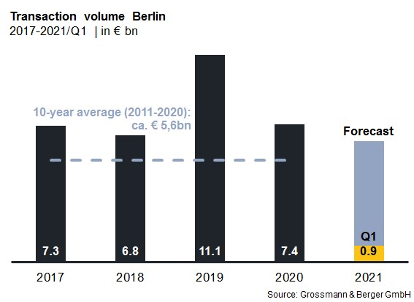

Selected top transactions | investments in Berlin | 1st quarter of 2021
Project/property  Street no. | Sub-market | Asset class | Buyer/investor | Vendor: | Purchase price*  [approx. €m]
“Alte Post”,  Karl-Marx-Strasse 97-99 | Periphery south | Industry/ commerce | Ivanhoé Cambridge | Commodus Real Estate | confidential
Nike,  Warschauer Strasse 70a | Friedrichshain | Offices | Real I.S. for specialist fund | Patrizia Deutschland | confidential
Klarna Headquarters,  Chausseestrasse 117 | Mitte | Offices | Real I.S. for specialist fund | Patrizia Deutschland | confidential
* The purchase prices stated are based on publicly available data, where none is available an estimate is used instead

The complete office market survey Berlin will soon be available and can be downloaded from our website.

About Grossmann & Berger
Grossmann & Berger GmbH is one of the leading service providers for selling and letting commercial and residential properties in North Germany. Headquartered in Hamburg, the Company has a branch office in Berlin, a total of fourteen property shops, and some 190 employees who cover the entire North German market. With over 85 years of experience in the business, Grossmann & Berger offers a complete package of real estate expertise. Grossmann & Berger is a member of the HASPA Group of Companies, which also includes Germany's largest savings bank, Hamburger Sparkasse (Haspa). Moreover, the Company is a founding member of the nation-wide commercial property network German Property Partners (GPP) and the working group of brokers associated with banks and building societies, Arbeitsgemeinschaft ImmobilienVermittler Banken Bausparkassen e.V. (IVBB).

Please consult our website for Grossmann & Berger’s data privacy policy. Here you will also be able to access our press kit and the associated Terms of Use. If in future you would prefer not to receive any more information from our press office please e-mail us at presse@grossmann-berger.de quoting as reference "Abmeldung aus Presseverteiler” / “Unsubscribe from press mailing list”.

