Hamburg: Office letting market, 1st-2nd quarters of 2020
“People are arranging viewings again”

Hamburg, 1st July 2020 - As a result of the Corona lockdown office space lettings in Hamburg during the 1st half of 2020 were at their lowest since 2004. Figures analysed by Grossmann & Berger, a member of German Property Partners (GPP), reveal take-up during the 1st half of the year at a mere 165,000 m². However, by June moves to relax the lockdown measures had started to generate a recovery. “People are starting to view properties again. But since the full effects of the Corona pandemic are not as yet known, many potential occupants are worried,” says managing director Andreas Rehberg reviewing the current state of the market.

Market details:
- In terms of vacant space a new picture is emerging: Starting from an extremely low base, the amount of office space available at relatively short notice is growing. Accordingly, by the end of the quarter the vacancy rate had climbed to 3.3 %, which translates into some 454,000 m². Year on year the range of properties available to new tenants increased by 34,500 m².
- Greater choice means that property owners will face real competition once more. Rents will therefore remain stable at their current levels. Thus, in the months to come, tenants will probably find that they are offered more generous incentive packages than in the recent past.
- Despite this, the average rent in the 1st half year of 2020 was €17.60/m²/month, or 2.9 % higher than in the same quarter of 2019, while the premium rent rose by 8.9 % to a new high of €30.50/m²/month.

Office market | Hamburg | 2020 | Q1 -2
Space take-up [m²] | 165,000
against prior yr [%] | -46.8
Premium rent [€/m²/month net of services] | 30.50
against prior yr [%] | +8.9
Average rent [€/m²/month net of services] | 17.60
against prior yr [%] | +2.9
Stock of office space [millions m²] | 13.9
Vacant space [m²] | 454,000
against prior yr [%] | +8.2
Vacancy rate incl. sub-let space [%] | 3.3
Completions 2020+2021 [m²] | 310,000
Pre-let ratio [%] | 75
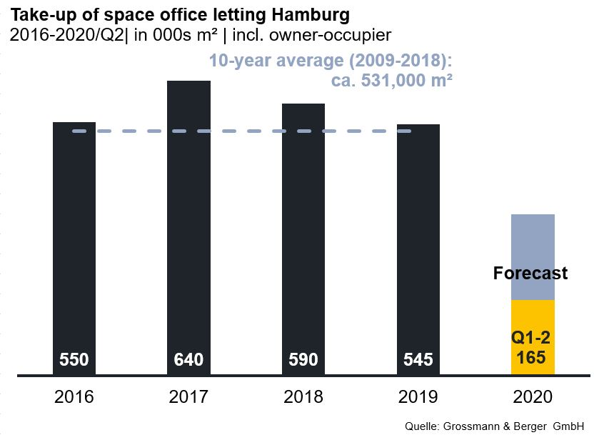

Selected agreements | offices in Hamburg | 1st and 2nd quarters of 2020
Tenant/owner-occupier | Property/project | Street no. | Sub-market | Rental area  [ca. m²]
Hansainvest Hanseatische Investment | “Oval Office” | Überseering 10 | City North | 6,000
Wärtsilä SAM Electronics |  | Behringstrasse 120 | Altona | 5,900
MSH Medical School Hamburg | “HafenCity Gate” | Am Sandtorkai 74-77 | HafenCity | 5,800
Wärtsilä SAM Electronics |  | Gasstrasse 18 | Bahrenfeld | 5,700
officepointONE | “Speicher N26” | Am Sandtorkai 26 | HafenCity | 4,300

New transactions or those occurring in the quarter covered by this report, are highlighted

The complete market survey will soon be available and can be downloaded from our website.

About Grossmann & Berger
Grossmann & Berger GmbH is one of the leading service providers for selling and letting commercial and residential properties in North Germany. Headquartered in Hamburg, the Company has a branch office in Berlin, a total of fourteen property shops, and over 190 employees who cover the entire North German market. With over 85 years of experience in the business, Grossmann & Berger offers a complete package of real estate expertise.

Grossmann & Berger is a member of the HASPA Group of Companies, which also includes Germany's largest savings bank, Hamburger Sparkasse (Haspa). Moreover the Company is a founding member of the nation-wide commercial property network German Property Partners (GPP) and the working group of brokers associated with banks and building societies, Arbeitsgemeinschaft ImmobilienVermittler Banken Bausparkassen e.V. (IVBB).

Please consult our website for Grossmann & Berger’s data privacy policy. Here you will also be able to access our press kit and the associated Terms of Use. If in future you would prefer not to receive any more information from our press office, please e-mail us at presse@grossmann-berger.de quoting as reference "Abmeldung aus Presseverteiler” / “Unsubscribe from press mailing list”.

