TOP 7 OFFICE MARKETS Q2/2022
Pent-up demand and new work environment boost office market

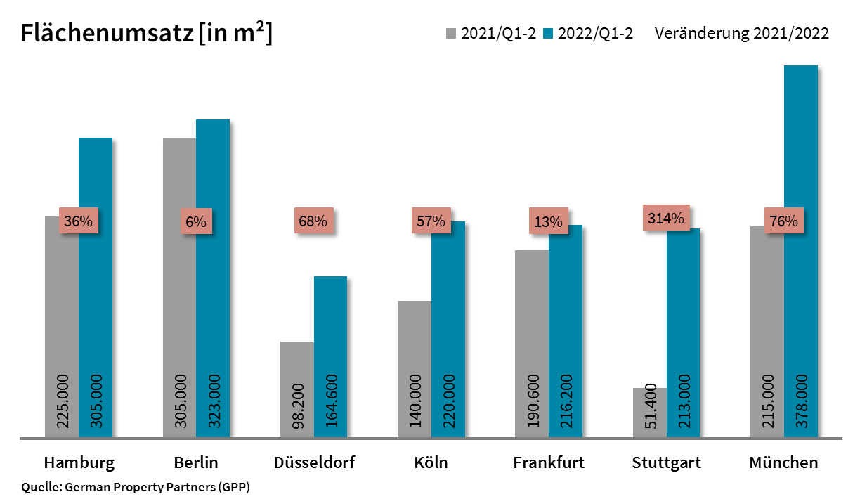

2022-07-04, Hamburg. During the 1st half of 2022 the market for office space in Germany’s top 7 cities owed much to the public sector, IT companies and the providers of financial services. During this period 1.82m m² of office space was let or absorbed by owner-occupiers. Year on year, take-up of space shot up by 49 % to record the best ever result since 2019, when the total was 1.85m m². “To date, demand for space in most cities has more than compensated for adverse market conditions such as inflation, rising interest rates, sky-rocketing construction costs and disrupted supply chains. Partly, this is because new working environments have been created and partly because talks about office space that were postponed due to Covid 19 were recommenced and agreements signed,” says Andreas Rehberg, spokesperson for German Property partners (GPP). This commercial property network consists of Grossmann & Berger, Anteon Immobilien, GREIF & CONTZEN Immobilien, blackolive and E & G Real Estate. Since four of the 14 agreements for more than 10,000 m² of space were concluded by owner-occupiers, their share of the market rose year on year from 5 to 13 %.

Stuttgart and Cologne post highest numbers of large-volume agreements
Take-up grew in all top 7 cities, although at enormously varying rates. Stuttgart returned a new record result, with growth of 314 % and has already surged far past the full-year figures posted for 2020 and 2021. Owner-occupiers were behind almost half of the 213,000 m² of take-up; this total included 65,000 m² for the insurance company Allianz, the biggest agreement signed in any top 7 city so far this year. In Cologne, where take-up of 220,000 m² represented the fourth-highest increase (+57 %) in the top 7, the noteworthy aspect of the result was that exactly half was take-up by the public sector. The two biggest agreements signed in the cathedral city of Cologne since 2016 added more than 80,000 m² to the total. Likewise in Berlin and Düsseldorf the public sector was very active. Stuttgart and Cologne each reported three agreements for more than 15,000 m² of space – they were thus uncharacteristically propelled to the top of the list of the year’s biggest-volume contracts in the top 7 cities. Berlin, Hamburg and Frankfurt each posted only one agreement for over 25,000 m² of space.

New builds fuel rental rates
Without exception, both average and premium rents in the top 7 cities rose in the first half of 2022. Year on the year the premium rent increased most in Stuttgart, climbing by +18 % to €29.40/m²/month. At €32.50/m²/month, premium rents in Hamburg reached a new high. And the highest increase in average rents was noted here too, with 15 % growth pushing the rate above the 20-euro mark for the first time, to €20.60/m²/month. As Rehberg explains, “18 of the 24 rental agreements for more than 2,000 square metres of space were signed at rates of over 20 euros per square metre.” In Berlin the average monthly rent broke the €30/m² barrier for the first time. “At the moment top quality space of new-build quality is especially sought-after. Firms are even more attracted if such premises are centrally sited and address ESG issues. Indeed, companies are prepared to pay for better offices so that it is easier to recruit staff,” remarks Rehberg. Office rents could well rise further in response to the enormous increases in construction costs. In the longer term, however, the growth of rental rates will probably slow in view of uncertainties about future developments.

empty space Generally at a healthy level
At the end of the 1st half year the vacancy rate in the top 7 cities was 4.8 % compared with 4.2 % a year before. Only in Cologne was there still a two before the decimal point (2.7 %). Year on year the vacancy rate in Cologne, Frankfurt and Hamburg fell from its level at the end of June 2021. At the end of the 1st half year, German Property Partners’ figures show total building completion volumes for 2022 and 2023 at 3.57m square metres. To date 59 % of this total has been pre-let.

Major known agreements for 10,000 m² or more | Top 7 locations | Q1-2 2022
City | Project/property | Tenant/owner-occupier | Rental area (ca. m²)
STU | “Allianz Park”, Hessbrühlstrasse | Allianz Owner-occupier | 65,000
CGN | Site north of the city centre | Public institution | 45,000
BER | Otto-Braun-Strasse 70-72 | BIM Owner-occupier | 40,000
CGN | Leonhard-Tietz-Strasse 1 | Cologne municipality | 38,800
HAM | “Deutschlandhaus”, Dammtorstrasse 1 | Hamburger Sparkasse | 30,800
FFM | Ludwig-Erhard Strasse 7, Eschborn | Deutsche Gesellschaft für Internationale Zusammenarbeit, giz (Fed. int. aid org.) owner occupier | 28,000
STU | “W11”, Weissacher Strasse 11 | Komm.ONE | 21,500
STU | “Atlanta Business Center”, Vaihinger Strasse 131 | Ed. Züblin owner-occupier | 21,400
MUC | “aer”, Fritz-Schäffer-Strasse 9 | Bosch Building Technologies | 20,000
DUS | “Yorcks”, Yorckstrasse 19-23 | Volkshochschule Düsseldorf (adult education centre) | 17,570
CGN | Konrad-Adenauer Strasse 25, Bahnstrasse | CBS Cologne Business School | 16,000
BER | Wagner-Régeny-Strasse 2-9 | Siemens Mobility | 16,000
DUS | “Pandion Rise”, Völklinger Strasse 2 | Ernst & Young | 14,740
HAM | “Elbbrückenquartier”, Versmannstrasse | VTG | 11,500
Transactions occurring in the quarter covered by this report are highlighted. Source: German Property Partners (GPP)

Top 7 cities | 1st-2nd quarters of 2022
 | HAM | BER | DUS | CGN | FFM | STU | MUC | Top 7
Take-up of space  in m² | 305,000 | 323,000 | 164,600 | 220,000 | 216,200 | 213,000 | 378,000 | 1,819,800
Change  against prior yr in % | +36 | +6 | +68 | +57 | +13 | +314 | +76 | +49
Premium rent  in €/m²/month | 32.50 | 41.80 | 29.00 | 27.00 | 46.20 | 29.40 | 41.00 | -
Average rent  in €/m²/month | 20.60 | 30.00 | 17.10 | 17.80 | 22.60 | 16.40 | 22.50 | -
Total stock of office space  in millions m² | 13.96 | 20.90 | 7.41 | 8.10 | 11.73 | 8.38 | 23.40 | 93.88
Vacant space incl. sub-let space [m²] | 525,500 | 870,000 | 549,000 | 215,000 | 939,600 | 322,000 | 1,125,000 | 4,546,100
Vacancy rate incl. sub-let space [%] | 3.8 | 4.2 | 7.4 | 2.7 | 8.0 | 3.8 | 4.8 | 4.8
Completions  2022 + 2023 in m² | 549,000 | 1,009,000 | 257,100 | 220,000 | 404,800 | 276,400 | 850,000 | 3,566,000
Pre-let ratios 2022 + 2023 in % | 76 | 61 | 66 | 70 | 37 | 47 | 56 | 59
Source: German Property Partners (GPP)

ABOUT GERMAN PROPERTY PARTNERS
German Property Partners is a national network of property service providers; they are all leaders in their local markets. Membership now consists of Grossmann & Berger, Anteon Immobilien, GREIF & CONTZEN Immobilien, blackolive and E & G Real Estate. The network is remarkable for the members’ intimate knowledge of local markets, the experience of the partner firms’ long-standing property consultants and the personal dedication of the owners and directors.

In Germany’s top 7 cities - Hamburg, Berlin, Düsseldorf, Cologne | Bonn, Frankfurt, Stuttgart and Munich - network partners have their own offices offering services in the field of property investment, commercial letting, corporate real estate management (CREM), property valuation and research. Rounding off the range of skills are banking, finance and administration services.

Currently, more than 420 property specialists work for the network. Nationwide, German Property Partners brokered lets in 2021 involving 640,000 m² of commercial property, and managed investment transactions totalling €2.6bn.

www.germanpropertypartners.de/en

German Property Partners’ data protection declaration is available on the GPP website: www.germanpropertypartners.de/datenschutz. If in future you would prefer not to receive any more information from the GPP press office, please e-mail us at presse@germanpropertypartners.de quoting as reference "Abmeldung aus Presseverteiler” / “Unsubscribe from press mailing list”.

