TOP-7-INVESTMENT MARKETS Q1-4/2022
Reticence instead of year-end rally

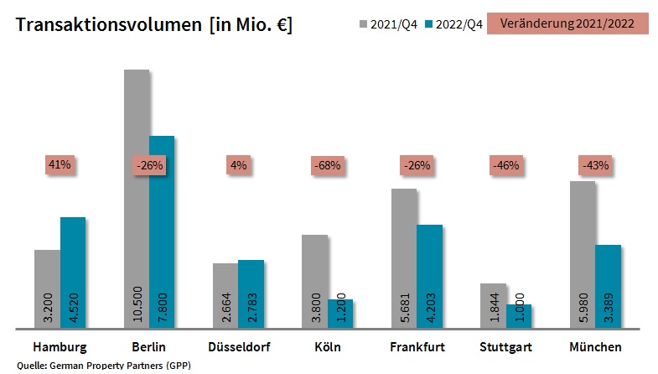
03 January 2023, Hamburg. At the close of 2022 the volume of investments in commercial properties located in Germany’s top 7 cities totalled some €24.9bn. Year on year this result represents a 26 % drop and is well below the ten-year average of €29.4bn. It is the lowest figure seen since 2014 (€21.8bn) Merely one sixth (€4.4bn) of the total volume was generated in the 4th quarter, when trading levels are usually high. These findings are contained in a survey compiled by German Property Partners (GPP), the commercial real estate network formed by Grossmann & Berger, Anteon Immobilien, GREIF & CONTZEN Immobilien, blackolive and E & G Real Estate.

Andreas Rehberg, GPP spokesman, says that, “Up to the end of the third quarter the volume of transactions in the top 7 cities was slightly higher year on year owing to some outlier trades. In particular, due to Brookfield’s take-over of the huge alstria portfolio, the year got off to a flying start that buoyed transaction volumes during the course of the year. In fact, from the second quarter onwards the market slowed appreciably due to the deteriorating business environment. Now, at the close of the year, the decline can no longer be hidden.”

VOLUME OF TRANSACTIONS: IN HAMBURG and Düsseldorf outlier trades predominate
When interest rates leapt up, many investors paused active trading and adopted a wait-and-see attitude. “Above all when it comes to big-ticket investments, we observe considerable caution. Even though more sellers are now prepared to lower the asking price, many potential sales still founder when the parties fail to agree on price”, says Rehberg. Some properties were withdrawn from the market because there was so little competition.

Only two of the top 7 cities posted higher results than the prior year – Hamburg, up by 41 % to €4.5bn, and Düsseldorf, growth of 4 % to €2.8bn. Both in Hamburg and Düsseldorf, the capital of North Rhine-Westphalia, this result is essentially due to the 1st-quarter alstria take-over and to other take-overs and investments in development projects. The other cities fell well below their totals for 2021: Cologne (-68 % to €1.2bn), Stuttgart (-46 % to €1.0bn), Munich (-43 % to €3.4bn), Berlin (-26 % to €7.8bn) and Frankfurt (-26 % to €4.2bn). As expected, no city experienced a year-end rally, quite the opposite: looking at the 4th quarter alone, the volume of transactions was 68 % below the figure for 2021. Between October and December the trading result in Cologne dropped by 87 % and in Stuttgart by a similarly massive 85 %. Even Düsseldorf, with a higher overall year on year result, posted a very weak 4th quarter (-71 %).

Prime yields: Higher on all classes of asset
Because the base rate was increased several times during the course of the year, prime yields on every type of asset rose too. Year on year prime yields on office properties in the top 7 averaged growth of 0.59 percentage points to 3.28 %. The sharpest rise was noted in Cologne and Stuttgart, where the prime yield on offices reached 3.50 % (in each case growth of 0.8 percentage points) thus climbing to the highest level among cities in the top 7. Likewise, on industrial and logistics properties the average prime yield in the top 7 cities rose by 0.52 percentage points to 3.86 %. Frankfurt posted the steepest rise, gaining 0.7 percentage points to 3.90 %. Düsseldorf (+0.65 percentage points) and Stuttgart (+0.6 percentage points) posted an even higher yield at 4.10 %.

The proportion of international investors in the top 7 cities rose year on year by an average of 14 percentage points to 48 %. They were the biggest players in Berlin with 60 % of the market, and least in evidence in Cologne with 19 %. Portfolio sales accounted for 29 % of the volume traded, far more than in the year before (Q1-4 2021: 17 %), likewise a result of the alstria trade. In 2022, as in previous years, office properties remained the top-ranking class of asset in all 7 cities. On average, offices accounted for some 73 % of the volume traded. Building land and mixed-use properties trailed far behind, with 8 % and 7 % of the market respectively.

FORECAST: Rally in the middle of the year
GPP expects the year to start rather sluggishly. Rehberg remarks that, “If and when interest rates settle and investors have greater certainty about plans for the future, the market could rally and prices find a new level at some time in the middle of the year.” He adds that the challenging market environment does offer opportunities for some players, “In Hamburg we started to see a growing number of smaller transactions in the fourth quarter driven by investors with deep pockets who benefit from the weak competition. This trend will probably continue in 2023.” Demand is likely to focus on core properties in central locations that will retain their value well.

Top 10 known agreements | top 7 cities | 1st-4th quarters of 2022
City | Project/property | Buyer/investor | Vendor | Pur. price*  (about €m)
FFM | Marienturm, Taunusanlage 9+10 | DWS for the National Pension Service of Korea (NPS) | Aermont Capital / PWREF II fund managed by Perella Weinberg | ±800
BER | Sony Center,  Potsdamer Platz 2 | Norwegian Government Pension Fund Global | Oxford Properties/Madison International Realty for institutional investor | 677
BER | Voltair | Norwegian Government Pension Fund Global / Swiss Life | Gädeke & Sons / ABG | 457
BER | QH Spring / QH Core | Vivion Group | Aggregate Holdings | 456
HAM | Altes Fernmeldeamt,  Schlüterstrasse 51-55 | Values Real Estate | Peakside Capital | 400
MUC | Brienner Strasse 22-28 | Doblinger Unternehmensgruppe | Bayerische Landesbank | 360
MUC | Olympia Business Center (OBC), Georg-Brauchle-Ring 23-25 | Athos Family Office | Europa Capital /Bayern Projekt (joint venture) | 300
BER | Urban Tech Republic | Land Berlin Liegenschaftsfonds (real estate fund) | Bundesanstalt für Immobilienaufgaben (Federal real estate) | 261
MUC | New headquarter Wacker Chemie, Gisela-Stein-Strasse | Wacker Chemie pension fund | Patrizia AG | 250
BER | Techno Campus | Caleus Capital Partners for Singapore State Fund | AXA IM | confidential
Transactions occurring in the quarter covered by this report are highlighted. Source: German Property Partners (GPP)
Top 7 cities | 1st-4th quarters of 2022
 | HAM | BER | DUS | CGN | FFM | STU | MUC | Top 7
Transaction volume  In €m | 4,520 | 7,800 | 2,783 | 1,200 | 4,203 | 1,000 | 3,389 | 24,895
Change  against prior yr in % | 41 % | -26 % | 4 % | -68 % | -26 % | -46 % | -43 % | -26 %
Prime yield*, offices  in % | 3.10 | 3.00 | 3.40 | 3.50 | 3.35 | 3.50 | 3.10 | 3.28
against prior yr in percentage points | 0.50 | 0.40 | 0.60 | 0.80 | 0.60 | 0.80 | 0.40 | 0.59
Prime yield*, logistics in % | 3.80 | 3.50 | 4.10 | 4.00 | 3.90 | 4.10 | 3.50 | 3.86
against prior yr in percentage points | 0.30 | 0.30 | 0.65 | 0.60 | 0.70 | 0.60 | 0.40 | 0.52
Strongest  Asset class | Offices | Offices | Offices | Offices | Offices | Offices | Offices | Offices
Strongest  asset class in % | 78 % | 73 % | 71 % | 73 % | 81 % | 75 % | 59 % | 73 %
* Net initial yield; Source: German Property Partners (GPP)

ABOUT GERMAN PROPERTY PARTNERS
German Property Partners is a national network of property service providers; they are all leaders in their local markets. Membership now consists of Grossmann & Berger, Anteon Immobilien, GREIF & CONTZEN Immobilien, blackolive and E & G Real Estate. The network is remarkable for the members’ intimate knowledge of local markets, the experience of the partner firms’ long-standing property consultants and the personal dedication of the owners and directors.

In Germany’s top 7 cities - Hamburg, Berlin, Düsseldorf, Cologne | Bonn, Frankfurt, Stuttgart and Munich - network partners have their own offices offering services in the field of property investment, commercial letting, corporate real estate management (CREM), property valuation and research. Rounding off the range of skills are banking, finance and administration services.

Currently, more than 420 property specialists work for the network. Nationwide, German Property Partners brokered lets in 2021 involving 640,000 m² of commercial property, and managed investment transactions totalling €2.6bn.
www.germanpropertypartners.de

German Property Partners’ data protection declaration is available on the GPP website: www.germanpropertypartners.de/datenschutz. If in future you would prefer not to receive any more information from the GPP press office, please e-mail us at presse@germanpropertypartners.de quoting as reference "Abmeldung aus Presseverteiler” / “Unsubscribe from press mailing list”.

