TOP 7 INVESTMENT MARKETS Q4/2021
Large transactions contrasted with shortage of real estate gives good result overall
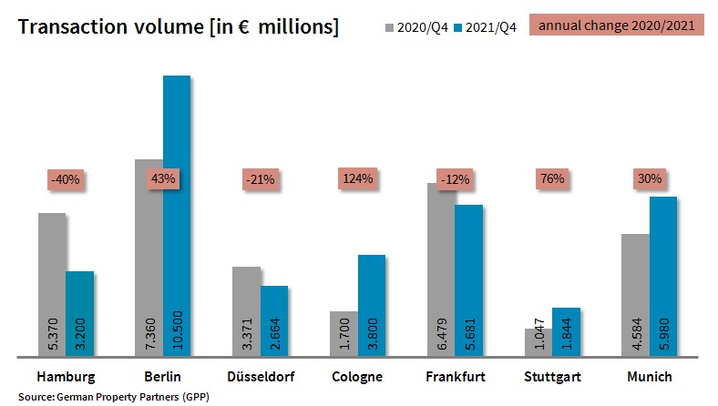

13 January 2022, Hamburg. Overall in 2021, investment in commercial properties located in Germany’s top 7 cities rose by a good 13 % compared with the first year of COVID in 2020. The total transaction volume for the year was €33.67bn. However, activity on these seven markets did vary quite considerably. “In some locations the market increasingly features very large individual transactions while the actual number of sizeable trades is trending downwards. There is unabated demand for investment-grade properties, but in many cities too little real estate is available,” remarks Andreas Rehberg, spokesperson for German Property Partners (GPP). This commercial property network consists of Grossmann & Berger, Anteon Immobilien, GREIF & CONTZEN Immobilien, blackolive and E & G Real Estate.

LARGE individual TRANSACTIONS BOOST TRADING VOLUME
The biggest rise in trading volume was seen in Cologne with growth of 124 %; the total of €3.8bn was a new record for this city on the Rhine. This superb result owed much to RFR Holding which paid some €1.1bn for the “Rheinpark-Metropole” and “Koelnmesse” properties held in the relevant Oppenheim/Esch real estate funds. Notable results were also returned in Stuttgart (+76 %) and Berlin (+43 %) as a result of some big-ticket trades. Indeed, Germany’s national capital posted its best-ever 4th quarter result. Five trades, each with a volume of over €500m, boosted Munich’s turnover by 30 %. Due to the acute shortage of available properties, trading slumped in Hamburg (-40 %) and Düsseldorf (-21 %). In Frankfurt the usual end-of-year investment rally failed to materialize so that the transaction volume fell by 12 % year on year. Taking all top 7 cities together, total portfolio purchases accounted for 30 % less than in 2020.

Office properties remain popular investments
Year on year the proportion of international investors on the market fell by 7 percentage points in 2021 to 34 %. Whereas such actors were appreciably less active in four of the top 7 cities, they played a bigger role in Berlin, Düsseldorf and Cologne. In 2021, as in previous years, office properties remained the predominant class of asset in all 7 cities. “Although work patterns are changing and new office concepts are emerging, offices are still considered a safe investment,” explains Rehberg. “Demand for hotels and shop properties remains far lower.” Reflecting the high demand for office properties, prime yields on these assets have contracted in all top 7 cities. Year on year, prime yields on office properties contracted by an average 0.16 percentage points to 2.69 %. Prime yields on office real estate softened most in Cologne, dropping 0.30 percentage points to 2.70 %. The lowest prime yield on this class of asset, 2.60 %, was noted in Hamburg and Berlin. Prime yield compression on industrial and logistics real estate was considerable, averaging a loss of 0.44 percentage points and falling to 3.39 %. Frankfurt and Stuttgart posted the highest decline at -0.60 percentage points.

Forecast: transaction total for 2022 same or lower due to shortage of real estate on the market
In view of as yet unpromising economic forecasts, it remains hard to predict how the markets for investment in commercial properties located in Germany’s top 7 cities will develop in the year ahead. “Demand for investment properties is unabated, but a lack of interesting real estate on the market will probably slow the pace of trading in many cities,” says Rehberg. Overall, GPP expects the transaction volume in 2022 to be similar to the total seen in 2021. Only in Berlin can one expect brisk trading on the market in 2022, because many properties are being offered for sale and investors have deep pockets.

Top 10 known agreements | top 7 locations | 1st-4th quarters of 2021
City | Project/property | Buyer/investor | Vendor: | Pur. price*  (about €m)
FFM | “FOUR – T1”, Grosse Gallusstrasse 10-14 | Allianz Real Estate and Bayerischer Versorgungskammer | Groß & Partner Grundstücksentwicklungs-gesellschaft | 1,400
CGN | “Rheinpark-Metropole” / “Koelnmesse” | RFR Holding | 3 Oppenheim/Esch real estate funds | 1,100 (in total)
BER | “Fürst”, Kurfürstendamm 206-209 | Aggregate Holdings | Vivion | > 1,000
MUC | “Highlight Towers”  Mies-van-der-Rohe-Strasse 6 | Imfarr + SN | Commerz Real | > 650
MUC | “Media Works”,  Rosenheimer Strasse 145a-i / Anzinger Straße 1-17 | Union Investment and Hines | Blackstone | 650
MUC | “Pandion Officehome”, Anzinger Straße 29 | Union Investment. | Pandion | 600
MUC | “O2 Tower”  Georg-Brauchle-Ring | DIC Asset | GIC | 570
FFM | “Skyper”, Taunusanlage 1 | HDI Deutschland | Allianz Real Estate | 560
MUC | “Elementum”, Bayerstrasse 49-53 | Imfarr + SN | Credit Suisse | 500
BER | “Victoriastadt Lofts”  Schreiberhauerstrasse 30 | Signa Real Estate | Schroder Properties for Illmarinen | 425
Transactions occurring in the quarter covered by this report are highlighted. Source: German Property Partners (GPP)

Top 7 cities | 1st-4th quarters of 2021
 | HAM | BER | DUS | CGN | FFM | STU | MUC | Top 7
Transaction volume  In €m | 3,200 | 10,500 | 2,664 | 3,800 | 5,681 | 1,844 | 5,980 | 33,669
Change  against prior yr in % | -40 | +43 | -21 | +124 | -12 | +76 | +30 | +13
Prime yield*, offices  in % | 2.60 | 2.60 | 2.80 | 2.70 | 2.75 | 2.70 | 2.70 | 2.69
against prior yr  in percentage points | -0.20 | -0.10 | -0.10 | -0.30 | -0.15 | -0.20 | -0.10 | -0.16
Prime yield*, logistics  in % | 3.50 | 3.40 | 3.45 | 3.50 | 3.20 | 3.60 | 3.10 | 3.39
against prior yr  in percentage points | -0.50 | -0.30 | -0.30 | -0.30 | -0.60 | -0.60 | -0.50 | -0.44
Strongest  Asset class | Offices | Offices | Offices | Offices | Offices | Offices | Offices | -
Strongest  asset class in % | 66 | 56 | 73 | 58 | 86 | 65 | 71 | -
* Net initial yield; Source: German Property Partners (GPP)

ABOUT GERMAN PROPERTY PARTNERS
German Property Partners is a national network of property service providers; they are all leaders in their local markets. Membership now consists of Grossmann & Berger, Anteon Immobilien, GREIF & CONTZEN Immobilien, blackolive and E & G Real Estate. The network is remarkable for the members’ intimate knowledge of local markets, the experience of the partner firms’ long-standing property consultants and the personal dedication of the owners and directors.

In Germany’s top 7 cities - Hamburg, Berlin, Düsseldorf, Cologne | Bonn, Frankfurt, Stuttgart and Munich - network partners have their own offices offering services in the field of property investment, commercial letting, corporate real estate management (CREM), property valuation and research. Rounding off the range of skills are banking, finance and administration services.

Currently, more than 410 property specialists work for the network. Nationwide, German Property Partners brokered lets in 2020 involving 462,800 m² of commercial property, and managed investment transactions totalling €2.45bn.

www.germanpropertypartners.de/en

German Property Partners’ data protection declaration is available on the GPP website: www.germanpropertypartners.de/en/privacy-policy. If in future you would prefer not to receive any more information from the GPP press office, please e-mail us at presse@germanpropertypartners.de quoting as reference "Abmeldung aus Presseverteiler” / “Unsubscribe from press mailing list”.

