TOP-7-INVESTMENT MARKETS Q1/2023
Weak start to the year due to ongoing process of price discovery
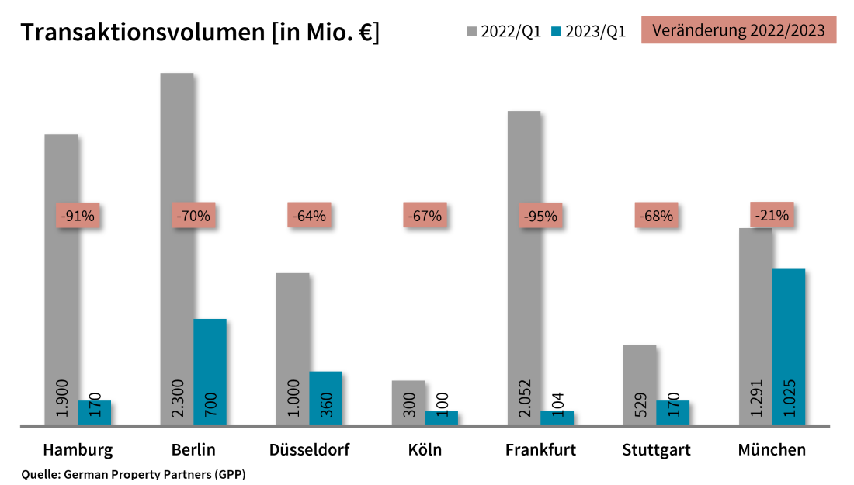

04 April 2023, Hamburg. At the close of the first quarter of 2023 the volume of investments in commercial properties located in Germany’s top 7 cities totalled some €2.6bn. This translates into a year on year decline of around 72 %. However, at the start of 2022 the take-over of alstria by Brookfield Properties propelled the transaction volume to a record high of around €9.4bn. These findings come from research conducted by German Property Partners (GPP). This commercial real estate network consists of Grossmann & Berger, Anteon Immobilien, GREIF & CONTZEN Immobilien, blackolive and E & G Real Estate.

“Nationwide, the investment market started the year very sluggishly,” says GPP spokesman Andreas Rehberg. “Investors remained hesitant due to uncertainty about how the economic environment would develop and closed appreciably fewer contracts than in the prior year – above all, large-volume transactions were scarce.”

VOLUME OF TRANSACTIONS: CONTRACTION NOTED IN ALL TOP 7 CITIES
During the first three months of the year political and economic worries continued to depress investment market activity in Germany’s top 7 cities. In view of high interest rates the most successful buyers on the market were investors with deep pockets and property developers. Investors who rely on loan capital remained waiting in the wings. “Buyers and sellers have not yet completed their process of price discovery. Investors are simply waiting for a suitable opportunity to buy, but transactions are still hampered by wide gaps between the players’ concepts of fair market prices,” remarks Rehberg.

Year on year the volume of transactions dropped in all top 7 cities. Declines were most pronounced in Frankfurt (-95 % to €104m), Hamburg (-91 % to €170m) and Berlin (-70 % to €700m). Year on year appreciable falls were also noted for Düsseldorf (-64 % to €360m), Cologne (-67 % to €100m) and Stuttgart (-68 % to €170m). Here too, developments were heavily impacted by the alstria transaction, an outlier trade that fuelled turnover volumes at the start of 2022 in every city except Munich. The Bavarian capital posted the smallest decline, dropping to around €1bn or 21 % below the same quarter a year before, whose stronger result owed nothing to an outlier trade.

Retail properties comprised the biggest share – 37 % – of the assets traded. This result was due essentially to the big-ticket sale of the “PEP Shopping Centre” in Munich and the sale of shares in the “KaDeWe” department store in Berlin. Offices accounted for some 28 % of the volume traded. Building land and mixed-use properties trailed behind, taking 16 % and 14 % of the market respectively. Accounting for 32 % of total trading in Germany’s top 7 cities, international investors were holding back. They were most active in Berlin, where they comprised 70 % of the market. Portfolio sales were rare, making up about 4 % of the total traded. This information is based on a small number of transactions, which thus limits its validity.

Yields: rising on all classes of asset
The base rate was increased several times in the past twelve months, so that yields continue to rise on all classes of asset. The prime yield on office properties in the top 7 climbed year on year by 0.93 percentage points to 3.61 %. The biggest increase was noted in Berlin. In this city prime yields surged by 1.15 percentage points to 3.75 %. Regarding industrial and logistics properties, year on year growth in prime yields was highest in Munich (+1.40 percentage points to 4.50 %). Across the board, the top 7 cities posted a rise of 0.85 percentage points to 4.14 % in this segment. These estimates are, however, based on only a small number of reference cases.

Market revival to follow close of price discovery phase
It is very hard to forecast when investment markets in the top 7 cities will pick up speed, because the business environment is currently marked by uncertainty. “Investors have not lost interest,” says Rehberg, adding that, “As soon as the process of adjusting prices has been completed and stable interest rates make financial planning more reliable, we expect to see increasingly brisk trading.”
Biggest known agreements | top 7 locations | Q1 2023
City | Project/property | Buyer/investor | Vendor | Pur. price*  (about €m)
MUC | “PEP Shopping Mall”, Ollenhauerstrasse 6 | ECE Projektmanagement GmbH & Co. KG and Generali Real Estate S.p.A. | US teachers’ pension funds TIAA-CREF | 530
MUC | “Apple Campus” (extension), Seidlstrasse 15-19 | Apple | Free State of Bavaria | 251
DUS | “Böhler-Areal”, Hansaallee 321 | Jamestown | voestalpine | 156
MUC | VINZENT (new HQ of KUVB), Rupprechtstrasse 22-24 | Kommunale Unfallversicherung Bayern KUVB (Bavarian state insurance for occupational safety & health) | Bauwerk Capital | 110
STU | Eberhardstrasse 28/Steinstrasse 4 | City of Stuttgart | Signa Holding GmbH | > 58
HAM | “Phoenix Center” Hannoversche Strasse 66 (25%), | Deutsche EuroShop AG | Otto Group | > 29
DUS | “Maxfrei Offices”, Ulmenstrasse 91 | Barmenia | HTTP / Interboden | confidential
BER | Tauentzienstrasse 21-24 | Harng Central Department Store | Signa Prime Selection AG | confidential
BER | Spichernstrasse 2-3 | Macquarie Office Trust | Ardian Real Estate | confidential
BER | Mariendorfer Damm 292-298 | Redos Real Estate | HGHI Holding | confidential
Source: German Property Partners (GPP)
Top 7 cities | 1st quarter of 2023
 | HAM | BER | DUS | CGN | FFM | STU | MUC | Top 7
Transaction volume  In €m | 170 | 700 | 360 | 100 | 104 | 170 | 1,025 | 2,629
Change  against prior yr in % | -91 % | -70 % | -64 % | -67 % | -95 % | -68 % | -21 % | -72 %
Prime yield*, offices  in % | 3.50 | 3.75 | 3.60 | 3.50 | 3.85 | 3.60 | 3.50 | 3.61
against prior yr in percentage points | 0.90 | 1.15 | 0.80 | 0.90 | 1.05 | 0.90 | 0.80 | 0.93
Prime yield*, logistics in % | 4.20 | 3.80 | 4.10 | 4.00 | 3.90 | 4.50 | 4.50 | 4.14
against prior yr in percentage points | 0.90 | 0.60 | 0.65 | 0.70 | 0.70 | 1.00 | 1.40 | 0.85
Strongest  Asset class | Offices | Retail | Mixed use | Commercial buildings | Offices | Land/development | Retail | Retail
Strongest  asset class in % | 42 % | 50 % | 50 % | 49 % | 85 % | 40 % | 52 % | 37 %
* Net initial yield; Source: German Property Partners (GPP)

ABOUT GERMAN PROPERTY PARTNERS
German Property Partners is a national network of property service providers; they are all leaders in their local markets. Membership now consists of Grossmann & Berger, Anteon Immobilien, GREIF & CONTZEN Immobilien, blackolive and E & G Real Estate. The network is remarkable for the members’ intimate knowledge of local markets, the experience of the partner firms’ long-standing property consultants and the personal dedication of the owners and directors.

In Germany’s top 7 cities - Hamburg, Berlin, Düsseldorf, Cologne | Bonn, Frankfurt, Stuttgart and Munich - network partners have their own offices offering services in the field of property investment, commercial letting, corporate real estate management (CREM), property valuation and research. Rounding off the range of skills are banking, finance and administration services.

Currently, more than 420 property specialists work for the network. Nationwide, German Property Partners brokered lets in 2022 involving 580,000 m² of commercial property, and managed investment transactions totalling €1.5bn.

www.germanpropertypartners.de
German Property Partners’ data protection declaration is available on the GPP website: www.germanpropertypartners.de/en/privacy-policy. If in future you would prefer not to receive any more information from the GPP press office, please e-mail us at presse@germanpropertypartners.de quoting as reference "Abmeldung aus Presseverteiler” / “Unsubscribe from press mailing list”.

