TOP-7-INVESTMENT MARKETS Q1/2022
Volume of transactions reaches new high

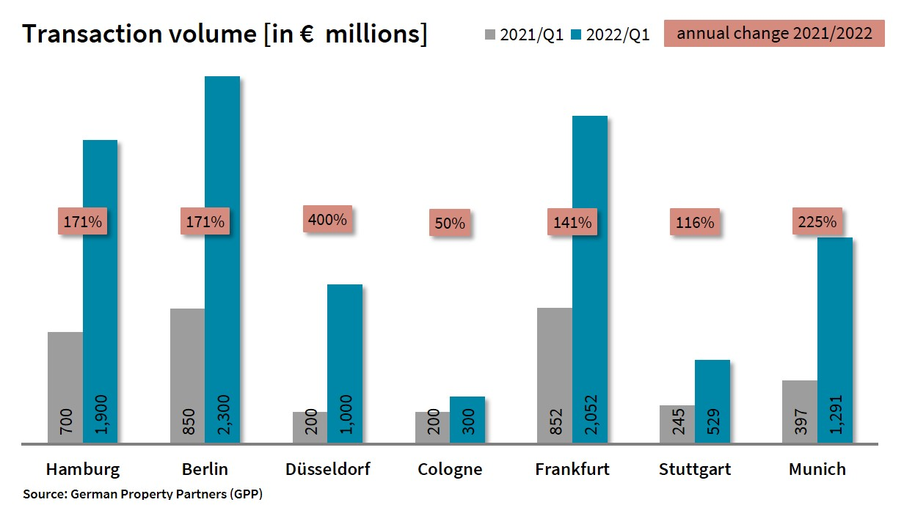

2022-04-04, Hamburg. By the end of the first quarter of 2022 the volume of trading in commercial properties located in Germany’s top 7 cities had climbed to an unprecedented new height. German Property Partners (GPP) has calculated that the volume of transactions totalled some €9.4bn. This translates into a rise of 172 % compared with the all-time low returned in the same quarter a year before and is also appreciably higher than the previous record set in 2007 (some €8bn). “The record result is essentially due to the enormous size of the alstria portfolio, containing numerous properties across the country, that was taken over by Brookfield, and does not give an accurate picture of the market,” says GPP spokesperson Andreas Reberg commenting on the figures. This commercial property network consists of Grossmann & Berger, Anteon Immobilien, GREIF & CONTZEN Immobilien, blackolive and E & G Real Estate.

Transaction totals fuelled by alstria takeover
Brookfield Properties, an asset management firm from Canada, caused a huge spike in trades by taking over Hamburg-based alstria office, a company that manages office buildings. German properties held in this portfolio are valued at €4.5bn and GPP has calculated that about 90 of these, worth some €3.7bn, are located in the top 7 cities (with the exception of Munich). Düsseldorf saw the biggest year on year surge in trading volumes, posting growth of 400 % and a total of about €1bn. Munich reported good growth even without the alstria trade (+225 % and some €1.3bn). Prime contributors to this result were four trades at over €100m each, including the sale of the Olympia Business Centre (OBC). Hamburg (+171 %), Berlin (+171 %) and Stuttgart (+116 %) also benefited greatly from the alstria portfolio transaction. Eight transactions with price-tags over €100m also played a role in Berlin’s good result. Apart from the boost given by the alstria properties, Frankfurt’s good result (+141 %) owes much to the sale of the Marienturm high-rise for more than €800m. Cologne posted a transaction volume that was 50 % higher than the same quarter a year before. Much of this total was generated by a development in the centre of Cologne which was sold for more than €50m.
In connection with the alstria take-over, international investors played an unusually large role on the markets in Germany’s top 7 cities, with a share of 72 % of the trading volume (Q1 2021: 14 %) For the same reason the proportion of portfolio trades is also a remarkably high 44 % (Q1 2021: 15 %)

Office properties are the top selling assets
As Rehberg remarks, “Investor interest in office properties remains high in all the top 7 cities.” Due to the take-over of alstria, trading in office property assets comprised 80 % of the total investment volume. Trailing a long way behind were mixed use properties (7 %) and hotels (4 %).
Prime yields on office properties in the top 7 cities contracted year on year by 0.16 percentage points to 2.69 %. Prime yields on office real estate softened most in Cologne, dropping 0.40 percentage points to 2.60 %. The prime yields on industrial and logistics real estate in the top 7 cities dropped 0.45 percentage points year on year to 3.32 %. Stuttgart reported the largest yield contraction (-0.70 percentage points) followed by Hamburg and Frankfurt (each with -0.60 percentage points). On commercial buildings, prime yields were practically unchanged at 2.88 %.

Forecast
In view of the war in Ukraine, rising inflation and the persistence of Covid infections, it is hard to predict how the commercial property investment markets will develop in Germany’s top 7 cities. “Investors are still eager to buy. As we have seen before, people tend to prefer tangible assets in times of crisis, which is likely to keep demand at high levels, despite the fraught political situation,” says Rehberg, adding, “With interest rates already rising, investors could be motivated to act quickly. If the ECB does indeed increase rates as is expected, it might mark the end of the period of steadily rising property prices.”

Top 10 known agreements | top 7 locations | Q1 2022
City | Project/property | Buyer/investor | Vendor | Pur. price*  (about €m)
FFM | Marienturm, Taunusanlage 9+10 | DWS for the National Pension Service of Korea (NPS) | Aermont Capital / PWREF II fund managed by Perella Weinberg | > 800
MUC | Olympia Business Center (OBC), Georg-Brauchle-Ring 23-25 | Athos Family Office | Europa Capital /Bayern Projekt (joint venture) | 300
MUC | Lauchstädter Strasse 5-11 | CV Real Estate AG | JP Morgan | 160
MUC | Quadriga, Apianstr. 2-20 | Apollo Global Management, LLC | Aroundtown | 121
BER | Sheraton Berlin Grand Hotel Esplanade | DFI / Cells | Archer Hotel Capital / Event Hotels | 116
HAM | building land  Seehafenstrasse | Project developers | Corporate | 70
CGN | Office development  Schildergasse 56-58 / Herzog-strasse 2-12 / Perlenpfuhl 39 | Union Investment for “UniImmo: Deutschland" | Bauwens | 50
FFM | Kastor, Platz der Einheit 1 | Brookfield Asset Management | alstria office REIT-AG | confidential
STG | Epplestrasse 225 | Brookfield Asset Management | alstria office REIT-AG | confidential
FFM | Solmsstrasse 27-37 | Brookfield Asset Management | alstria office REIT-AG | confidential
STG | Badensche Strasse 131 | Züblin | alstria office REIT-AG | confidential
STG | Breitwiesenstrasse 3-5 | Brookfield Asset Management | alstria office REIT-AG | confidential
Source: German Property Partners (GPP)
Top 7 cities | 1st quarter of 2022
 | HAM | BER | DUS | CGN | FFM | STU | MUC | Top 7
Transaction volume  In €m | 1,900 | 2,300 | 1,000 | 300 | 2,052 | 529 | 1,291 | 9,372
Change  against prior yr in % | +171 | +171 | +400 | +50 | +141 | +116 | +225 | +172
Prime yield*, offices  in % | 2.60 | 2.60 | 2.80 | 2.60 | 2.80 | 2.70 | 2.70 | 2.69
against prior yr in percentage points | -0.10 | -0.10 | -0.10 | -0.40 | -0.10 | -0.25 | -0.05 | -0.16
Prime yield*, logistics in % | 3.30 | 3.40 | 3.45 | 3.30 | 3.20 | 3.50 | 3.10 | 3.32
against prior yr in percentage points | -0.60 | -0.35 | -0.30 | -0.30 | -0.60 | -0.70 | -0.30 | -0.45
Strongest  Asset class | Offices | Offices | Offices | Offices | Offices | Offices | Offices | Offices
Strongest  asset class in % | 86 | 59 | 94 | 63 | 95 | 88 | 71 | 80
* Net initial yield; Source: German Property Partners (GPP)

ABOUT GERMAN PROPERTY PARTNERS
German Property Partners is a national network of property service providers; they are all leaders in their local markets. Membership now consists of Grossmann & Berger, Anteon Immobilien, GREIF & CONTZEN Immobilien, blackolive and E & G Real Estate. The network is remarkable for the members’ intimate knowledge of local markets, the experience of the partner firms’ long-standing property consultants and the personal dedication of the owners and directors.

In Germany’s top 7 cities - Hamburg, Berlin, Düsseldorf, Cologne | Bonn, Frankfurt, Stuttgart and Munich - network partners have their own offices offering services in the field of property investment, commercial letting, corporate real estate management (CREM), property valuation and research. Rounding off the range of skills are banking, finance and administration services.

Currently, more than 420 property specialists work for the network. Nationwide, German Property Partners brokered lets in 2021 involving 640,000 m² of commercial property, and managed investment transactions totalling €2.6bn.

www.germanpropertypartners.de
German Property Partners’ data protection declaration is available on the GPP website: www.germanpropertypartners.de/en/privacy-policy. If in future you would prefer not to receive any more information from the GPP press office, please e-mail us at presse@germanpropertypartners.de quoting as reference "Abmeldung aus Presseverteiler” / “Unsubscribe from press mailing list”.

