TOP 7 INDUSTRIAL AND LOGISTICS PROPERTY MARKETS 2021
Trend toward rising rents and purchase prices likely to continue in 2022
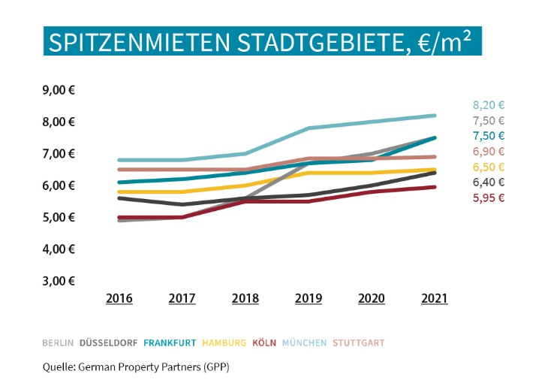

In 2021 the premium rents for industrial and logistics properties rose year on year in every single one of Germany’s top 7 cities. Source: German Property Partners

13 December 2021, Hamburg. In 2021 industrial and logistics properties became considerably more significant in the eyes of both tenants and investors. Demand clearly outstrips supply on the rental and investment markets; however, this is also a result of the shortage of building land for commercial development in each of the top 7 logistics regions. In some areas the result has been surging prices. “Online trade and supply chains have now grown to dimensions that impact on the entire economy. One effect has been to attract new investors who had previously focussed on other classes of asset,” says Oliver Schön, spokesperson for German Property Partners (GPP). For Germany’s top 7 cities the GPP companies Grossmann & Berger, Anteon Immobilien, GREIF & CONTZEN Immobilien, blackolive and E & G Real Estate have compiled an overview of current premium rents, prime yields and real estate prices, and compared them with the figures for recent years.

Premium rent rises by more than 10 %
Whereas in some cities rents for logistics and industrial space remained constant throughout the first half of 2021, when the economy started to recover in the summer premium rents rose in all top 7 regions. Increases were noted both in central city locations and the environs. An excess of demand over supply coupled with the persistent shortage of space are the greatest cost drivers. The biggest year on year increase was seen in the city of Frankfurt, where rents rose by 10.29 % in 2021 to €7.50/m²/month. Strong rent rises were also posted for locations within the city limits of Berlin (+7.14 %) and Düsseldorf (+6.67 %) Currently, industrial firms and logistics companies face the highest rents in Munich, where up to €8.20/m²/month can be charged. Meanwhile, premium rents in Berlin and Frankfurt are closing the gap and are now only 70 cents below this peak.

Biggest decline in prime yields since 2016
With demand greater than supply, yields on logistics properties are being squeezed in all the cities surveyed. Consequently, in each city prime net yields have continued to fall over the course of the year, resulting in an average decline of some 0.50 percentage points in Germany’s top 7. Overall, this contraction is bigger than at any time since 2016. The steepest fall in prime yields on logistics properties was noted in Stuttgart at -0.70 percentage points. Frankfurt followed close behind, with prime yields dropping by 0.60 percentage points. “In many logistics centres, such as Düsseldorf, Cologne|Bonn and Frankfurt, the prime yields on logistics properties are now similar to those attained on commercial buildings,” remarks Schön. Some of the top 7 cities also posted steeply rising prices for development sites in the wake of the economic recovery. Starting from a high base, prices remained stable in only two cities – Munich and Düsseldorf. As in the past, the Bavarian capital Munich and its greater metropolitan area command the highest land prices.

OUTLOOK: INDUSTRIAL AND LOGISTICS PROPERTIES WILL REMAIN IN GREAT DEMAND IN 2022
The shortage of land for commercial development will not abate in 2022, thus further pushing up prices and limiting the availability of new-build properties. German Property Partners therefore expect rents to keep rising in 2022, especially because economists are confident that the economy will grow and online retailers will continue to expand. There is already considerable interest in existing buildings with development potential and this is likely to persist or even increase. “Increasingly, businesses are considering locations in peripheral areas or even outside established logistics centres,” says Schön. Against this backdrop, logistics properties which can readily be let to third parties, that are well-sited and occupied by highly creditworthy tenants remain at the top of investors’ wish lists, so that next year will see ongoing competition for a commodity in short supply. In view of the potential for increasing rents, the shortage of properties and a capital market that offers few alternatives, prime yields on logistics properties are set to fall in the coming year.

You may download the Fact Sheet on the top 7 industrial and logistics real estate markets 2021 i.e. Hamburg, Berlin, Düsseldorf, Cologne|Bonn, Frankfurt, Stuttgart and Munich, from our website.

ABOUT GERMAN PROPERTY PARTNERS
German Property Partners is a national network of property service providers; they are all leaders in their local markets. Membership now consists of Grossmann & Berger, Anteon Immobilien, GREIF & CONTZEN Immobilien, blackolive and E & G Real Estate. The network is remarkable for the members’ intimate knowledge of local markets, the experience of the partner firms’ long-standing property consultants and the personal dedication of the owners and directors.

In Germany’s top 7 cities - Hamburg, Berlin, Düsseldorf, Cologne | Bonn, Frankfurt, Stuttgart and Munich - network partners have their own offices offering services in the field of property investment, commercial letting, corporate real estate management (CREM), property valuation and research. Rounding off the range of skills are banking, finance and administration services.

Currently, more than 410 property specialists work for the network. Nationwide, German Property Partners brokered lets in 2020 involving 462,800 m² of commercial property, and managed investment transactions totalling €2.45bn.

www.germanpropertypartners.de/en

German Property Partners’ data protection declaration is available on the GPP website: www.germanpropertypartners.de/en/privacy-policy. If in future you would prefer not to receive any more information from the GPP press office, please e-mail us at presse@germanpropertypartners.de quoting as reference "Abmeldung aus Presseverteiler” / “Unsubscribe from press mailing list”.

