German Property Partners
Andreas Rehberg is new spokesperson for German Property Partners (GPP)
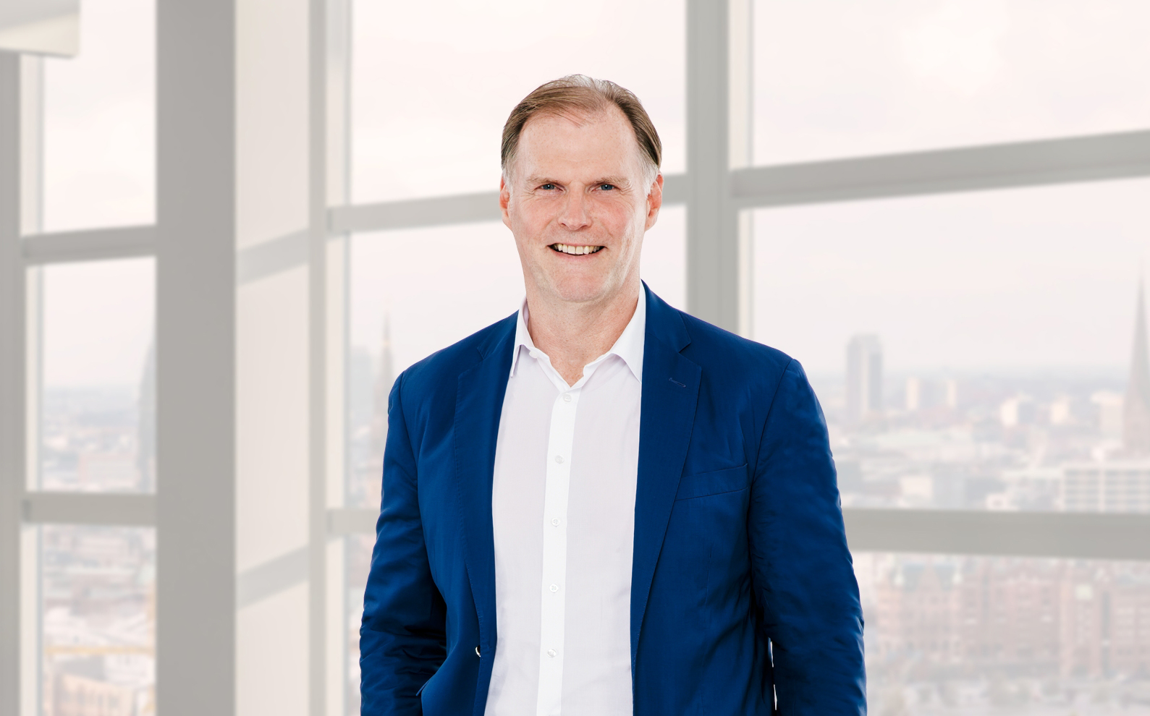

Andreas Rehberg from Grossmann & Berger is now spokesperson for German Property Partners (GPP)
Source: Grossmann & Berger GmbH

xx January 2022 Hamburg As of 1st January 2022 Andreas Rehberg, spokesperson and managing director of Grossmann & Berger, has also assumed the role of spokesperson for German Property Partners (GPP). “We look back on our fruitful cooperation with some exciting successes along the way and wish to take this unity of purpose forward to new strengths. I am delighted that the tenth anniversary of GPP is to be celebrated during my term of office,” says Rehberg. Every two years GPP, the German-wide network of property services providers – all leaders in their local markets – chooses a new spokesperson. Andreas Rehberg takes over from Oliver Schön, founder and managing director of blackolive. Apart from Grossmann & Berger and blackolive, GPP membership comprises Anteon Immobilien, GREIF & CONTZEN Immobilien and E & G Real Estate .

German-wide expertise at the service of commercial clients
The five partners in the network, founded in 2013, cooperate closely in the fields of office letting and commercial real estate investment; they operate in Germany’s top 7 cities - Hamburg, Berlin, Düsseldorf, Cologne, Frankfurt, Stuttgart and Munich. The owner-managed firms are characterized by an intimate knowledge of their local property markets and long-serving employees with their own personal networks. “Thanks to our GPP network we can broker real estate transactions anywhere in Germany and provide our clients with the real estate services they require from people who really know their local markets,” says Rehberg. GPP also cooperates on the international stage with Carter Jonas (Great Britain) and Van Gool Elburg (Netherlands).

Concentrated knowledge of the market
The GPP partners meet for regular exchanges on the major developments in Germany’s top 7 cities. Current topics include users’ changing requirements in terms of office space and purchasing commercial properties. “With many more people working from home and the resulting changes in how space is used, companies now face huge challenges. The EU rules regarding ESG investment means that clients’ consultancy needs have grown,” says Rehberg.

ABOUT GERMAN PROPERTY PARTNERS
German Property Partners is a national network of property service providers; they are all leaders in their local markets. Membership now consists of Grossmann & Berger, Anteon Immobilien, GREIF & CONTZEN Immobilien, blackolive and E & G Real Estate. The network is remarkable for the members’ intimate knowledge of local markets, the experience of the partner firms’ long-standing property consultants and the personal dedication of the owners and directors.

In Germany’s top 7 cities - Hamburg, Berlin, Düsseldorf, Cologne | Bonn, Frankfurt, Stuttgart and Munich - network partners have their own offices offering services in the field of property investment, commercial letting, corporate real estate management (CREM), property valuation and research. Rounding off the range of skills are banking, finance and administration services.

Currently, more than 410 property specialists work for the network. Nationwide, German Property Partners brokered lets in 2020 involving 462,800 m² of commercial property, and managed investment transactions totalling €2.45bn.

www.germanpropertypartners.de/en

German Property Partners’ data protection declaration is available on the GPP website: www.germanpropertypartners.de/en/privacy-policy. If in future you would prefer not to receive any more information from the GPP press office, please e-mail us at presse@germanpropertypartners.de quoting as reference "Abmeldung aus Presseverteiler” / “Unsubscribe from press mailing list”.

