TOP 7 OFFICE MARKETS Q4/2021
Noticeable upswing as market leaves lowest point behind
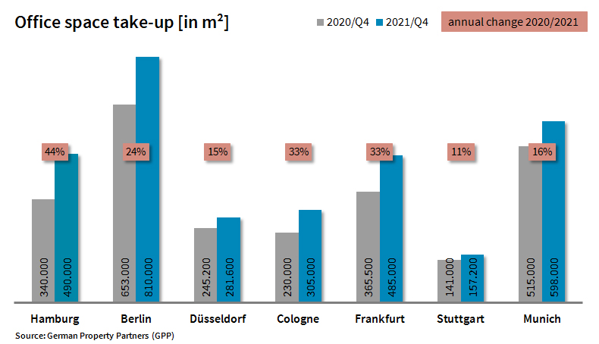

10 January 2022, Hamburg. In view of take-up of office space that totalled 3.13m square metres by the end of the 4th quarter of 2021, it would appear that the office-letting markets in Germany’s top 7 cities have recovered from the depression caused in 2020 by the coronavirus pandemic. Year on year take-up has surged by a good quarter. Although the result is still below the ten-year average of 3.37m square metres, it has passed the psychologically important pre-pandemic threshold of three million square metres. In the first half of the year tenants and owner-occupiers were rather reluctant to commit, but later, especially between October and December, the willingness to sign agreements returned. As shown in figures compiled by the German Property Partners (GPP) network for commercial real estate, take-up of space during the latter period totalled 1.10m square metres, making it the strongest quarter of 2021. GPP Membership now consists of Grossmann & Berger, Anteon Immobilien, GREIF & CONTZEN Immobilien, blackolive and E & G Real Estate.

From moderate to very brisk
Accordingly, take-up of office space rose in each of the top 7 cities. In Hamburg the office-letting business was particularly brisk, growing by 44 %. “This growth stems from the diversity of Hamburg’s economy,” remarks Andreas Rehberg, spokesperson for GPP. The relatively modest rates of growth in Stuttgart, Düsseldorf and Munich would have been even lower without the unusually high surge in the 4th quarter. “In Stuttgart industrial clients used to rent large volumes of space, but no such agreements were signed in 2021; in both Munich and Düsseldorf only one “outlier” contract was signed,” says Rehberg. Growth of between a third and a quarter was noted in Cologne, Frankfurt and Berlin due to demand from the public sector. In each city, it is true to say that demand has recovered appreciably and that more agreements were signed. However, as a rule it took longer to finalize contracts than it had the year before. The rate of owner-occupiers in the top 7 cities rose slightly year on year from 5 % to 8 %.

Expansion and relocation have become easier
At the end of 2021 the vacancy rate in the top 7 cities had risen to 4.7 % from 3.6 % a year before. Thus the space available at short notice in Hamburg, Berlin, Düsseldorf, Cologne, Frankfurt, Stuttgart and Munich climbed to a total of 4.36m square metres, a third more than at the end of 2020. “But even when it comes to empty office space, there are two sides to the coin. If the market approaches a state of having practically no more offices to let, as happened in recent years, companies are unable to expand as planned. Consequently, this hampers the growth of businesses which, in many cases, have already suffered from the pandemic,” Rehberg notes. “In this respect greater choice of office space in most cities is a boon to companies seeking larger premises. This is especially true in Berlin and Munich, where the vacancy rate was only about 2 per cent a year ago.” Observers were pleased to note that even in Frankfurt the vacancy rate remained below 10 %, at 9.1 %, despite a rate rise that was second only to that of Munich. In relation to total office stock, the lowest amount of available space was posted in Cologne and Stuttgart at 3.2 %.

Premium rents soar in some cities
GPP noted that office rents leapt up in Munich and Cologne. The premium rent in Munich, capital of Bavaria, increased by €3.50/m²/month, the average rent by €2.20/m²/month. In Cologne premium rents also rose by the unusually high amount of €2.00/m²/month. The reasons are to be found in agreements, some off-plan in exclusive new-builds, for space in the CBD or city centre and in the Altstadt sub-market of Munich. Rehberg adds that, “Since some new-build rents in Munich’s CBD are already well over 40 euros per square metre and since tenants are paying, on average, 35 to 36 euros per square metre in the new urban hotspot called “Werksviertel”, we expect premium rents in the city to keep setting new records in 2022.” He continues, “The premium rent in Berlin has pushed through the 40-euro barrier for the first time and is now approaching the heights seen in Frankfurt and Munich.” Since all the prime locations in the central city have been let already, potential new tenants must expect rents to continue rising here too.

Outlook
The outlook is less rosy when considering the pre-letting ratios of new-build developments. “Many developers and builders are postponing speculative schemes until the market stabilizes, having benefited from the shortage of space in recent years to complete developments on speculation,” says Rehberg. Accordingly, by the end of 2021 the pre-letting rates for 2022 and 2023 were around half of the 3.46m square metres of new office space scheduled for completion in the top 7 cities. “The economic forecasts are less positive than they were and the pandemic is not yet over. No-one can say exactly how this will affect employment and the office markets. Certainly, the current level of enquiries is no indication of how the market will develop,” says Rehberg in conclusion.

Major known agreements for 15,000 m² or more | Top 7 locations | Q1-4 2021
City | Project/property | Tenant/owner-occupier | Rental area (ca. m²)
MUC | Anzinger Strasse | Deutsches Patent- und Markenamt (Patents office, DPMA) | 45,000
BER | “Upbeat”, Heidestrasse | DKB Bank | 34,900
DUS | Nord sub-market | confidential | 26,000
FFM | “Boersenplatz Eschborn”,  Boersenplatz 1-6, Eschborn | Federal Office for Economic Affairs and Export Control (BAFA) | 21,400
BER | “New Courts”, Gerichtstrasse 48-49 | Federal Office for Consumer Protection and Food Safety (BVL). | 20,000
FFM | “Kreisler”, Baseler Straße 46-48 | Nestlé Deutschland | 20,000
HAM | “Ipanema”, Überseering 30 | Berenberg Bank | 19,200
CGN | Ehrenfeld sub-market | confidential | 19,000
MUC | Freisinger Landstrasse | SAP | 18,000
CGN | Cologne East sub-market | Federal agency | 18,000
MUC | Gisela-Stein-Strasse | Wacker Chemie | 17,800
HAM | “Michaelis Quarter”, Ludwig-Erhard-Strasse 11-17 | Hamburg State Prosecutor | 17,600
CGN | Josef-Lammerting-Allee 24-34 | Federal agency | 16,200
CGN | confidential | confidential | 16,000
FFM | “Atricom”, Lyoner Strasse 15 | Worldline Germany | 15,400
FFM | “The Move Blue”, (Gateway Gardens),  De-Saint-Exupèry-Strasse 3, 5-7 | Siemens (owner-occupier) | 15,000
Transactions occurring in the quarter covered by this report are highlighted. Source: German Property Partners (GPP)

Top 7 cities | 1st-4th quarters of 2021
 | HAM | BER | DUS | CGN | FFM | STU | MUC | Top 7
Take-up of space  in m² | 490,000 | 810,000 | 281,600 | 305,000 | 485,000 | 157,200 | 598,000 | 3,126,800
Change  against prior yr in % | +44 | +24 | +15 | +33 | +33 | +11 | +16 | +26
Premium rent  in €/m²/month | 31.50 | 40.30 | 28.50 | 28.00 | 45.50 | 25.00 | 42.00 | -
Average rent  in €/m²/month | 18.10 | 29.30 | 16.70 | 17.00 | 21.70 | 16.00 | 24.50 | -
Total stock of office space  in millions m² | 13.96 | 20.51 | 7.33 | 8.00 | 11.68 | 8.26 | 23.40 | 93.14
Vacant space incl. sub-let space [m²] | 537,600 | 690,000 | 551,500 | 255,000 | 1,057,500 | 268,000 | 998,000 | 4,357,600
Vacancy rate incl. sub-let space [%] | 3.8 | 3.4 | 7.5 | 3.2 | 9.1 | 3.2 | 4.3 | 4.7
Completions  2022 + 2023 in m² | 556,000 | 911,000 | 307,000 | 260,000 | 482,600 | 271,600 | 670,000 | 3,458,000
Pre-let ratios 2022 + 2023 in % | 57 | 58 | 58 | 55 | 31 | 47 | 46 | 51
Source: German Property Partners (GPP)

ABOUT GERMAN PROPERTY PARTNERS
German Property Partners is a national network of property service providers; they are all leaders in their local markets. Membership now consists of Grossmann & Berger, Anteon Immobilien, GREIF & CONTZEN Immobilien, blackolive and E & G Real Estate. The network is remarkable for the members’ intimate knowledge of local markets, the experience of the partner firms’ long-standing property consultants and the personal dedication of the owners and directors.

In Germany’s top 7 cities - Hamburg, Berlin, Düsseldorf, Cologne | Bonn, Frankfurt, Stuttgart and Munich - network partners have their own offices offering services in the field of property investment, commercial letting, corporate real estate management (CREM), property valuation and research. Rounding off the range of skills are banking, finance and administration services.

Currently, more than 410 property specialists work for the network. Nationwide, German Property Partners brokered lets in 2020 involving 462,800 m² of commercial property, and managed investment transactions totalling €2.45bn.

www.germanpropertypartners.de/en

German Property Partners’ DATA PROTECTION DECLARATION is available on the GPP website: www.germanpropertypartners.de/en/privacy-policy. If in future you would prefer not to receive any more information from the GPP press office, please e-mail us at presse@germanpropertypartners.de quoting as reference "Abmeldung aus Presseverteiler” / “Unsubscribe from press mailing list”.

