TOP 7 OFFICE MARKETS Q1/2022
Office markets benefit from moves to choose locations that will boost staff loyalty

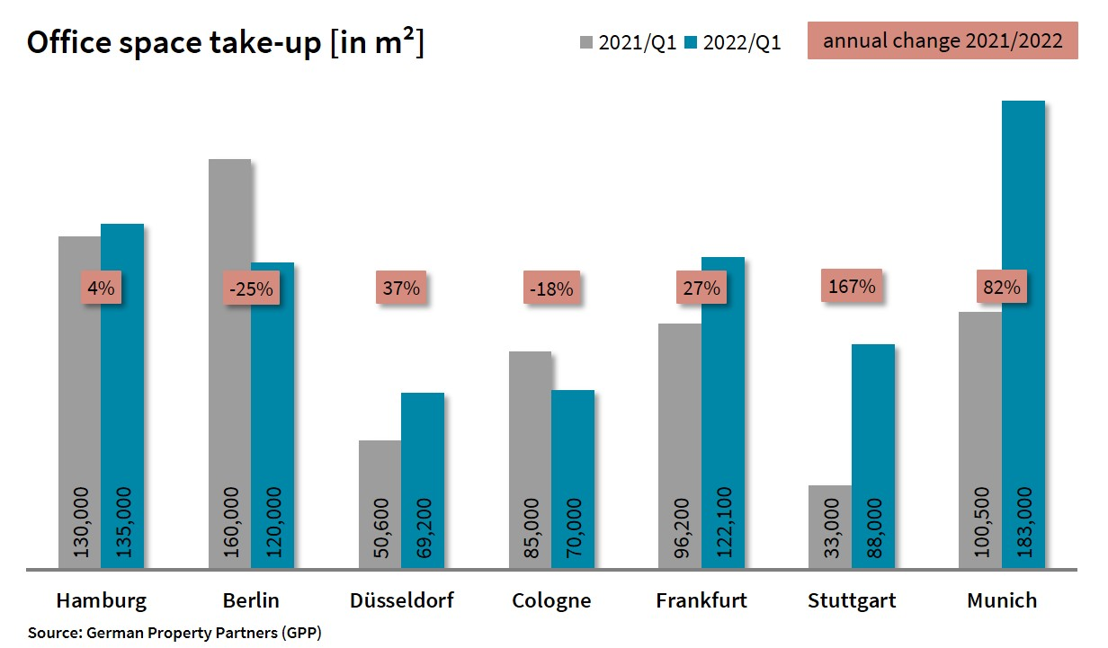

2022-04-01, Hamburg. There was definitely demand for office space in Germany’s top 7 cities, as may be seen by the fact that year on year take-up grew overall by about a fifth in the 1st quarter of 2022 to total 785,600 m². “Whether large-volume agreements were signed in late 2021 or between January and March of this year made a huge difference in the relative performance of cities. For example, the former scenario applies to Berlin, where take-up of 115,000 m² was below average. The latter describes the situation in Stuttgart, where take-up of space grew by an above-average 167 per cent,” says Andreas Rehberg, spokesperson for German Property Partners (GPP). This commercial property network consists of Grossmann & Berger, Anteon Immobilien, GREIF & CONTZEN Immobilien, blackolive and E & G Real Estate. “In addition to the pandemic, whose widespread effects are still in evidence, office markets in the top 7 cities are now facing the problems caused by the Ukraine crisis and forecasts of rising inflation rates.”

Take-up of space increases in 5 cities
In the 1st quarter the spread of take-up results varies enormously between -28 % in Berlin and + 167 % in Stuttgart. Cologne, like the national capital, returned a lower result, dipping 18 % year on year. Unlike Cologne, where two agreements for very large premises were signed, the biggest property lease in Berlin was a mere 5,300 m². Rehberg believes it is safe to say that, “Although the national capital started the year 2022 slowly, ongoing demand from the technology sector is reason to expect an appreciably brisker market during the remaining months of the year.” The fact that the biggest-volume transaction in Stuttgart involved the purchase of an existing office block and that the two biggest agreements in Frankfurt were construction starts, propelled their proportion of owner-occupiers to one third. Across the top 7 cities, owner-occupiers accounted for 101,160 m² of take-up, which translates into a market share of 13 %.

Companies are investing in quality
Both the average and premium rents paid in the top 7 office markets increased year on year in the 1st quarter of 2022. Only in Düsseldorf was no change in either rent noted. In Cologne rents stabilized against the previous quarter, although a decline of 50 cents/m²/month was noted for the average rent. Rising by €1.90/m²/month, the average rent climbed by more in Berlin than elsewhere and the new figure of €29.90/m²/month is more than €5/m²/month higher than the rate in the next most expensive city. However, compared with the previous quarter the growth in rents has slowed noticeably. “In order to bolster maximum rents, landlords in Berlin are offering incentives such as rent-free periods or fit-out grants once more,” reports Rehberg. Stuttgart posted a surge in premium rents of €4.40/m²/month. This was caused by a higher number of agreements to rent high-quality office space. Rehberg adds that, “Office rents reflect what we have been seeing on the ground: companies are investing far more in their offices than before the pandemic, either by selecting a better location, higher-quality space or both.”

Once again, tenants have a choice in Berlin and Munich
Of a total stock of 93.72m m² of office space in the top 7 cities, 4.62m m² were available at short notice at the end of the 1st quarter. Although the volume of empty space rose by a quarter in the top 7 cities, their vacancy rates remained a moderate 4.9 %. The changes in volumes of empty space in Berlin and Munich appear significantly elevated. “But the office space is coming onto the market gradually, not all at once,” explains Rehberg. “Therefore, for the first time in many years, companies in Berlin and Munich find a reasonable reserve of available space on the market or, to put it another way, they finally have a real choice.” Conversely, the galloping increase in the volume of empty office space in Frankfurt has now slowed to 7 %. Helping to satisfy the demand for top quality office space in the top 7 cities, 3.52m square metres of newly completed space will be available in 2022 and 2023. Berlin and Munich are still the undisputed hotspots for new-builds, reporting 915,800 m² and 850,000 m² respectively. The pre-letting ratio in the top 7 cities was 55 %. At the end of the 1st quarter the highest levels of off-plan rentals were posted in Berlin, Hamburg and Cologne. In these three cities pre-letting ratios were 60 %.

Major known agreements for 5,000 m² or more | Top 7 locations | 1st quarter 2022
City | Project/property | Tenant/owner-occupier | Rental area (ca. m²)
FFM | Ludwig-Erhard Strasse 7, Eschborn | Deutsche Gesellschaft für Internationale Zusammenarbeit, giz (Fed. int. aid org.)owner occupier | 28,000
STU | “Atlanta Business Center”, Vaihinger Strasse 131 | Ed. Züblin owner-occupier | 21,400
MUC | “aer”, Fritz-Schäffer-Strasse 9 | Bosch Building Technologies | 20,000
CGN | confidential | confidential | 16,000
HAM | “Elbbrückenquartier”, Versmannstrasse | confidential | 11,500
STU | Bülowbogen/Heilbronner Strasse 150 | City of Stuttgart, dept. of digitalization | 9,480
MUC | Technology Centre.  Schatzbogen/Hollerithstrasse 1-3 | Deutsche Telekom | 9,430
FFM | “Sparda Bank Tower”, Europa-Allee 68 | Sparda-Bank Hessen owner-occupier | 9,100
CGN | confidential | confidential | 8,000
DUS | Theodorstrasse 109 | Bima (Federal real estate agency) | 7,950
STU | “Campus Sternhöhe”, Epplestrasse 225 | Bechtle | 7,550
FFM | “IBC”, Theodor-Heuss-Allee 70-74 | Deutsche Bank | 6,100
HAM | “EDGE HafenCity”, Amerigo-Vespucci-Platz 1 | Veolia Umweltservice | 5,700
BER | Badensche Strasse 28 | Bamf (Fed. Agency Migration + Refugees) – extension | 5,530
HAM | Essener Bogen 6a-d | Evotec | 5,300
Source: German Property Partners (GPP)

Top 7 cities | 1st quarter of 2022
 | HAM | BER | DUS | CGN | FFM | STU | MUC | Top 7
Take-up of space  in m² | 135,000 | 115,000 | 69,200 | 70,000 | 122,100 | 88,000 | 183,000 | 780,600
Change  against prior yr in % | +4 | -28 | +37 | -18 | +27 | +167 | +82 | +19
Premium rent  in €/m²/month | 31.50 | 41.00 | 28.50 | 27.00 | 45.50 | 29.40 | 40.00 | -
Average rent  in €/m²/month | 18.50 | 29.90 | 16.85 | 17.00 | 21.60 | 17.20 | 22.50 | -
Total stock of office space  in millions m² | 13.96 | 20.84 | 7.42 | 8.06 | 11.72 | 8.37 | 23.35 | 93.72
Vacant space incl. sub-let space [m²] | 493,200 | 850,000 | 585,600 | 255,000 | 1,038,800 | 300,000 | 1,100,000 | 4,662,600
Vacancy rate incl. sub-let space [%] | 3.5 | 4.1 | 7.9 | 3.2 | 8.9 | 3.6 | 4.7 | 4.9
Completions  2022 + 2023 in m² | 578,000 | 915,800 | 254,800 | 260,000 | 421,400 | 240,066 | 850,000 | 3,520,000
Pre-let ratios 2022 + 2023 in % | 60 | 60 | 57 | 60 | 33 | 42 | 56 | 55
Source: German Property Partners (GPP)

ABOUT GERMAN PROPERTY PARTNERS
German Property Partners is a national network of property service providers; they are all leaders in their local markets. Membership now consists of Grossmann & Berger, Anteon Immobilien, GREIF & CONTZEN Immobilien, blackolive and E & G Real Estate. The network is remarkable for the members’ intimate knowledge of local markets, the experience of the partner firms’ long-standing property consultants and the personal dedication of the owners and directors.

In Germany’s top 7 cities - Hamburg, Berlin, Düsseldorf, Cologne | Bonn, Frankfurt, Stuttgart and Munich - network partners have their own offices offering services in the field of property investment, commercial letting, corporate real estate management (CREM), property valuation and research. Rounding off the range of skills are banking, finance and administration services.

Currently, more than 420 property specialists work for the network. Nationwide, German Property Partners brokered lets in 2021 involving 640,000 m² of commercial property, and managed investment transactions totalling €2.6bn.

www.germanpropertypartners.de/en

German Property Partners’ data protection declaration is available on the GPP website: www.germanpropertypartners.de/en/privacy-policy. If in future you would prefer not to receive any more information from the GPP press office, please e-mail us at presse@germanpropertypartners.de quoting as reference "Abmeldung aus Presseverteiler” / “Unsubscribe from press mailing list”.

