TOP-7-INVESTMENT MARKETS Q3/2021
Greater willingness to invest stabilizes market

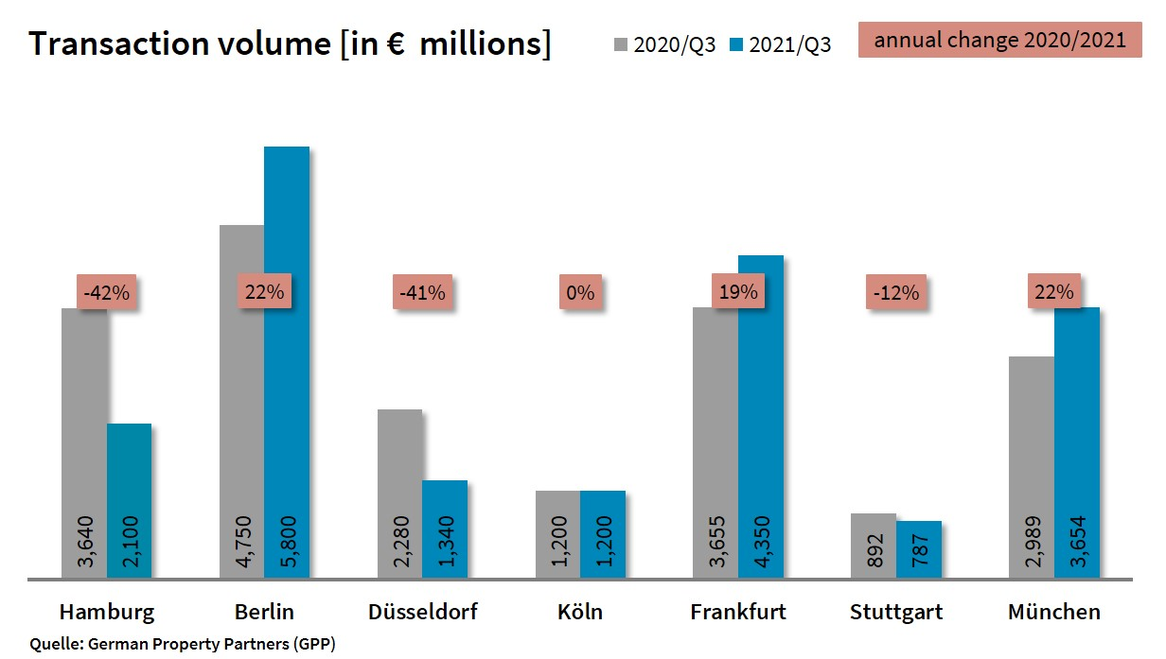

04 October 2021, Hamburg. At the close of the 3rd quarter of 2021 the volume of investments in commercial properties located in Germany’s top 7 cities remained consistently stable. Real estate changed hands for a total of €19.2bn, down year on year by a mere 1 %. However, the volume of trading still varied quite considerably from city to city. “In the majority of markets the choice of investment properties remains very limited. High rates of increase, such as those posted in Berlin, Frankfurt and Munich, are very much the result of outlier trades. But they do indicate that there are plenty of investors willing to spend,” says Oliver Schön, spokesperson for German Property Partners (GPP). This commercial property network consists of Grossmann & Berger, Anteon Immobilien, GREIF & CONTZEN Immobilien, blackolive and E & G Real Estate.

Outlier trades and economic revival boost investment markets
Frankfurt posted an especially strong 3rd quarter. The sale of the “FOUR – T1” and the “Skyper” for a total of about €2bn contributed most to the total trading volume, which grew by 19 % after an extremely weak 1st half year. Berlin and Munich posted the biggest 3rd-quarter increases, each closing 22 % higher. Both of these major cities benefited from strong results and outlier trades in the preceding quarters. Moreover, several properties were sold in Berlin at prices exceeding €100m. So far, the volume of trading in Cologne has stayed at the same level as the previous year; however, investors are now far more active and have initiated several sales processes. In Stuttgart the volume of trading dipped 12 % below the previous year. Nevertheless, year on year appreciably more real estate was traded in the 3rd quarter of 2021 in this city, the state capital of Baden-Württemberg. The ongoing acute shortage of core real estate in Hamburg (-42 %) and Düsseldorf (-41 %) resulted in persistently low trading volumes. Compared with the first two quarters of 2021, however, the Hamburg market has seen a marked revival because investors are starting to include other risk classes too. By contrast, investors in Düsseldorf, remained more hesitant and opted for safe core properties. In four of the top 7 cities portfolio sales still comprised a small proportion of trading, with Berlin posting the segment’s largest contraction at -73 %. But in Stuttgart portfolio trades were up by 257.5%.

Prime yields on offices and logistics properties remain threatened
Accounting for 33 % of the market, overseas investors remained a steady factor. Whereas their market share was largely unchanged year on year in most of the top 7 cities, it fell far below previous levels in Hamburg and Frankfurt. Office properties remained the most popular asset class. “Due to the coronavirus pandemic and doubts about the stability of the employment market, many market players were reluctant to invest in office properties. Since the end of the second lockdown many cities have seen their office markets revive appreciably, which obviously keeps investors interested in this important class of assets,” says Schön. Office properties made up 83 % of the trading volume in Frankfurt, a higher proportion than in the other 6 cities. Berlin is the exception; here the 2nd-quarter sale of the “Fürst” propelled the mixed use category to a commanding 45 % share. Overall, high demand for commercial real estate puts further pressure on prime yields. Year on year, prime yields on office properties contracted by 0.08 percentage points to 2.80 %. Prime yields on office real estate softened most in Munich, dropping 0.25 percentage points to 2.75 %. The lowest prime yield on this class of asset, 2.60 %, was noted in Hamburg. Prime yield compression on industrial and logistics real estate was considerable, averaging a loss of 0.38 percentage points and falling to 3.58 %. Hamburg posted the highest decline (-0.70 percentage points), followed by Stuttgart and Munich, each dropping 0.50 percentage points.

Forecast: Trading volume in the top 7 set to be similar to prior year
“Some fairly large transactions are still in the pipeline in all top 7 cities. Therefore we expect to see an interesting rally before the year ends,” remarks Schön. Overall, the trading volume is likely to remain very similar to last year’s figure. In Berlin, it will be higher than expected because a large number of big-ticket trades are awaiting completion. Frankfurt should see more investment by the end of the year as cash-rich investors urgently seek opportunities. German Property Partners expect Hamburg and Düsseldorf to return satisfactory results, although these will fall below the prior year due to the huge, ongoing shortage of property on the market.

Top 10 known agreements | top 7 locations | 1st-3rd quarters of 2021
City | Project/property | Buyer/investor | Vendor: | Pur. price*  (about €m)
FFM | “FOUR T1”, Grosse Gallusstrasse 10-14 | Allianz Real Estate and Bayerische Versorgungskammer (pensions) | Groß & Partner Grundstücksentwicklungs-gesellschaft | 1,400
BER | “Fürst”, Kurfürstendamm 206-209 | Aggregate Holdings | Vivion | > 1,000
MUC | “Highlight Towers”  Mies-van-der-Rohe-Strasse 6 | Imfarr + SN | Commerz Real | 650
MUC | “Media Works”,  Rosenheimer Strasse 145a-i / Anzinger Straße 1-17 | Union Investment and Hines | Officefirst | 650
MUC | “O2 Tower”  Georg-Brauchle-Ring | DIC Asset | GIC | 570
FFM | “Skyper”, Taunusanlage 1 | HDI Deutschland | Allianz Real Estate | 560
FFM | Ludwig-Erhard Strasse 7, Eschborn | Deutsche Gesellschaft für Internationale Zusammenarbeit (Fed. int. aid org.) | PHOENIX Real Estate Development | 220
BER | “Quartier 206”,  Friedrichstrasse 71 | RFR Holding | Bank consortium headed by Credit Suisse | 220
FFM | “Westend Carrée”,  Grüneburgweg 14-18 | Ardian Real Estate | publity | > 200
FFM | “Sparda Bank Tower”  Europa Allee 68 | Sparda-Bank Hessen | Gustav Zech Stiftung | Confiden-tial
Transactions occurring in the quarter covered by this report are highlighted. Source: German Property Partners (GPP)

Top 7 cities | 1st-3rd quarters of 2021
 | HAM | BER | DUS | CGN | FFM | STU | MUC | Top 7
Transaction volume  In €m | 2,100 | 5,800 | 1,340 | 1,200 | 4,350 | 787 | 3,654 | 19,231
Change  against prior yr in % | -42 | +22 | -41 | 0 | +19 | -12 | +22 | -1
Prime yield*, offices  in % | 2.60 | 2.65 | 2.90 | 3.00 | 2.90 | 2.80 | 2.75 | 2.80
against prior yr in percentage points | -0.20 | -0.05 | -0.05 | 0.00 | -0.05 | 0.00 | -0.25 | -0.05
Prime yield*, logistics in % | 3.50 | 3.50 | 3.75 | 3.50 | 3.60 | 3.70 | 3.50 | 3.58
against prior yr in percentage points | -0.70 | -0.30 | -0.25 | -0.30 | -0.10 | -0.50 | -0.50 | -0.38
Strongest  Asset class | Offices | Mixed use | Offices | Offices | Offices | Offices | Offices | -
Strongest  asset class in % | 62 | 45 | 61 | 50 | 83 | 36 | 79 | -
* Net initial yield; Source: German Property Partners (GPP)

ABOUT GERMAN PROPERTY PARTNERS
German Property Partners is a national network of property service providers; they are all leaders in their local markets. Membership now consists of Grossmann & Berger, Anteon Immobilien, GREIF & CONTZEN Immobilien, blackolive and E & G Real Estate. The network is remarkable for the members’ intimate knowledge of local markets, the experience of the partner firms’ long-standing property consultants and the personal dedication of the owners and directors.

In Germany’s top 7 cities - Hamburg, Berlin, Düsseldorf, Cologne | Bonn, Frankfurt, Stuttgart and Munich - network partners have their own offices offering services in the field of property investment, commercial letting, corporate real estate management (CREM), property valuation and research. Rounding off the range of skills are banking, finance and administration services.

Currently, more than 430 property specialists work for the network. Nationwide, German Property Partners brokered lets in 2020 involving 462,800 m² of commercial property, and managed investment transactions totalling €2.45bn.

www.germanpropertypartners.de/en

German Property Partners’ data protection declaration is available on the GPP website: www.germanpropertypartners.de/en/privacy-policy. If in future you would prefer not to receive any more information from the GPP press office, please e-mail us at presse@germanpropertypartners.de quoting as reference "Abmeldung aus Presseverteiler” / “Unsubscribe from press mailing list”.

